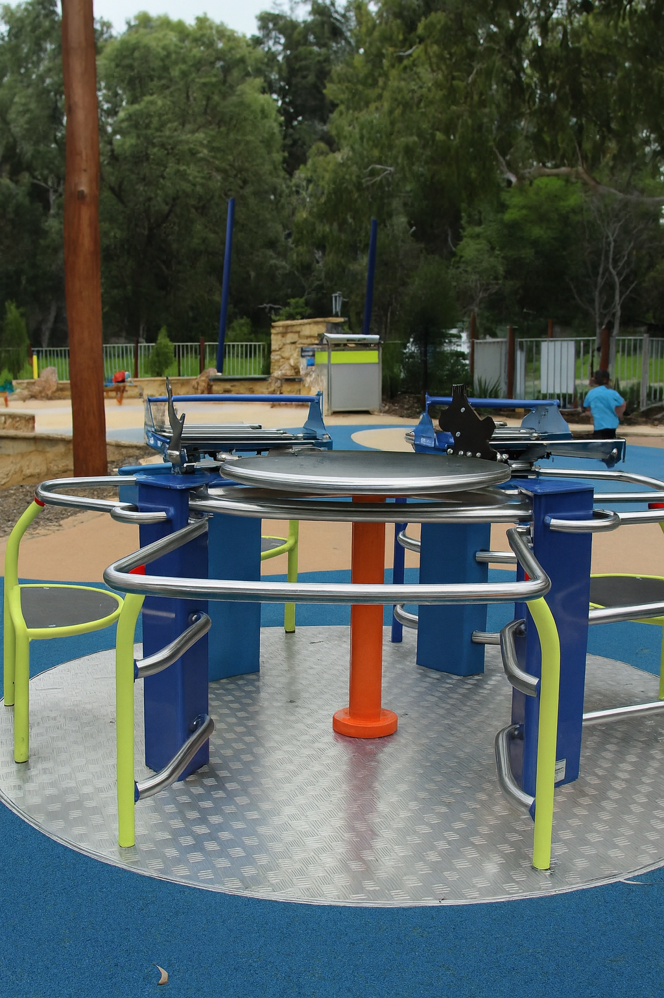
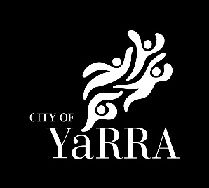

Summary version: Universal Design and Disability Inclusion Policy

Overview

Purpose of the policy
The Universal Design and Disability Inclusion Policy (The Policy) sets out the City of Yarra's commitment to using a universal design approach to create an inclusive, accessible and welcoming community for people of all abilities.
It guides how Council designs its services, facilities, public spaces and communications, and includes people of all abilities. This Policy will inform Council plans, strategies, service delivery and decision-making. It also provides a framework for the Disability Inclusion Action Plan.

Why universal design?
A universal design (UD) approach is the most effective ways for local governments to improve disability inclusion because it embeds accessibility from the outset across places, services and information – for the widest possible range of users, including people with disability, older people, parents with prams, people with temporary injury, and people with different language and literacy needs. UD shifts effort from retrofitting individual adjustments to designing mainstream environments and systems that are usable to the greatest extent possible without specialised design, reducing barriers and supporting safer, more independent participation in everyday community life.

Embedding a universal design approach
This Policy will require the principles of universal design to be applied to all new and renewed activities of Council, including but not limited to:
- The planning, design, construction, refurbishment, maintenance and operation of Council-owned and managed buildings, facilities and open space and recreation assets.
- Footpaths, parking, public toilets, wayfinding and the broader public realm.
- Communication and information (digital and non-digital), community engagement and customer experience across all channels.
- Council services, programs and events including emergency preparedness and response.
- Policies, plans, processes and procurement that shape how decisions are made, how money is spent, and projects are delivered.
- Employment and volunteering including inclusive recruitment, workplace adjustments and volunteer support.
- Civic participation and volunteering
It is relevant to all departments and forms the basis for operational planning.

Priority areas for disability inclusion
This Policy and our commitments consider input from our community, obtained through detailed consultation and engagement exercises, and ongoing advice and direction from Council's Disability Advisory Committee.

Priority 1: Accessible & Inclusive Places and Transport
Improve Yarra's buildings, parks, streets and transport to ensure equitable access and inclusion
  - Apply a Universal Design approach to all new and upgraded Council buildings, facilities, and open spaces to achieve the best possible accessibility outcomes

  - Improve footpaths, kerbs, lighting, and other elements of the public realm

  - Improve transport access, accessible parking, wayfinding and connected paths of travel.

  - Partner with people with disability to identify access barriers and shape upgrades to buildings and spaces.

Priority 2: Inclusive Services, Programs & Information
Deliver Council services, programs and information in ways that everyone can access and participate
2.1 Design all Council services and programs to be inclusive, flexible and responsive.

2.2 Make Council's website, online services and materials accessible.

2.3 Offer multiple communication pathways and accessible customer service options.
2.4 Use inclusive consultation and engagement methods.

Priority 3: Inclusive Participation and Employment
Council can use its role as a civic leader, partner and connector to encourage inclusive practices, strengthen pathways and promote opportunities across Yarra.
3.1 Promote inclusive employment and leadership in Yarra

3.2 Encourage local employment participation pathways

3.3 Support Yarra sports clubs, recreation groups, arts and volunteer organisations to
welcome participation by people with disability.

Priority 4: Fairness and Safety
Build a community where people with disability feel safe and supported through advocating for fairness, equity and inclusion.
4.1 Advocate to state transport authorities for more accessible public transport.

4.2 Support local businesses, events and festivals to improve accessibility through
tools, guidance and partnerships.

4.3 Promote accessible housing options, including advice on heritage-related
upgrades and modifications.

4.4 Strengthen access to food relief, outreach programs and community support for
people with disability, families and carers.

4.5 Improve emergency preparedness information and support for people with
disability.

Priority 5: Belonging and Celebration
Promote disability inclusion, pride and belonging in Yarra by celebrating the contributions, leadership and culture of people with disability and carers.
5.1 Increase the representation of people with disability in Yarra's communications,
cultural outputs and public art.

5.2 Celebrate awareness days and events that promote disability pride and challenge
stigma.

5.3 Acknowledge the essential role of carers and support their wellbeing and
participation.

5.4 Promote opportunities for people with disability to engage in local arts, culture,
community life and volunteering.

5.5 Create and promote inclusive events and social connection opportunities for
people with disability and carers.

Priority 6: Effective data and reporting outcomes
Collect meaningful data, track progress and keep improving disability inclusion across Council.
6.1 Collect high-quality disability data across surveys, engagements, programs and
service reviews.

6.2 Embed evaluation and continuous improvement across Council.

6.3 Strengthen transparency and organisational accountability.
Universal Design Guidelines

Universal Design at Yarra:
To meet Council's aim of building an accessible and inclusive Yarra, we will apply a Universal Design (UD) approach to the design of the built and non-built environment, including buildings, open spaces and the public realm; information, communication, services, programs and events.
A Universal Design approach will be applied to systematically consider how to achieve the best possible accessibility outcomes, while recognising that existing urban environments, site constraints and other intersecting factors may influence the final outcomes.

What is Universal Design:
Universal Design (UD) is the design of products, environments, programs and services so they can be used by all people, to the greatest extent possible, regardless of age, disability or background.¹
Unlike minimum accessibility standards such as the Access to Premises Standards 2010 and AS 1428 which are the minimum compliance thresholds and usually only consider basic access rather than inclusion, universal design goes further - it aims to create environments that work well for everyone from the outset.
While disability-accessible design may retrofit ramps, lifts, or tactile indicators to remove barriers, UD considers the whole experience encompassing movement, sensory needs, cognition, wayfinding, comfort, safety, and enjoyment, and integrates these considerations into the design.

Guiding Principles of Universal Design at Yarra
These are adapted from: https://design.ncsu.edu/research/center-for-universal-design/
1. Equitable Use   | The building/service/public space is useable by people with diverse physical, cognitive, sensory and social abilities.
2. Flexibility in Use   | The design accommodates a wide range of individual needs, preferences and abilities.
3. Simple and Intuitive Use   | Use of the design is easy to understand, regardless of the user's experience, knowledge, language skills, or current concentration level.
4. Perceptible Information   | The design communicates necessary information effectively to the user, regardless of ambient conditions or the user's sensory abilities.
5. Tolerance for Error   | The design minimises hazards and the adverse consequences of accidental or unintended actions.
6. Low Physical Effort   | The design can be used efficiently and comfortably, with minimal effort or fatigue.
7. Size and Space for Approach and Use   | Appropriate size and space are provided for approach, reach, manipulation, and use regardless of the user's body size, posture, or mobility.
8. Cultural appropriateness   | Respecting diverse cultures and First Peoples and ensuring designs are a cultural fit for their community and user groups

Yarra City Council acknowledges the Wurundjeri Woi Wurrung people as the Traditional Owners and true sovereigns of the land now known as Yarra. We also acknowledge the significant contributions made by other Aboriginal and Torres Strait Islander people to life in Yarra. We pay our respects to Elders from all nations and to their Elders past, present and future.

