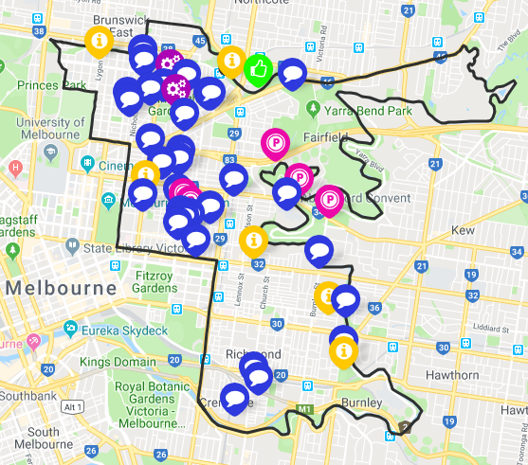
SUMMARY OF STAGE 1 CONSULTATION: October – November 2018
Stage1 Consultation: Online survey and in-person discussion opportunities including 3 library sessions
Promotion
- Direct email
- Article in Yarra Life eNewsletter
- Promoted on social media
- Promotional postcards
Feedback
- Approximately 80 responses/ submissions/ in person sessions
- All suburbs represented
- All 4 Key directions represented

