DRAFT

Footpath Trading Policy



Contents
Contents 2
1. Purpose 3
2. Policy objectives 3
3. Background 4
4. Definitions 4
5. Eligibility Criteria 6
6. Application process 6
7. Footpath Trading Requirements 9
8. Management Requirements 13
9. Permit renewal 13
10. Condition of Permits 14
11. Cancelling Permits 14
12. Ceasing Permits 14
13. Enforcement of footpath trading 15
14. Other permits and legislative requirements 16
15. Document Control 16

Title | Footpath Trading Policy
Description | This policy sets out what businesses need to do to establish footpath trading within the City of Yarra and the various requirements they need to understand, consider and comply with.
Type | Policy
Approval authority | Compliance & Parking Services
Responsible officer | Manager Compliance & Parking Services
Approval date | XX
Review cycle | Every four years, or earlier if needed
Review date | XX

Purpose
The purpose of this policy is to establish a clear and consistent framework for the management of footpath trading activities within the Yarra. It provides guidance to businesses and the community on the requirements for obtaining and maintaining a Footpath Trading Permit and outlines the considerations that will inform Council's decision making and enforcement practices in alignment with the Local Law’s Principles.

Policy objectives
The objectives of this policy are to:
- Maintain a safe, clear, and unobstructed path of travel on all footpaths for people of all abilities, in compliance with the Disability Discrimination Act 1992.
- Balance the commercial use of public footpaths with the public’s right to unhindered access.
- Supporting long-term viability and sustainability of retail strips and acknowledging the importance footpath trading plays in achieving this.
- Enabling footpath trading activity that makes a positive contribution to the character and amenity of the area without compromising access to street furniture and public infrastructure.
- Offer clear and transparent guidelines for the application, approval, and management of footpath trading permits, ensuring consistency in Council’s administration and enforcement.

Background

Under Council’s Local Law, approval is required for the display of goods, advertising signs or Outdoor dining furniture on any footpath or Council land. This approval is called a Footpath Trading Permit.

This policy establishes the principles and criteria by which Council will exercise its discretion and powers under the Local Law to manage, regulate, and enforce footpath trading activities to achieve the stated objectives.

It applies to the use of all footpaths or Council land within the Yarra for commercial purposes, by an organisation, individual, mobile food vehicle or other business.

Definitions

4.1 General Terms

Footpath Trading: the use of sections of footpath or Council land for commercial activities as approved by the Yarra City Council, including the provision of outdoor dining areas and the display of goods and advertising signs. It also includes approved activities conducted by Mobile Food Vehicles which have not been engaged as part of either a private function or an organised event or festival.

Principal business: the business being lawfully conducted within a building directly adjoining the footpath area proposed for footpath trading.

Footpath Trading Permit: formal permission from Council to display goods or signs on any roadway (including a footpath). It usually includes conditions and plans.

4.2 Definitions

Walkway zone: extends from the property line to allow suitable passage by footpath users. This area of the footpath must be kept free from any items or structures at all times.

Trading zone: this is the only area of the footpath where the placement of goods, advertising signs, outdoor dining furniture or similar items is allowed.

Kerbside zone: this is a buffer zone adjacent to the kerb. It must be kept clear to allow for safe access to and from parked vehicles, including loading zones and disabled parking bays.

Access zone: this is to ensure clear access for pedestrians from the kerbside through the kerbside zone and trading zone into the walkway zone.

Footpath Sections | Footpaths less than 3.5m wide. | Footpaths 3.5m or more.
Walkway Zone | Minimum of 1.5m from the building line/shop front towards the kerbside. | Minimum of 1.8m from the building line/shop front towards the kerbside.
Trading Zone | Remaining area once walkway, kerbside and access zones are identified and met. | Remaining area once walkway, kerbside and access zones are identified and met.
Kerbside Zone | Minimum 0.4m from the kerb of the road. | Minimum 0.4m from the kerb of the road.
Kerbside Zone | Minimum of 0.7m from a loading zone parking bay. | Minimum of 0.7m from a loading zone parking bay.
Kerbside Zone | Minimum 1.5m from a disabled parking bay. | Minimum 1.5m from a disabled parking bay.
Access Zone | Minimum 0.5m from each side of where the building/shop front ends. | Minimum 0.5m from each side of where the building/shop front ends.
Access Zone | Minimum 1m must be provided every 3 metres for large trading areas. | Minimum 1m must be provided every 3 metres for large trading areas.
Example below:
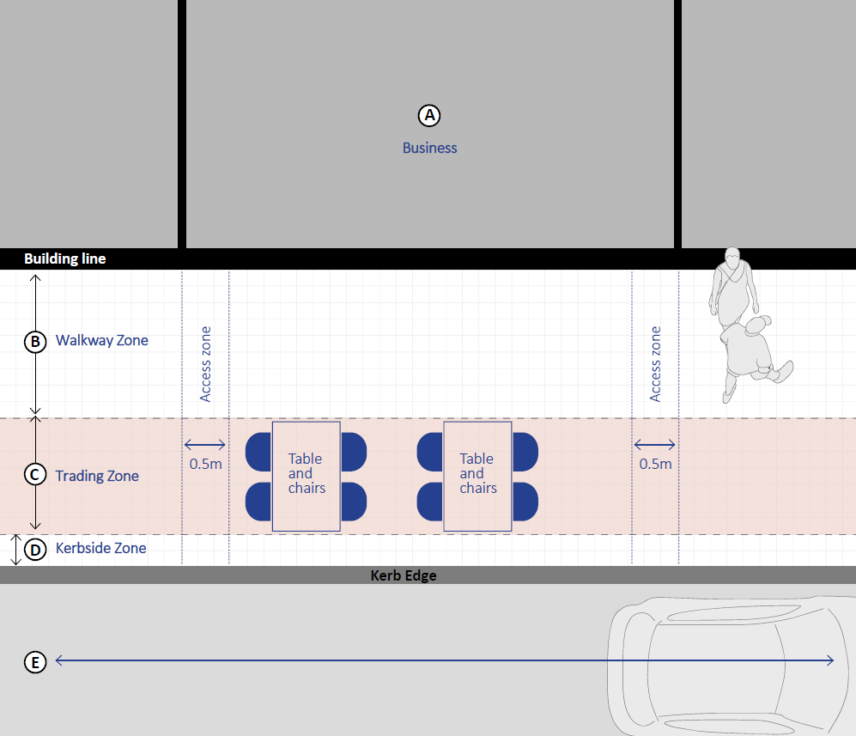

Eligibility Criteria
Applications for footpath trading will be considered for the following:

- Outdoor dining furniture: Only businesses where the primary activity of business is the service of food and beverage and those which are registered under the Food Act 1984 are eligible for outdoor dining furniture. Council may consider seating for other types of businesses on a case by case basis.
- Accessibility: Businesses must be able to meet the minimum required setbacks for each relevant zone as indicated above.
- Footpaths under 2.5m: Footpath trading is not permitted on footpaths that are less than 2.5m wide, as they cannot accommodate the required zones without obstructing pedestrian movement.

Application process

Applying for a Footpath Trading permit
Applications for footpath trading permits can be submitted year-round via the Yarra City Council website.

Fees are charged on a pro-rata basis, depending on the duration of the permit.

Types of Permits:
There are two types of permits available:

- Annual Permits
Annual permits are valid for up to twelve months, allowing for year-round placement of approved items. All permits have an expiry date and can be subject to change or revocation at any time at the discretion of an Authorised Officer or Council.
- Pop-Ups
These permits are typically issued for a business pop-up or promotional event for a limited duration, up to two weeks, and are subject to the same conditions.

Types of Footpath Trading permit items
Below are items intended for this policy to facilitate for businesses:
 | Outdoor dining furniture  This includes tables, chairs, umbrellas, screens/planter boxes, heaters, and similar items used by hospitality businesses to serve food and beverages to patrons.
 | Goods display  This includes:  Food displays, clothing racks, displays for merchandise or similar.
 | Advertising signs  This is limited to a portable advertising sign, often referred to as an "A-frame" sign.
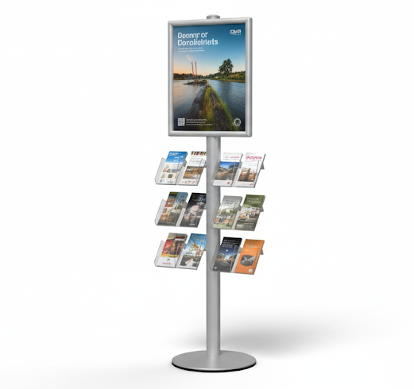 | Miscellaneous  This includes displays for produce, planter boxes, clothing racks, or other merchandise related to the business's core operations.

Applications for other items other equipment, will be considered on a case-by-case basis. Businesses must demonstrate how these items align with the purpose of their permit and do not impede public access.

Footpath Trading Fees
There are two main fees:

- Application Fee
- A flat application fee applies to all applications.
- Permit Fee
- Fees are calculated per item for tables, chairs and advertising frames. Items such as heaters are per permit and umbrellas and screens are free of charge.

Submitting an application
When applying, you’ll need to provide:

- Applicant and business details
- Business address and proposed footpath trading location (photos preferred)
- Footpath trading site plan that shows all three zones of the footpath, the placement of all items and dimensions.
- Public liability insurance certificate.
- Written consent from adjoining property/business owners (if applicable).
- Liquor licence (if applicable).
- Application fee.
- Declaration.

Council may request additional information depending on the site location and complexity of the design at any time, including even after a permit is issued.

Assessment
Once an application is submitted applications will be reviewed against policy requirements and may be referred to relevant internal departments for additional considerations.

Council reserves the right to refuse a permit. This includes situations where there are identified significant issues that cannot be mitigated through conditions of approval, or where internal referrals raise technical or safety concerns.

Depending on the complexity of your proposed site plan to place items on the footpath, an authorised officer may undertake an on-site inspection prior to any approvals.

Automatic Permitting
Applications for advertising signs and displays of goods are subject to automatic permitting. Once an application is submitted with all relevant information and fees paid, a permit will be issued instantly. The onus is entirely on the permit holder and business to carefully read and ensure that all permit conditions and policy requirements are adhered to when placing these items out. Any non-compliance will be enforced.
Additional Application Requirements

Insurance
Permit Holders must provide and maintain public liability insurance with Yarra City Council listed as an interested party. A current certificate of currency must be submitted with the application and updated upon expiry. The minimum coverage amount must be $20 million.

Liquor Licence
A Footpath Trading Permit does not authorise the sale or consumption of alcohol on public land.

If your business is licensed to serve alcohol, you must apply to the Liquor Control Victoria (LCV) to obtain the necessary license or approval to serve alcohol. Permits do not permit serving of alcohol on the footpath without approval from Liquor Control Victoria.

It is important to note that your right to occupy the footpath is granted only by your Footpath Trading Permit. All conditions of this policy must be followed at all times, even if they differ from the conditions of your liquor license.

Extending the Trading zone
If you have your neighbour's permission, which must be provided, you can apply to use their footpath area to place items and serve your customers. You cannot extend any further than an adjoining neighbour's footpath either side.

Variation of Existing Permit
A permit holder may apply to Council to add or remove existing items at any time. Council will assess any variations to ensure that they meet the requirements of this policy.

When assessing the request, Council will consider the impact of the proposed changes on the surrounding area and the permit holder's compliance history.

Making a decision
In making a decision, Council will have regard for all the applicable requirements outlined in this policy, as well as the following key factors:

- Accessibility: The primary concern is whether the proposal impacts access for pedestrians on the footpath. Where required accessibility standards are not met, such as the footpath trading zones, a permit will not be issued.
- Safety and Public Amenity: Whether the proposal could compromise pedestrian or traffic safety or negatively impact the functionality of the footpath and public assets. This includes ensuring clear access for everyone and preventing visual clutter.
- Visual and Amenity Impact: Council will consider the visual impact of the proposal, including the potential for "visual clutter," and the cumulative impact of all footpath trading in the area.
- Hours and Operations: Decisions may include restricting trading or display hours based on the surrounding land use and local conditions.
- Compatibility with the Environment: The proposal's interaction with existing heritage elements, key features of the local environment, and other public infrastructure will be assessed.

Special Considerations for Kerbside Dining
When assessing applications for new or refurbished kerbside extension areas, Council will specifically consider:

- Purpose of the Space: How the proposed commercial activity aligns with the intended use of the kerbside space.
- Public Access and Movement: The proposal must not fully occupy the space, and space should be retained for public use. The design must allow the public to move freely through and across the area.
- Positive and Negative Impacts: Council will weigh the potential for the proposal to negatively impact pedestrians and create sightline issues for motorists, against its potential to add to the area's vibrancy and improve public safety through ‘passive surveillance’.

Sites Not in Commercial Zones
For standalone sites not in commercial zones, a key consideration will be the intensity of trading and its impact on the local amenity, including parking, noise, and safety.

Final Approval and Discretion
An authorised officer has the discretion to approve applications as submitted or with modifications and conditions to align the proposal with the policy requirements. It's a condition of every permit that the Footpath Trading Policy must be complied with at all times.

Footpath Trading Requirements

Footpath trading activities must comply with the following requirements.

  - Safety and Accessibility

- A continuous and unobstructed Walkway Zone must be maintained at all times. The required width depends on the footpath's total width:
  - For footpaths between 2.5m and 3.5m wide, a minimum 1.5m setback is required.
  - For footpaths 3.5 metres and wider, a minimum 1.8m setback is required.
  - Access Zones must be provided as a clear path from the kerbside through the Trading Zone. A minimum 0.5m setback is required from any adjoining business's property line.
- No footpath trading is permitted on footpaths less than 2.5m wide.
- No footpath trading is permitted beyond a vehicle stop line on the approach of any type of pedestrian crossing.
- No footpath trading is permitted to extend beyond the building line or shop front if located at an intersection.
- All items must be stable, well maintained, and designed to withstand weather conditions without becoming a hazard.
- All items must be securely anchored by weights.
- Minimum 1m Access Zone must be provided every 3 metres for large trading areas.
- No items can be attached or affixed to any Council assets or other assets without written permission.
- Businesses are responsible for any costs associated with reinstatement works as a result of any damage to footpaths caused by any items. Enforcement action may also be taken by Council if appropriate.

  - Trading Hours and Removal

- All items must be removed from the footpath daily within 30 minutes of the business closing or by 11:00pm, whichever comes first, unless an extension has been approved in writing by Council.
- An approved extension allows a business to store outdoor dining furniture on the footpath beyond its regular trading hours. This is for storage purposes only and is not to impact the business's internal trading hours. All outdoor dining furniture must be rendered unusable during this time. The Council will not grant extensions for trading past 11:00 PM. The Council reserves the right to impose conditions on this extension and may withdraw it at any time.

  - Location and Setbacks

- Items must be located directly outside the premises to which the permit is issued. Trading in front of an adjoining businesses or property requires written permission from that business and an extension of the permit holder's public liability insurance. This must be supplied upon application or with a permit variation must be submitted and is subject to approval by Council.
- A minimum clearance of 0.5 metres must be maintained from any permanently fixed asset on the footpath, such as bins, parking meters, or bike racks.
- A minimum clearance of 1.0m must be maintained from any public seating, fire hydrant, or bus/tram stop. For 'super tram stops' with a tactile strip, a minimum 2.0m clearance is required from either side of the tactile strip. Council may extend this exclusion zone upon assessment to ensure safety and unobstructed access.
- Any request to move (or remove) rubbish bins, parking meters, public seating and /or bike racks, or other public infrastructure for the purposes of footpath trading, must be approved at by the relevant General Manager. Traders should take this into account when selecting a site. The approval for relocating these items will only be considered if all costs associated with these works are at the applicant’s expense and the items may be relocated nearby.
- No items may be placed between public seating and the property line or between public seating and the road.
- No items may be placed on roundabouts, road, traffic islands, or garden beds at any time.

  - Service Authority Works or Events

- Council or service authorities may require you to temporarily remove all items from the footpath for public works. Council will provide at least seven days' notice for planned works. In an emergency, you may need to clear the area immediately. All costs and responsibility for moving your items are associated with the business.
- During special events or community festivals, no footpath trading is permitted within the event area unless a specific exemption is granted by Council. This restriction includes the placement of all signs, goods displays, and outdoor dining furniture.

  - Design and Operational Requirements

General Requirements

- All items must be fully contained within the approved Trading Zone and must not encroach upon any public asset, including street furniture or signs.
- All items must be placed directly outside the business, unless permission from neighbouring businesses or properties is obtained.
- All items must be easily removable and not permanently fixed to the footpath without prior written approval.
- Any lock-in devices or in ground sleeves must be approved by Council and must be flush with the footpath when the items are removed. A road opening permit will be required prior to any installation.
- All items should have a contrasting colour to the footpath to assist people with vision impairment.

Outdoor Dining Furniture

Chairs
- The number of seats available per bench seat will be calculated at a rate of 600 mm is equivalent to one seat.

Screens
- Barriers or screens may be required for additional safety where any outdoor dining furniture is approved at the discretion of an authorised officer.
- Temporary barrier or screens must not be taller than 1.2m above the footpath. If you have an existing screen that is taller, it may be allowed to remain at the discretion of an Authorised Officer. This permission will be reviewed whenever you apply to renew or transfer your permit.
- Signage on all barrier screens and advertising signs must be maintained. No signs may be pornographic, offensive, or otherwise detract from the local amenity. All content is subject to the approval of an Authorised Officer.

Umbrellas
- Umbrellas are only permitted within the approved Trading Zone and must not overhang the kerb or roadway. When fully open, the lowest part of the umbrella canopy must be a minimum of 2.2 meters above the footpath.

Heaters
- Any overhead heaters must be securely affixed to an awning or verandah.
  - Council approval is required before installing any fixed heaters. A separate Building or Planning Permit might be required.
  - All outdoor heaters must comply with the safety standards set by Energy Safe Victoria.

Goods Display
- All goods and merchandise displays must be placed entirely within the designated Trading Zone. A single item or display unit must not
  - exceed a maximum height of 1.5m,
  - a length of 3m,
  - or a depth of 0.75m.
- Displays of goods must not diminish the amenity, safety, or appearance of an area. All goods display stands must be kept in good repair.
- No loose items are to be placed within the trading area.

Planter Boxes
- All planter boxes must be placed entirely within the designated Trading Zone. A single planter box must not:
  - exceed a maximum height of 1.5m, this includes the plants and foliage.
  - A length of 1.5m,
  - or a depth of 0.75m
- Planter boxes must be easily removable and not cause any damage to the footpath or other Council assets.
- They must have a locking mechanism to prevent them from moving and becoming a safety hazard.
- Planter boxes must be kept in good condition and free of litter, including cigarette butts
- All plants must be healthy and well-maintained. Failure to meet these standards may result in a directive from Council to remove the planter boxes.

Advertising Signs
- Advertising signs must not exceed
  - 600mm in width and
  - 1,000mm in height (including legs).
- A maximum of two signs may be approved, only for businesses with two separate frontages.
- No inflatable, portable electric, flags or banners, revolving, or flashing signs are permitted without specific written approval by Council. If approved, they must provide a minimum 2.2m clearance above the footpath if attached to a shop facade.

Other requirements
- Food and drinks may not be prepared, cooked, or heated within the Trading Zone unless Council grants a specific exemption. Additionally, cash registers are not permitted on the footpath.
- Existing curtain awnings may be affixed to planter boxes with written permission from Council. Installation of a curtain awning may require a separate Building or Planning Permit.

Real Estate Pointer Boards
- Real estate agents are required to obtain an annual permit for the display of free-standing "pointer board" signs.
- These signs are only permitted to be displayed during the following times:
  - Property Sale: Between 8:00 am and 5:00 pm on the day of a property auction or sale.
  - Open for Inspection: 30 minutes before and after a premise is open for inspection.
- All real estate signs must comply with all other general requirements of this policy.

Management Requirements

The Permit Holder is responsible for the conduct of patrons at tables and chairs in the outdoor seating area and must:
  - Ensure that patrons do not move tables and chairs into the Walkway, Kerbside or Access Zones.
  - Ensure that patrons do not allow pets, prams, bicycles or any other items to obstruct the Walkway, Kerbside or Access Zones.
  - Ensure that staff do not serve food or beverages to a person in the Walkway, Kerbside or Access Zones.
  - Ensure patrons do not congregate in the Walkway, Kerbside or Access Zones.
  - Adhere to the endorsed site plan and licence conditions at all times.
  - Ensure that patron behaviour does not interfere with other persons.
  - Ensure staff give pedestrian movement priority over their own movements across the Walkway Zone.
  - Always supply each outdoor table with a wind-proof ashtray where smoking is allowed.
  - Ensure that no noise or other disturbance emanates from the footpath trading activity and which causes a nuisance to others or detriment to the amenity of the neighbourhood.
  - Not permit any live entertainment, outdoor speakers, sound amplification equipment or jukeboxes on any footpath, except with the specific written approval of Council.
  - Maintain the area within and around the Trading Zone in a clean and safe manner.

Council reserves the right to impose any conditions that it may deem appropriate when approving an extension of trading hours and withdraw or vary any approved variations to the footpath trading permit due to adverse amenity impact to the area.

Unless otherwise specified on the permit, a permit will expire on the 30 September each year except in those instances when it is withdrawn or revoked by an Authorised Officer prior to the expiry date.

Permits may be transferred to a new owner provided there is no change or some change to the approved site plan. Before a new owner commences footpath trading, a new application with all the relevant information must be supplied and approved by Council.

Permit renewal

Permits are issued until 30 September of each year. A permit may be renewed upon:
  - the payment of the specified annual fee
  - proof of current public liability insurance

Council reserves the right to refuse to renew a permit in its absolute discretion.

Condition of Permits

Permits may be issued with specific conditions to address site-specific constraints and ensure the safe and effective operation of footpath trading. These conditions may relate to, but are not limited to, the following:

- Accessibility
Ensuring unobstructed access for pedestrians, including compliance with accessibility standards.

- Traffic Flow and Safety
Consideration of existing pedestrian patterns, sightlines, and potential impacts on road safety.

- Street Infrastructure
Assessment of the physical area and layout of the footpath, including kerbs, drainage, and utilities.

- Local Amenity and Community Impact
Minimising noise, visual impact, and other disruptions to nearby residents and businesses.

Note: For automatically issued permits, the permit holder and business is deemed to have accepted all permit conditions and policy requirements upon payment and issuance.

Cancelling Permits
The Council may alter, suspend or cancel a Permit if it considers that there has been:
- A substantial and/or continued failure to comply with this policy or any other relevant legislation
- Failure to pay fees
- At the request of the stallholder, or
- A prosecution found proven for breach of this policy and any permit condition

Ceasing Permits

If you change your mind and decide to cancel your permit, Council must be informed, and the existing permit will be cancelled.

The business must remove all items at their own cost and reinstate the area to its original condition.

Prepaid fees will be refunded on a pro rata basis to the original Permit Holder, once the items are removed and the area reinstated to its original condition.

Enforcement of footpath trading

Enforcement
A breach of any condition of a Footpath Trading Permit, or any person operating a commercial activity as governed by this Policy without a current permit is a breach of Councils Local Law with strict liability.

Council may instigate enforcement action or modify the conditions of a permit or suspend or revoke a permit after giving notice to the permit holder if:
  - There is non-compliance with any part of this Policy.
  - Permit conditions have not been met or there is non-compliance with an approved plan and there is failure to comply with directions of an Authorised Officer.
  - The Permit Holder fails to maintain public liability insurance.
  - In the opinion of Victoria Police or an Authorised Officer, the footpath trading conducted by the Permit holder poses an unacceptable safety hazard to pedestrians, motorists or cyclists.
  - In the opinion of an Authorised Officer the footpath trading has caused or is causing detriment to the amenity of the area, having regard to any complaints received and/or inspections undertaken
  - Instances of ongoing littering or untidiness are observed by Council.

Council may require a permit holder to place signs as reminders to patrons in an outdoor seating area to keep walkways unobstructed and clean.

Incidents of non-compliance will be noted on a permit holders file and will be relevant if enforcement or other action is being considered at a later time.

Incidents of non-compliance will be taken into consideration by Council when requests to vary, renew or obtain a new permit are considered.

An Authorised Officer investigating a breach of this Policy or permit conditions may issue a Notice to Comply or an Infringement Notice whichever is appropriate. Permit holders who are issued two or more Infringement Notices for the same or similar breaches may have their permit immediately revoked, and face prosecution in the Magistrates’ Court.

Should a permit be revoked in the instance of continued non-compliance, the permit holder will be directed to remove all items from the footpath at their own expense. Failure to remove any items, may result in Council impounding all items and any costs incurred will be the responsibility of the permit holder.

A permit may only be revoked after consultation with the Manager Parking & Compliance Services.

Proactive Inspections
Council will undertake proactive inspections throughout the course of the year to ensure that all businesses comply with their permit conditions and any relevant requirement within this policy.

Other permits and legislative requirements

If any works are proposed to install lock-in devices or sleeves into the footpath, a Road Opening Permit will be required from Council.

A building permit may be required for certain buildings and work, such as installation of overhead heaters or awnings.

In limited circumstances a planning permit may be required under the Planning Scheme for certain buildings and works. However, under the Planning Scheme, a planning permit is not required for:
- The use of land in a road if the use is associated with the use of adjoining land and is authorised by the Council under a local law (under Clause 62.02-1)
- Buildings and works associated with a use on adjoining land or street trading if authorised under a local law under (Clause 62.02-1)

Document Control
Document Owner: | Compliance & Parking Services
Version | Date | Author | Description
1 | August 2025 | Parking & Compliance Unit | Revision of policy in line with stage 1 community engagement feedback

