City Of Yarra
Community Engagement Summary Report
Yarra 2021: Help shape the next four years

Author: Clare Murrell
1/11/2017

Introduction 3
Background 3
Engagement objectives 3
Communications and engagement approach 3
How we engaged 3
Who we engaged with 4
Engagement Outcomes 6
Appendix 11
Promotional Postcard 11
Online Project Page (front page) 12

Introduction
This report provides a summary of the Yarra 2021: Help us shape the next four years community engagement process.
Following extensive consultation across a range of activities, over 1,100 contributors and 2,330 ideas were collated and presented to Councillors to develop a first draft Council Plan 2017-2021 incorporating the Municipal Public Health and Wellbeing Plan.
A draft Council Plan will be placed on public exhibition in April 2017 for further public comment, along with the Annual Budget.

Background
Every local council is required to produce a Council Plan following Local Government elections. The Council plan documents the medium to long-term vision for how council will respond to the opportunities and challenges facing the municipality over the four year Council term.
The Yarra Council Plan 2017-2021 details objectives and strategies and assists in identifying key projects and actions to be delivered each year.
A cross-organisational project team was established to develop an Engagement and Communications Plan which was endorsed by the Executive team in August 2016. The working team included staff from Corporate Performance, Social Policy and Research, and Communications and Engagement.

Engagement objectives
The project’s engagement objectives included:
- there will be inclusive and meaningful opportunities for participation
- information will be accessible and timely
- a broad cross section of the community will be given the opportunity to participate, including under-represented groups such as young people, older residents, people with low proficiency in English, people who are disadvantaged or vulnerable
- that engagement outcomes are used to inform Council Plan, Health Plan and annual plan and budget requirements

Communications and engagement approach
A range of communication and engagement activities were undertaken to inform, consult and involve participants across the community.

Broad promotion of the public engagement opportunity was through a range of corporate communication channels and community networks including:
- distribution of postcards directing people to Your Say Yarra online
- corporate communications including website, on hold messages, bright signs at all customer service centres
- social media promotion via Twitter and Facebook
- Yarra News article, distributed to over 45,000 Yarra households
- formal and informal email networks and e-newsletters including;
  - LINK public housing newsletter
  - E-Bulletin to the business community
  - Community Grants e-newsletter
  - Yarra Environment e-news
It is estimated that over 1100 community members were engaged during the first stage of the project, across the range of opportunities listed below.

Engagement activities, both online and in person, were predominately through an ‘ideas generation’ process, seeking response to four key questions;
- What do you love about Yarra?
Thinking about your current experience of living, working or enjoying Yarra, what do you love about this City?

- What would make Yarra even better?
Thinking about Yarra in the future, what would make Yarra a better place to live in four years’ time, by 2021?

- What do you want your Council to do over the next 4 years?
Thinking about the many decisions the newly elected Council needs to make, what do you want them to focus on?

- How can Council improve community health?
Thinking about the range of health needs in the community, what can Council do over the next four years?

 |  | How we engaged | Who we engaged
Online | Your Say Yarra Online portal | - yoursayyarra.com.au/councilplan2017-2021  - Open for 9 weeks  - Brainstormer tool across four questions  2 November 2016 to 23 January 2017 | - 123 registered participants  210 ideas were contributed with an additional 856 likes and 26 dislikes  - 1213 page visits
Online | Social Media | Used to promote listening post location and times and direct people to the Your Say Yarra project page. Relevant comments in response to Twitter and Facebook posts were recorded | - Twitter x 1  - Facebook x 32 relevant comments, plus 134 likes
Online | Written Submissions | Open at any time during the public engagement period | 21 written submissions via email
In Person | Listening Posts | At a variety of locations across the city  - Richmond, Gleadell Street Market  • Clifton Hill, Queens Parade  • Atherton Gardens Family Fun Day, Fitzroy  • Block Party (Napier St Youth Services, Fitzroy  • Carols by candlelight, Edinburgh Gardens, North Fitzroy  5 November to 8 December 2016 | 400+ conversations  560+ ideas gathered
In Person | Targetted engagement sessions | - Neighbourhood House Coordinators AGM  - Needle and Syringe Program clients  - Peer Education Support Program (PESP) people who have experienced homelessness  - Billabong BBQ  - St Mark’s community lunch  - Seniors Christmas Party  - Richmond Kindergarten  - Multicultural Playgroups, Collingwood and Richmond  - Richmond Chinese Elderly residents association  - Vietnamese Disability Turtle group  - After School Care Program, Richmond and Collingwood  - St Mary’s House of Welcome Community lunch  - Midsumma Carnival, LGBTQI community  20 November 2016 to 15 January 2017 | - 350 participants  - 580+ ideas
In Person | Advisory Committee Workshop | Attendees from across council’s14 advisory committees invited to participate  - December 2016 | - 45 participants  - 105+ ideas

Engagement Outcomes

The extensive engagement, held over a three month period, attracted feedback from a significant cross-section of our community on a variety of issues.
Although participation in the engagement activities is not wholly representative of the community, the main themes that emerged were consistent with the results of other research undertaken. The engagement feedback is generally consistent with the top issues arising out of the 2015 Annual Customer Satisfaction Survey as well as the top neighbourhood characteristics and preferred improvements identified in the recent Liveable Yarra project.
The following analysis focuses on the overall community response and the top 10 sub themes that were identified in the community engagement.
Overall, health and wellbeing issues dominated community feedback. This includes the sub themes of open space, social connectedness, recreation and leisure, and drugs and alcohol/community safety.
Other themes that attracted a large number of responses were land use planning and development, environmental sustainability, social justice, traffic and parking, arts, culture and diversity and service mix and delivery.

Figure 1 Overall Community Response table

Figure 2 top 10 sub themes

Within each sub theme there are a range of issues and priorities identified by the community:
Sub Themes  (# comments) | Key Issues | Theme
Sustainable Transport (192) | - Bicycle parking and infrastructure  - Encourage cycling and walking  - Maintenance of roads and bike paths/lanes  - Access to public transport  - Public Transport Advocacy | Environmental Sustainability
Drugs and Alcohol/Community Safety (189) | - Focus on Victoria Street/North Richmond drug use, trafficking and anti-social behavior  - Public safety and amenity related issues  - Support for Supervised Injecting Facility advocacy  - Minimise harm from drug and alcohol abuse  - Manage syringe litter  - Increase/introduce CCTV  - Manage graffiti  - Safety on the Estates | Health and Wellbeing
Open Space (180) | - Continue maintenance of open space and facilities  - Increase access to parks and playgrounds  - Increase street trees  - Improve facilities eg change rooms, BBQs, shade structures, toilets, drinking fountains  - Animal Management enforcement  - Contested space | Health and Wellbeing
Growth and Change (179) | - Development controls on apartment buildings eg height limits  - Concerns over Increasing density and quality of developments  - Pressure developers for green space  - Preserve neighbourhood character  - Related parking pressures of overdevelopment and parking waivers | Land Use Planning and Development
Social Connectedness (160) | - Accessibility, proximity and amenity of the municipality  - Community activity and interaction at events  - Village atmosphere and friendliness  - Strong connection to place and community | Health and Wellbeing
Service standards, levels and quality (142) | - Value placed on having access to various services influenced by the location of the engagement activity eg North Richmond Community Health identified by people who inject drugs, Youth Centre featured in Block Party responses, etc  - Childcare, kindergartens, playgroups and activities  - Neighbourhood Houses  - Aged Care  - Planning services for future growth and communities | Service mix and delivery
Recreation and Leisure (140) | - More sporting facilities eg Basketball Courts  - More open space for free/passive recreation  - Highly valued access to Leisure Centres and swimming pools | Health and Wellbeing
Diverse and Inclusive (78) | - Desire to retain Yarra’s community diversity - cultural and social.  - Value placed on Yarra being a welcoming community for all including refugees, LGBTIQ, Aboriginal, disabled, elderly  - Pride in Yarra’s Aboriginal history  - Continue focus on access for all abilities | Health and Wellbeing
Traffic Management (76) | - Support for traffic calming measures that are effective including reduced speed limits  - Improve enforcement of traffic calming measures  - Reduce traffic congestion and rat-running | Traffic and Parking
Advocacy and engagement (71) | - Support for Council to continue to take a stand on social issues such as refugees, family violence, marginalised and vulnerable residents  - Support for Council to continue to advocate for community issues such as East-West link, Doncaster Rail  - Improve/change how Council consults and engages | Social Justice and Diversity

Appendix

Promotional Postcard
Distributed across Yarra venues and cafes via Mr Moto, and placed in all Council operated spaces including Yarra Leisure, Libraries and Service Centres. Also distributed at listening posts.

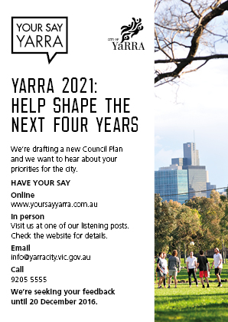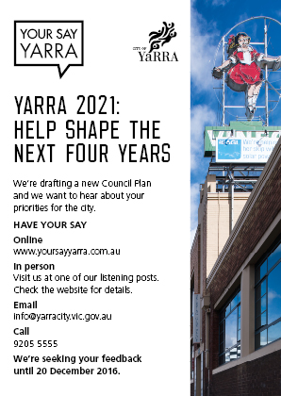

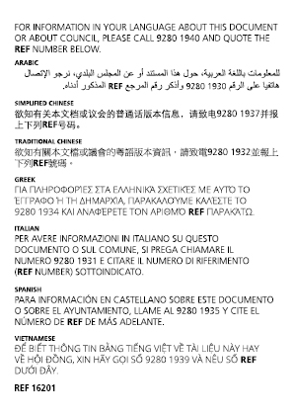

Online Project Page (front page)

