DRAFT - Parklet Policy

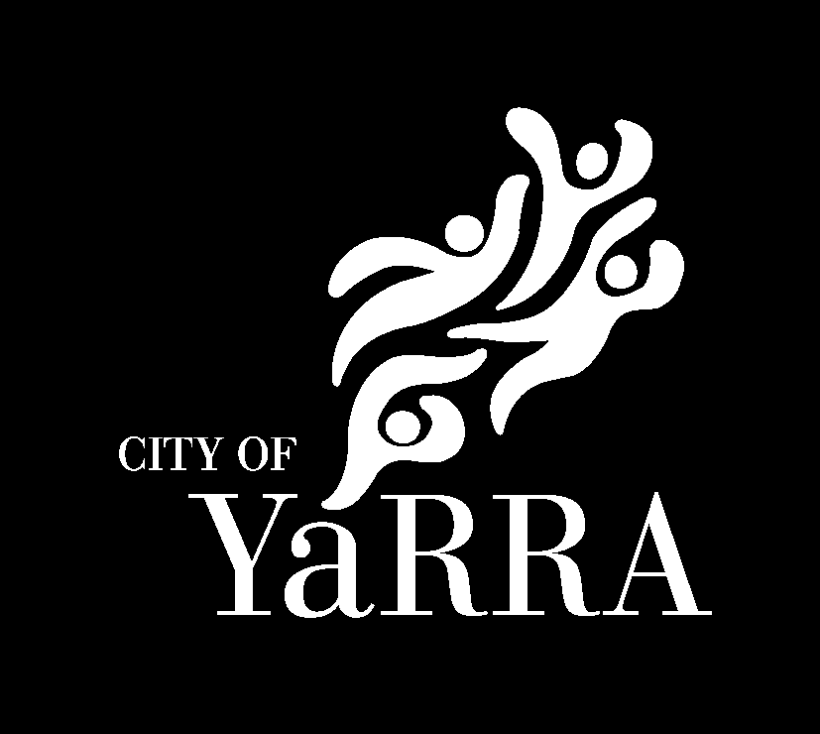

Title | Parklet Policy
Description | This policy sets out what businesses need to do to establish a parklet within the City of Yarra and the various criteria they need to understand, consider and comply with.
Type | Policy
Approval authority | Compliance & Parking Services
Responsible officer | Manager Compliance & Parking Services
Approval date | XX
Review cycle | Every four years, or earlier if needed
Review date | XX

Purpose
This policy sets out what businesses need to do to establish a parklet within the City of Yarra. It provides guidance to businesses and the community on the requirements for obtaining and maintaining a Parklet Permit and outlines the considerations that will inform Council's decision making and enforcement practices in alignment with the Local Law’s Principles.

Policy objectives
This policy’s objectives are to facilitate Yarra’s Parklet Program by:
- Providing safe, attractive and high quality parklets that contribute to the local character and provide opportunities for greening.
- Providing access for all and increasing general accessibility by providing alternative options for outdoor dining that does not restrict footpaths.
- Supporting local businesses and the vibrancy of the area more broadly
- Activating streets and improving perceptions of safety
- Recognising the needs of Council services, emergency services, utilities and other essential works
- Providing clear guidance for businesses and the community that also supports Council’s decision making and enforcement

Background
Yarra’s Parklet Program supports eligible businesses to offer outdoor dining in areas otherwise used as car parking bays. The Program sits alongside Yarra’s Footpath Trading Program.

Yarra’s Parklet Program will balance supporting a vibrant outdoor dining environment for businesses with ensuring pedestrian accessibility and the safety and amenity of all the community.

Definitions

Annual Permit: are parklets approved by Council for a period of 12 months. These must be renewed prior to 30 September each year.

Summer ‘Daylight Saving’ permit: are parklets approved by Council for the summer period which runs between 1 October and 31 March. These must be removed after the expiry date and businesses must reapply for the following summer.

Primary Street: are Brunswick Street (Alexandra to Victoria Parade), Smith Street, Gertrude Street. As they are in major precincts, they attract a higher fee structure.

Secondary Street: are all other streets that also have paid parking restrictions.

Neighbourhood Street: are all other streets that are not primary streets or secondary streets.

Edge treatments: the outside edge (barrier) of the parklet which interfaces with parking bays and traffic/cycle lanes.

Pro rata basis: This is a fee based on the proportional number of remaining days in the permit.

Public liability insurance: This is insurance to help protect against claims of personal injury or property damage as a result of the business (or parklet) operation.

Redundant crossover: This is a vehicle driveway / access point that is no longer needed or in use. The crossover relates to the section that crosses over the footpath and ramps down to the road to provide vehicle access.

Hospitality businesses: are businesses that serve food and have a current food registration under the Food Act 1984.

Eligibility Criteria
Applications for a parklet are restricted to the following:

- Hospitality businesses in Yarra
Only businesses operating within the hospitality sector are eligible to apply. Applications from other industries, sectors, or business types will not be considered.
- Located in the following areas
Eligible locations have been identified in consultation with the Department of Transport (DoT), Yarra Trams, and Yarra City Council. Only businesses located within these eligible areas may apply.

Eligible areas | Ineligible areas
Parallel parking or angled parking. | Within 10m of an intersection (unless appropriate visibility can be maintained and there is adequate parklet protection). An independent road safety audit and approval by Yarra Traffic Engineering will be required.
Straight road geometry ensuring uninterrupted sight lines for drivers. | Within 20m of a signalised intersection on the approach side.
At least 10m from an intersection (measured from the building line). | Within 20m from a tram stop flag (sign) on the approach side
A speed limit of 40km/hr or less. | Streets with speed limits above 40km/hour
Streets which are not controlled by VicRoads/Department of Transport. | Streets controlled by VicRoads/Department of Transport.
Streets which are not clearways. | Areas obstructing access for deliveries, essential and emergency vehicle access, commercial car parks, buildings and residences.
Redundant crossovers. | Areas with clearways/tow-away zones.
Any parklet within 20m of the departure side of a signalised intersection will be considered on a case-by-case basis. | Areas with protected cycle lanes.
 | Spaces designated for loading, disabled, no-stopping zone, 15 min, permit zone, mail zone and taxi zone.
 | Construction zones, unless relocated with support of the construction Permit Holder and Council.
 | Police and emergency vehicle parking bays.
 | Around utility access panels or storm drains within the parking space unless there is no fixed furniture or platform within the space.
 | Areas prone to significant flooding. Applicants will need to contact Council in the first instance to check if their proposed parklet location is in an area of significant flooding.

Existing parklet Permit Holders
It is recognised that there are a number of existing parklets currently in place following the revision of this policy, as such, existing permit holders must:
- demonstrate that the existing parklet meets current safety, accessibility and cleaning guideline requirements as detailed in this policy and the permit conditions
- pass a safety inspection(s)
- make any modifications as required by Council to ensure it meets the requirements detailed in this policy
- pay the required application and occupancy permit fees as required and during renewal periods.
- agree to all permit conditions (including new conditions, if required).

Application Process

Design options
Anyone who is applying should select from one of the following options when considering what kind of parklet they want to install:

- Purchase or hire a readymade option, these will still need to be assessed and adhere to the policy, design guidelines and permit conditions, and may only be installed once a permit is approved.
- Design your own, if you use a registered builder and you adhere to Policy, Design Guidelines and permit conditions; you are able to construct your own parklet once a permit is approved.

Please contact Yarra’s Compliance team to discuss this option before engaging any suppliers or submitting an application.

Applying for a Parklet Permit
Applications for parklet permits can be submitted year-round via the Yarra City Council website.

Fees are charged on a pro-rata basis, depending on the duration of the permit.

Types of Parklet Permits
There are two types of parklets available:

- Annual Permit
  - Valid from October 1 to September 30 annually.
  - Aligns with Yarra’s footpath trading permits.
  - Ideal for businesses seeking a long-term investment in parklet infrastructure.
  - Allows for annual renewal.

- Summer ‘Daylight Saving’ Permit
  - Valid from October 1 to March 31 annually.
  - Designed for seasonal use during warmer months.
  - Parklets must be easily disassembled and stored.
  - Recommended using ready-made or hire options for flexibility.
  - Will need to reapply prior to each summer.

Parklet Fees
There are two main types of fees:

- Application and Inspection Fee
  - A flat fee applies to all applications, regardless of location, size, or permit type.
- Occupancy Fee
  - Based on the street category and number of parking bays occupied.
  - Streets are classified as:
    - Primary Streets: Brunswick Street (Alexandra to Victoria Parade), Smith Street, Gertrude Street. These streets are also subject to Yarra Trams approval.
    - Secondary Streets: Streets with paid on-street parking, excluding Primary Streets.
    - Neighbourhood Streets: Eligible streets without paid parking.

Other Costs to Consider
Installing a parklet may involve additional costs depending on your design and location:

- Professional design services (architects, draftspeople)
- Structural engineering and compliance certificates
- Noise and amenity action plan
- Ongoing maintenance of the parklet if approved
- Construction materials and registered builder fees
- Permits for occupying Council land during installation
- Public liability insurance

Submitting an application
When applying, you’ll need to provide:

- Applicant and business details
- Business address and proposed parklet location (photos preferred)
- Professional plans and drawings, including site plan, floor plan and elevations that show construction and structural details to address the parklet requirements at section 7
- Public liability insurance certificate
- Yarra Trams approval (if applicable)
- Parklet maintenance plan
- Noise and amenity action plan
- Written consent from adjoining property/business owners (if applicable)
- Application and inspection fee

Council may request additional information depending on the site location and complexity of the design.

Notification and Assessment
Once an application is submitted:

- Council will notify adjacent and adjoining properties and seek feedback. This feedback will be considered during the assessment process.
- Applications will be reviewed against policy requirements, design guidelines, decision guidelines and referred to relevant internal departments for additional considerations.

Council reserves the right to refuse a permit. This includes situations where there are identified significant issues that cannot be mitigated through conditions of approval, or where internal referrals raise technical or safety concerns.

Additional Application Requirements

Insurance
Permit Holders must provide and maintain public liability insurance with Yarra City Council listed as an interested party. A current certificate of currency must be submitted with the application and updated upon expiry. The minimum coverage amount must be $20 million.

Yarra Trams Approval
Parklets on tram corridors require approval from Yarra Trams, including an independent risk assessment. Refer to their guidelines: On Road Hospitality Parklets – Installation on Tram Corridor Guidelines. Council will not approve parklets on tram corridors without this approval.

Liquor Licence
If your business is licensed to serve alcohol, you must apply to the Liquor Control Victoria (LCV) to obtain the necessary license or approval to serve alcohol. Permits do not authorise the serving of alcohol on the footpath or road without approval from Liquor Control Victoria.

Noise and Amenity Action Plan
A detailed management document will be required that describes the potential noise and amenity impacts arising from the operation of a licensed venue or a parklet, and outlines the specific measures that the applicant will take to mitigate any negative effects on surrounding residents and businesses.

Shared Parklets
Two hospitality businesses may share a parklet, but each must hold a valid permit. Shared use must be scheduled and documented, for example:

- Permit Holder A: Monday–Friday, 8am–4pm
- Permit Holder B: Thursday–Sunday, 4pm–9pm

Both parties must manage the responsibility of associated fees and maintenance collaboratively.

The required documentation for shared parklets is as follows:

- Written agreement to share the parklet
- Operating days and hours for each business
- Updated red line plan (if serving alcohol) which reflects parklet operating hours.

Approved Parklet Design
Once your initial application has been assessed and the proposed parklet has been approved, you must provide Council the:

- registered builder details
- date of construction or installation.

Depending on the design of your parklet, you may need:

- structural drawings and Certificate of Compliance (reg 126) – Design from an engineer.
- traffic management plan
- road occupation permit
- Certificate of Compliance (reg 126) – Inspection from an engineer following installation.

Council will advise what you need before your permit is issued.

Parklet Requirements

Any proposed parklet must comply with the following requirements, unless an alternate outcome is deemed suitable at the discretion of Council.

The plans submitted with the application must clearly demonstrate how all relevant requirements are being met.

7.1 General Use Requirements
Parklets must comply with the following use requirements:
- Parklets that are not located in, or abutting, a residential zone may operate Monday to Sunday, from 7am to 11pm (unless there is a specific planning condition that stipulates otherwise), with service ceasing by 11pm.
- Applications located in, or abutting, a residential zone must:
  - Not impact resident safety or the amenity of the area.
  - Not trade past 9pm, unless accompanied by written consent from residents affected and it can be demonstrated there would be no impact on residential amenity.
- No amplification equipment (including speakers, amplifiers or other audio equipment) may be installed.
- Must maintain the parklet to ensure it remains in satisfactory condition at all times. This includes promptly addressing any damage or deterioration to prevent negative impacts on the surrounding amenity and removing or painting over any graffiti.
- Must not be used as an exclusive smoking area.
- Must not be used as an extension of a business’s kitchen to cook food.
- Must have a current food premises registration.

7.2 General Design Requirements
Every parklet must:
- Be designed by a qualified professional, and structures designed by a registered Engineer or Architect
- Retain views to heritage buildings and businesses, to ensure that structures do not obstruct or detract from heritage buildings/streetscapes and ground floor shops
- Create open and inviting spaces that feel public and not privatised
- Activate the street, by allowing outdoor dining to be seen from along and across the street and not creating hiding spaces
- Be recessive in the streetscape, with lightweight structures, limited clutter, muted colours that don’t conflict with the road and no advertising is to be displayed
- Be able to be packed up and moved away if required
- Appear as a parklet (and prevent vehicle access), even when small items are packed away at night
- Maintain the function and amenity of the footpath
- Occupy whole parking bays (not part/s of bay/s) and
  - For parallel parking, parklets must not exceed four (4) parking bays.
  - For angled parking, occupy a minimum of two parking bays, with a maximum length of 24 meters
- Occupy whole parking bays (not part/s of bay/s)
- Be setback at least 1m from fire hydrants and other fire plugs, sluice valves or other services, trees and other permanent structures/fixtures, and not be fixed or in contact with any tree.

7.3 Materials
Materials used for the construction of the parklet must be:
- High quality and suitable for the local context and streetscape character
- Able to be maintained, weather-resistant and long lasting
- Treated/finished to manage graffiti/vandalism
- Non-reflective and non-slip (for ground/floor surfaces)
- Sustainably and/or locally sourced where possible
- Able to be reused/recycled where possible
Materials must be:
- Concrete (for planter boxes) of light colour
- Metal (for planter boxes and fencing), thick is preferred
- Treated timber materials, noting that:
  - Hardwood timber is preferred; however treated pine may be used as an alternative provided it is painted/sealed
  - Plywood is not appropriate for outdoor use and not permitted.
  - Consider appropriate construction methods to avoid timber items buckling/warping over time. For example, timber planters may benefit from using a steel frame with timber slats to provide a more robust structure
- Recycled plastic
- Glass, that is thick and fixed and built-in accordance with current Australian Standards (AS1288). A Glazing Certificate will need to be provided
- If timber decking is used, it must be a suitable structural timber framework (spaced no more than 400mm apart) and end blocking with clearances for rainwater/litter escape
- Exterior grade non-slip decking all fixed and constructed to current Australian Standards (AS1684).

The following materials will not be permitted:
- Composite materials
- Astroturf
- Loose materials that can overflow onto surrounding roads and gutters

7.4 Lighting
Any lighting must:
- Be fully contained within the parklet
- Not create any safety issues (for instance, conflict with road lighting)
- Not rely on electrical cables that extend across or over the footpath. Any proposals to run in wiring would be assessed on a case-by-case basis and would require sign off by a qualified electrician in the form of a Certificate of Electrical Safety

7.5 Furniture
Any furniture must:
- Be designed for outdoor use and made from materials that are long lasting and weather resistant.
- Minimise hazards, such as tripping from angled legs, with heights and position of legs providing ample space
- Provide a 30mm solid leg / rubber pads to protect asphalt surfaces
- Unless furniture has been explicitly approved to remain fixed, all items within the parklet must be removed at the end of trading each day. If a business requires items to remain in the parklet beyond permitted trading hours due to internal operating needs, a written request must be submitted to Council. Permission will only be granted for storage purposes, and all items must be secured in a way that clearly prevents public use during non-permitted parklet operating hours.

7.6 Umbrellas
Any umbrellas must:
- Be safely secured to comply with high/very high wind zone loading
- Be located fully within parklet space
- Be no closer than 750mm to adjacent traffic lanes when fully opened
- Be a minimum of 2.2 metres high at the lowest point and easily removable.

7.7 Heaters
Any heaters must:
- Be fully located within the parklet area
- Not be an overhead outdoor type
- Not be wired to electricity and free standing.

7.8 Overhead Structures
Any overhead structures must:
- Not compromise the edge treatment/walls and be structurally compliant
- Comprise open structures for the purpose of providing shade and rain protection
- Provide suitable clearances
- Be open above the planter box or fencing and lightweight in appearance
- Be designed so that any roof structure manages water runoff and wind load
- Not be fully enclosed, including plastic blinds or similar

Marquees will not be permitted.

7.9 General Structural Requirements
Any structures must be:
- Located outside of flood prone areas, unless with Council Drainage Engineers approval
- Setback 600mm from stormwater drains
- Be accompanied by an Engineers Certificate of Compliance -(Reg 126) – Design. An Engineers Certificate of Compliance (Reg 126) - Inspection will be required at completion of works confirming installation compliance.

7.10 Access requirements
Parklets must:
- Be fully contained within the parking bay as to not obstruct pedestrians, motorists and other road users path of travel
- Not compromise waste vehicles access or obstruct loading, service vehicles, construction zones or entrances to private buildings and carparks
- Provide for all ability access via a platform that is level with the footpath, or otherwise through a compliant ramp that is integrated into the platform structure. This must include:
  - At least one entrance which is in an unobstructed area and is a minimum width of 1m (with no running slope)
  - An accessible path of travel into the parklet, that connects to the accessible entrance and provides a wheelchair turning and resting space
  - Where a parklet cannot feasibly provide accessible access, the business must have the ability to obtain a footpath trading permit to facilitate outdoor dining for patrons that require accessibility or otherwise demonstrate that the needs of all patrons, regardless of accessibility requirements, can be met by the business.
- Any platform must:
  - Not be fixed to the road surface or kerb and channel (including any heritage bluestone kerb and channel)
  - Provide a generally level surface
  - Ensure that water drains effectively off the platform and does not pool in the space or onto the adjacent footpath
  - Not cover any drainage grates, pits and outlets
  - Allow for adequate drainage and clearing of any drainage channel, by providing:
    - 300mm wide x 110mm high clear space underneath the platform next to the kerb and channel
    - A liftable threshold platform/gutter (or similar) along the length of the platform over the channel
    - Supporting legs set back from the kerb and easily accessible
    - An overflow hole or clear space (away from the channel) to allow for excess water to run through as needed

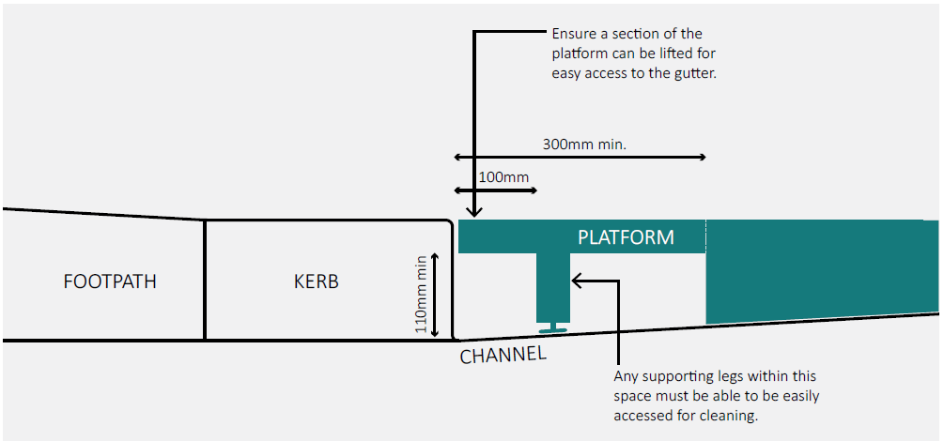
- Any ramp must:
  - Be integrated into the design of the parklet and located within the parklet space
  - Be at least 1000mm clear width containing solid sides at least 450mm high
  - Have perimeter handrails/balustrading at least 1m above finished floor level
  - Meet one of the following:
    - An inclined surface on a continuous accessible path of travel with a maximum rise of 190 mm, a length not greater than 1520 mm and a gradient not steeper than 1 in 8
    - An inclined surface on a continuous accessible path of travel with a maximum rise of 190 mm, length not greater than 1900 mm and a gradient not steeper than 1 in 10
    - An inclined surface on a continuous accessible path of travel with a maximum rise of 35 mm, length not greater than 280 mm and a gradient not steeper than 1 in 8
    - An inclined surface on a continuous accessible path of travel between two landings with a gradient steeper than 1 in 20 but not steeper than in 14.
- Any steps must:
  - be consistent and minimum 250mm clear width nosing to nosing
  - consistent risers maximum 190mm and
  - minimum 115mm along with illuminance non-slip nosing strip

7.11 Edge treatments
Parklets must:
- Provide an edge treatment to protect the space from vehicles and keep patrons within the parklet space, that meets the following requirements unless an independent Road Safety Audit is submitted to demonstrate that road safety requirements will be met:
  - Provision of the following minimum setbacks from the edges of the car parking bay adjacent to other parking bays:
    - 500mm setback at each end (see diagrams overleaf), from parallel bays.
    - 300mm setback at each side, for angled or 90-degree parking bays.
    - 300mm from the side/end of the parking bay where it interfaces with the traffic lane, where there is no buffer space on the traffic side (e.g. cycle lane) or if the road width is otherwise constrained.
  - Provision of a visible and continuous physical barrier (no gaps) around the entire outside edges of the parklet in the form of planter boxes and fencing as shown on the diagram overleaf that is:
    - At least 800mm and no higher than 1200mm (considering plants in max height), for the height of planters/fencing above the road surface.
    - For any planter boxes:
      - At least 800mm long and 400mm wide.
      - Filled completely with soil (or similar).
    - For any fencing:
      - Maximum of 2000mm in length.
      - Must be fixed to other items (e.g. planter boxes, platforms).
  - Provision of a concrete planter that measures at least 800mm wide by 800mm long and 800mm high (above the road level), completely filled with soil and planted with a tree or appropriate planting, for the approach to the parklet (refer to diagram):
    - On primary streets (Brunswick, Smith and Gertrude), unless there is already a kerb extension or tree in the road space immediately next to the parklet on the approach side.
    - On the departure side of an intersection (on any street), if there is no protection leading up to the parklet (e.g. through a kerb outstand, tree, parking).
  - Provision of the following signage/reflective tape:
    - Chevron sign (a directional arrow sign) on the approach side on the planter box.
    - Reflective tape along the outside edges of the parklet.

Example: Planters and fencing.
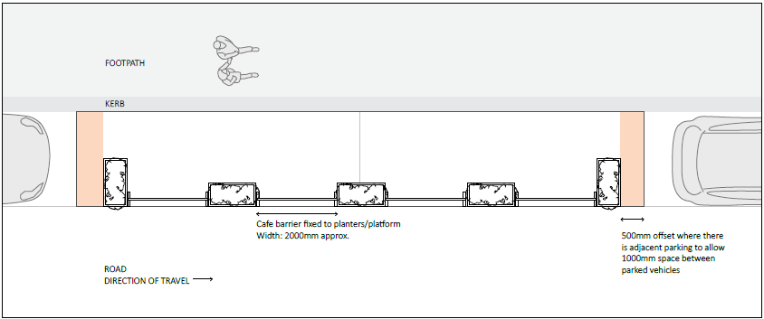

Example: Planters, fencing and concrete planter on approach.
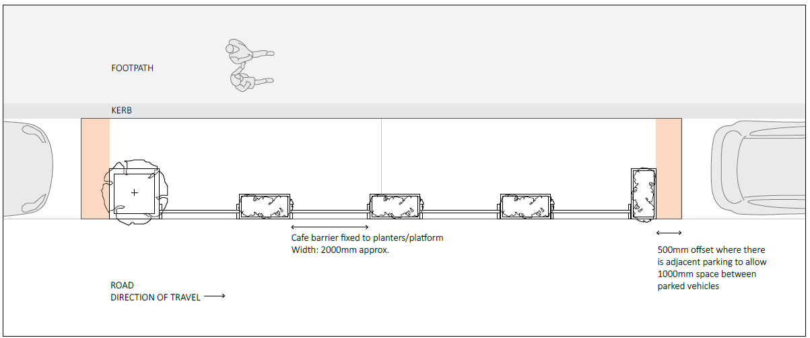

7.12 Street Tree Protection
- No structure or items are to be placed within the tree plot (as defined by granitic sand, timber mulch, bonded gravel or similar)
- The fixing of anything to the trunk or canopy of any public tree is not permitted.
- The pruning of public trees is not permitted.
- No hard materials may come into direct contact with the tree bark.
- No outdoor heaters, including cables or wiring, may be placed within the canopy of any public tree.
- Awnings, umbrellas or any other overhead coverings must not be in contact with branches within the canopy of any public tree.

7.13 Planting requirements
Any planting proposed in parklets must:
- Be suited to local conditions, able to be maintained and hardy and drought tolerant species
- Prioritise larger plant stock to minimise opportunities for plant theft
- Maintain clear sightlines for traffic by:
  - Height of plantings not exceeding 1.2 metres from road level (except for trees).
  - Pruning tree to provide a clear trunk.

7.14 Tram Corridor Requirements
Parklets on tram corridors require approval from Yarra Trams, including an independent risk assessment.
Yarra Trams has published guidelines to guide the construction of all new parklets along tram corridors. The guidelines specify where parklets can be built in relation to:
- the setback from tram tracks
- distance from a tram stop
- maximum length of a parklet
- gaps between the parklet and the next parked car.

Refer to their guidelines: On Road Hospitality Parklets – Installation on Tram Corridor Guidelines. Council will not approve parklets on tram corridors without this approval.

Decision Guidelines
Before deciding on an application, in addition to the parklet requirements at section 6, the following matters will be considered, as appropriate:
- The purpose of this policy.
- Whether there would be any adverse impact on accessibility of the area.
- The effect of the proposed parklet on the amenity of adjoining or nearby residentially. zoned properties where there is a higher level of expected amenity.
- Any relevant operational history of the business and operator.
- The feedback of any notified properties owners or tenants.

Management of Parklet

9.1 Conditions on permits
Permits may be issued with specific conditions to address site-specific constraints and ensure the safe and effective operation of parklets. These conditions may relate to, but are not limited to, the following:
- Accessibility
Ensuring unobstructed access for pedestrians, including compliance with accessibility standards.
- Traffic Flow and Safety
Consideration of existing traffic patterns, sightlines, and potential impacts on road safety.
- Street Infrastructure
Assessment of the physical structure and layout of the street, including kerbs, drainage, and utilities.

- Existing Parking Arrangements
Compatibility with current parking restrictions, loading zones, and residential parking schemes.
- Business Operations and Deliveries
Ability for the business to continue receiving deliveries legally and without disruption.
- Local Amenity and Community Impact
Minimising noise, visual impact, and other disruptions to nearby residents and businesses.
The Permit Holder is required to comply with all permit conditions outlined on their permit and all other legislation or Acts associated with operating a business in a food premises and extending the operation onto the street.
If non-compliance of any of the conditions is proven, enforcement action may be taken.
Some standard conditions used by Council include:
- Upon completion of works, the Engineer must inspect and issue a Certificate of Compliance (Reg 126) - Inspection.
- Permit Holders are responsible for any costs to reinstate the road, to fix any damage to the road as a result of the parklet.
- No amplification equipment is permitted within parklets. No speakers, amplifiers or other audio equipment may be used to direct sound into the public domain without Council’s prior written consent.
- Permit Holders are responsible for monitoring and managing patron behaviour, and must ensure that if they operate licensed premises, that staff practice responsible serving of alcohol in accordance with their liquor licence.
- Permit Holders must safely carry out all routine parklet maintenance duties on an as-needed basis, including:
  - regularly water, prune, fertilise and replace plants as needed
  - bring any small potted plants inside at night to reduce instances of theft
  - remove any rubbish or cigarette butts on a regular basis
  - manage water runoff
  - cleaning the parklet platform, seating and other elements as required
  - removing debris, grime or graffiti from the parklet
  - safely cleaning around the edges of the parklet
  - removing any debris that is impeding drainage flow (for example autumn leaves) along the gutter and beneath the parklet surface

9.2 Amending Permits
The Permit Holder can make minor changes as required such as changing the arrangement of furniture or adding plants.
For major changes to the appearance or structure of the parklet, such as changing the materials, function or size, Permit Holders will need to apply for an amendment to their parklet permit. Council may approve an amendment to a permit and in making its decision, it will consider any Council requirements as well as the current operation of the parklet.
Permits may be subject to change at any time during the permit period to ensure that safety and amenity is not compromised.

9.3 Permit Renewal
To extend your permit, you must renew your permit before 30 September each year by paying the appropriate permit fees.
Parklets within or abutting residential areas will be subject to review throughout the permit period. Applications to extend after that period will be carefully weighed against impacts on local residents.
Permit Holders may be required to address any concerns prior to their permit being renewed.

9.4 Ceasing Permits
If you change your mind and decide to cancel your permit, Council must be informed and the existing permit will be cancelled.
The business must remove the parklet at their own cost and reinstate the area to its original condition.
Prepaid fees will be refunded on a pro rata basis to the original Permit Holder, once the parklet is removed and the area reinstated to its original condition.

9.5 Ownership Change
If a business changes ownership, the incoming operator must submit a formal change of ownership request if they wish to retain the existing parklet.

The new owner will assume full responsibility for:
- Ongoing maintenance of the parklet
- Compliance with any amendments or requirements issued by Council
- All associated costs, including those related to upgrades, repairs, or removal if necessary

Additionally, the new operator must agree to comply with all terms outlined in the Parklet Program Policy.

9.6 Permit Holder Responsibilities
The Permit Holder is responsible for the ongoing cleaning, maintenance, and repair of the parklet space.

As part of the application process, a Maintenance Plan must be submitted outlining how these elements will be regularly cleaned, maintained, and repaired.

In the event of damage or graffiti, the Permit Holder is required to promptly remove or cover graffiti on any permanent infrastructure within the parklet, including planter boxes, fences, bollards, barricades, and screens.

To ensure safety, accessibility, and compliance with Council standards, regular inspections will be conducted. Permit Holders are encouraged to familiarise themselves with all maintenance requirements and contact Council with any questions or concerns prior to installation.

9.7 Enforcement of Parklets
A breach of any condition of a Parklet Permit, or any person operating a commercial activity as governed by this Policy without a current permit is a breach of Councils Local Law with strict liability.
Council may instigate enforcement action or modify the conditions of a permit or suspend or revoke a permit after giving notice to the permit holder if:
- There is non-compliance with any part of this Policy.
- Permit conditions have not been met or there is non-compliance with an approved plan and there is failure to comply with directions of an Authorised Officer.
- The Permit Holder fails to maintain public liability insurance.
- In the opinion of Victoria Police or an Authorised Officer, the footpath trading conducted by the Permit holder poses an unacceptable safety hazard to pedestrians, motorists or cyclists.
- In the opinion of an Authorised Officer the footpath trading has caused or is causing detriment to the amenity of the area, having regard to any complaints received and/or inspections undertaken
- Instances of ongoing littering or untidiness are observed by Council.
Council may require a permit holder to place signs as reminders to patrons in an outdoor seating area to keep walkways unobstructed and clean.
Incidents of non-compliance will be noted on a permit holders file and will be relevant if enforcement or other action is being considered at a later time.
Incidents of non-compliance will be taken into consideration by Council when requests to vary, renew or obtain a new permit are considered.
An Authorised Officer investigating a breach of this Policy or permit conditions may issue a Notice to Comply or an Infringement Notice whichever is appropriate. Permit holders who are issued two or more Infringement Notices for the same or similar breaches may have their permit immediately revoked, and face prosecution in the Magistrates’ Court.
Should a permit be revoked in the instance of continued non-compliance, the permit holder will be directed to remove the parklet at their own expense and reinstate the area to its original condition. Failure to remove the parklet, may result in Council undertaking the removal of the parklet and any costs incurred will be the responsibility of the permit holder.
A permit may only be revoked after consultation with the Manager Parking & Compliance Services.

9.7 Emergency Works and Road Works
It is important that the parklet is designed for easy removal and re-installation as it could save time and money in the future.
Parklets may need to be removed temporarily or permanently for streetscape improvements or other works as required by Council, its contractors or other third- party construction managers.
Council will give the Permit Holder as much notice as possible in these situations, but in instances where emergency works such as a burst water main, gas leak or fallen power line need to occur, or if emergency vehicles need access to the space, removal of all structures, furniture and equipment is required immediately.
Where a parklet is required to be temporarily removed or accessed, the cost to disassemble, remove, store, and re-install is incurred will be at the Permit Holder’s expense. Any damage incurred during emergency access will also be at the Permit Holders’ expense.
Further, if the parklet presents a major public safety hazard or if the Permit Holder fails to comply with the permit conditions, Council may require the permanent removal of the parklet. If the parklet is removed permanently, it is still the Permit Holder’s responsibility to restore the street area to its original condition.
Failure to remove the parklet may result in Council removing the parklet at the Permit Holder’s expense.

Document Control

Document Owner: | Compliance & Parking Services
Version | Date | Author | Description
1 | August 2025 | Compliance & Parking Services Branch | Revision of policy in line with stage 1 community engagement feedback

Appendix: Parklet Landscaping Guidance

Always seek advice from the local nursery or a qualified professional to ensure the proposed planting is suitable for the location and type/size of planters, and that the maintenance requirements are understood.
However here are some things to consider getting you started and should be read in conjunction with the requirements on the previous page.
- Understand the position of your parklet and local weather conditions and choose plants to suit. For example: - Is it located in full sun all day?
- Is it shaded in the morning but receive the sometimes-hot afternoon sun?
- Is it an exposed and windy site?
- Setting up the planters
- Provide good quality topsoil, a drainage layer and a drainage outlet to ensure the soil drains properly.
- Ensure that the soil depth is appropriate for the plant types.
- Ensure the planter has a low centre of gravity and does not become top heavy.
- When planting think about spacings and avoid large gaps which can fill up with weeds and hinder an effective plant display. Consider mature plant size to guide you.
- Maintenance
- How much time will you spend on maintenance and upkeep? Potted plants (depending on plant species) require varied amounts of watering which also changes throughout the seasons depending on available rainfall and wind present. Some plant species will require pruning as they grow and flowering plant species will benefit from tip pruning.
- Be aware that on a hot summer day, some plants may require watering twice daily. During Winter/rainy periods, some plants may not be able to solely rely on rain and may need additional watering.
- Plant species selection
- Not recommended to use only annuals or vegetables in planters given their short lifespan and need for regular replacement. If used, consider a combination with for example English box to provide structure.
- Annuals and vegetables tend to require high amounts of watering especially during hot and dry periods.
- Consider the height of the plants, do you want the plants to provide a “solid” green screen or views onto for example the street for sitting patrons.
- Sometimes trailing plants can provide visual interest if you are using one type of small shrub in the planters.
- Consider evergreen varieties to provide an abundant display throughout the year.
- Consider native plants that are suitable for growing in containers, to increase biodiversity.
- Consider the examples overleaf as a starting point, ensuring that the plants chosen are suitable for the local conditions.
- Trees
- Some examples are provided overleaf. Consider evergreen varieties to provide greenery all year round.

Here are some examples of plants that can grow well in pots/planters, with the right conditions and maintenance. These examples also show the type of quality and appearance that is expected.
Ensure you seek advice from your local nursery or a qualified professional before finalising your plant selection.
- Silver Ponysfoot
- Lilyturf
- Common Box (varieties)
- Lavender
- Silver Bush
- Sage (varieties)
- Xanadu Philodendron
- Rosemary (dwarf or prostrate varieties)
- Olive
- Magnolia/Michelia (evergreen)
- Citrus
- Bay
