
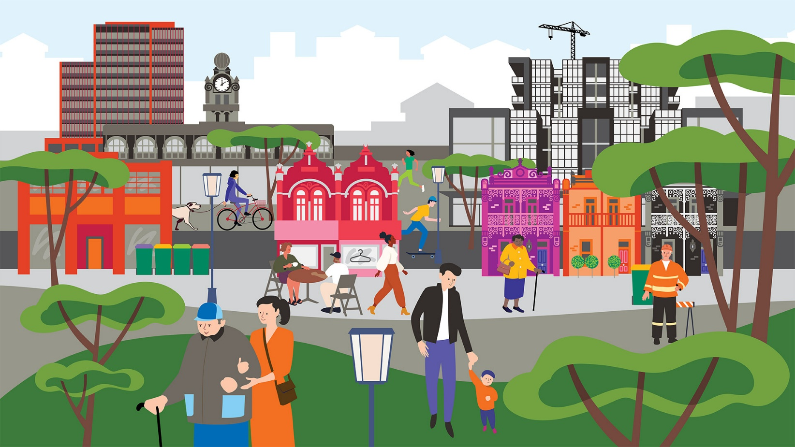
Whats
Businesses key changes in action
Community Local Law

The Draft Community Local Law 2026 is more than just a regulatory update. We want to make running a business easier in Yarra and to do that, we will be cutting red tape.

To ensure these changes work for you, we need your feedback. Whether you are a business owner, a community advocate, or a local resident, your feedback on the Draft Community Local Law, Footpath Trading Policy, and Parklet Policy is important.

Key Changes Planned
Before we finalise the Community Local Law, please give us your feedback on these items:
- No permit required: for certain activities (personal trainers and commercial dog walkers) a permit and fees will no longer be required, but mandatory requirements on Council’s website will need to be met.
- Automatic (instant) permits: move from waiting weeks to receiving permits (for skip bins, advertising signs and goods display) in minutes. This means businesses can commence trading straight away once they submit their application and pay the fee (if applicable).
- Dynamic forms: ensures you only answer what is relevant, reducing errors and eliminating incomplete applications or follow up by Council.
- Data: Council will use real-time application and permit data to identify and fix bottlenecks or errors before they impact your business.
- Clear and simple: we’ve made our draft our Community Local Law, Footpath Trading Policy, Parklet Policy to be clearer and easier to understand. Ease to use guides will help businesses to understand what they need to do.
- Permit Guides: clear roadmaps that translate regulations into easy-to-follow guides to obtain permits.

Example Case Studies  Example 1: Café owner  “Meet Marco, the owner of a new local café looking to draw patrons in with an advertising sign. Under the current system, Marco would have had to wait between 5-10 business days for a permit. With the proposed new Local Law, Marco simply needs to complete an online form, upload his documents, pay the fee and receive his permit within 5-10minutes, allowing him to set up his display and start attracting customers that same day”  Example 2: Dog walker  “Meet Sarah, a local resident who just launched Paws & Paths, a professional dog walking service. Currently, Sarah would have been stuck applying for a permit, paying annual fees and waiting weeks for Council approval before she could legally take her clients’ dogs to the local park. With the proposed Local Law, the red tape has been cut entirely and commercial dog walking is now a mandatory requirements – so doesn’t require a permit., Sarah simply checks the Council’s simplified online guide to confirm which zones are off-leash, the maximum dog to walker ratio is and other requirements and she’s able to start her business immediately” | Example 3: Personal trainer  “Meet Jax, a personal trainer who runs Apex Outdoors, a series of high intensity bootcamp sessions. Currently, Jax found it frustrating to keep up with permits and the associated overhead costs to use the local reserve for an hour each morning. With the proposed Local Law, Jax no longer needs to apply for a permit or wait for approval. They simply visit Council’s website to find approved locations, maximum people allowed and other requirements. The change allows Jax to focus on their clients’ health rather than their business's paperwork.”

How does this translate from the Draft Community Local Law?
Clause | Change
3.1 Outdoor dining, goods displays and signs  4.8 Skip bins | While a permit remains necessary to ensure safety and accessibility, we will be transitioning goods displays, advertising signs and skip bins to an automatic permitting model.  This shift provides businesses with instant permits.
3.5 Commercial fitness activities  3.6 Commercial dog walkers | We have removed the permit requirement for these activities to support small businesses.  This means you no longer need to apply for a permit to operate, you simply need to adhere to the established mandatory requirements.

