Yarra Spatial Economic and Employment Strategy

Final report
City of Yarra

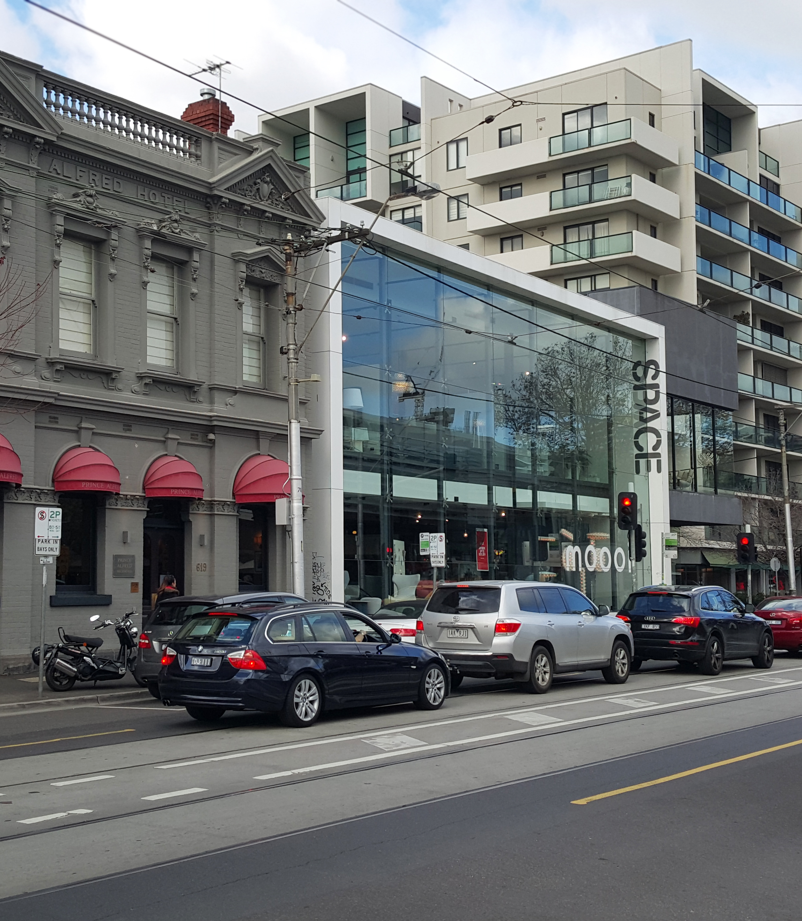
16 February 2017



This report has been prepared for City of Yarra. SGS Economics and Planning has taken all due care in the preparation of this report. However, SGS and its associated consultants are not liable to any person or entity for any damage or loss that has occurred, or may occur, in relation to that person or entity taking or not taking action in respect of any representation, statement, opinion or advice referred to herein.

SGS Economics and Planning Pty Ltd
ACN 007 437 729
www.sgsep.com.au
Offices in Canberra, Hobart, Melbourne and Sydney

TABLE OF CONTENTS
Executive Summary 4
1 Introduction 8
1.1 Project context 8
1.2 Objectives of this Strategy 9
1.3 Employment, economic activity and land use planning 9
1.4 Structure of the SEES 10
2 Trends and drivers 11
2.1 Historical context 11
2.2 Strategic context 11
2.3 Key trends affecting Yarra 13
2.4 Employment growth projections 18
2.5 Employment floor space demand 22
2.6 Summary 25
3 Planning Framework 26
3.1 Overview 26
3.2 Plan Melbourne 26
3.3 Yarra Planning Scheme 31
3.4 Structure Plans and Local Area Plans 33
3.5 Other studies and strategic developments 33
3.6 Summary of existing policy and planning gaps 36
4 Yarra’s Precincts 37
4.1 The distribution of employment activity 37
4.2 Defining and understanding the diverse precincts of Yarra 38
4.3 Assessing employment floor space capacity 42
4.4 Alignment of employment floor space demand with capacity 44
4.5 Summary: floor space demand and capacity analysis 51
5 Spatial strategy 53
5.1 Approach 53
5.2 Vision and objectives for Yarra’s employment lands 53
5.3 Strategies 54
5.4 Strategy 1: Support employment growth in Activity Centres 56
5.5 Strategy 2: Retain and grow Yarra’s Major Employment Precincts 58
5.6 Strategy 3: Identify preferred locations for housing growth 61
5.7 Strategy 4: Support the expansion of health related employment and services in Yarra’s health precincts 61
5.8 Strategy 5: Retain other C2 zoned precincts (unless strategic planning support change) 63
5.9 Strategy 6: Retain Yarra’s existing industrial precincts for manufacturing and urban services 67
References 69
Appendix A: Employment forecasts 70
Appendix B: Capacity analysis 72
Appendix C: existing zoning 78

Glossary

ABR Australian Business Register
BILS Yarra Business and Industrial Land Strategy (2011)
CUB Carlton United Brewery
EDS Yarra Economic Development Strategy (2013)
GVA Gross Value Add
JLAP Johnston Street Local Area Plan (2015)
LPPF Local Planning Policy Framework
VPP Victorian Planning Provisions

Executive Summary
The City of Yarra (Yarra) plays a vital role in the economy of Metropolitan Melbourne. It sustains a diverse range of businesses that contributed $10,085 million Gross Value Add (GVA) to Melbourne’s economy in 2015, equivalent to 4.3% of its total output. By way of comparison, Yarra represents just 0.2% of Greater Melbourne’s land area and hosts 2% of its population. This economic activity is comprised of a diverse and evolving mix of employment and land uses that make a unique contribution to the metropolitan region. Yarra’s mix of retail and entertainment precincts, mixed employment precincts, and health and education facilities provide employment and services that are metropolitan in their reach and, arguably, vital to Melbourne’s ‘brand’ as a creative urban economy.

This Spatial Economic and Employment Strategy (the Strategy) has been developed to assist the City of Yarra to understand and capitalise on Yarra’s economic strengths and respond to key trends and economic drivers over the next 10 to 15 years.

Trends and drivers
The Yarra economy is continuously evolving. In recent decades employment in Yarra has becoming increasingly knowledge intensive and services oriented with an economy that benefits from a well-connected, inner city location with access to workers, customers and other businesses. The number of knowledge workers in Yarra has increased rapidly in recent times. Health care is expanding rapidly to become the largest employment sector in Yarra. It currently employs 19,000 people (19% of Yarra’s jobs) and by 2031, provided capacity constraints can be overcome, healthcare employment is projected to grow to more than 32,000 (23% of Yarra’s jobs and one third of total employment growth). Retail and hospitality have also grown substantially with this sector increasing in size from 10,000 jobs in 1996 to an estimated 19,800 in 2016. In recent decades manufacturing employment has declined in absolute terms but has also evolved to more highly specialised niches including perishable products and advanced manufacturing.

The drivers behind these changes – the rise of advanced business services, greater global economic integration between countries, outsourcing, technological advancements, and an ageing population – are factors that are likely to become more influential in the coming decades. Deepening structural economic change can continue to be leveraged by Yarra to support local economic growth.

Continued and high growth in employment is projected over the next 15 years in Yarra (see figure below). Accommodating this growth will require changes in the type of employment floor space on offer across the municipality. Over the next 15 years SGS’ modelling estimates that there will be demand for an estimated 275,000 sqm of additional commercial floor space, 56,000 sqm of additional retail floor space, 164,000 sqm of additional institutional floor space, and a net reduction in demand of 334,000 sqm of industrial floor space. In line with employment floor space trends, these projections assume the average floor space per job will contract between 2016 and 2036 by an average of 20%.

Demand for housing is also significant in accessible high amenity areas like Yarra. In this context it is important that demand for housing is managed (or appropriately calibrated) so as to limit ‘ad hoc’ conversion of employment land for residential purposes, or speculative land trading, both of which can undermine the ongoing viability of existing employment precincts.
Yarra employment PROJECTIONS by industry, (‘000)
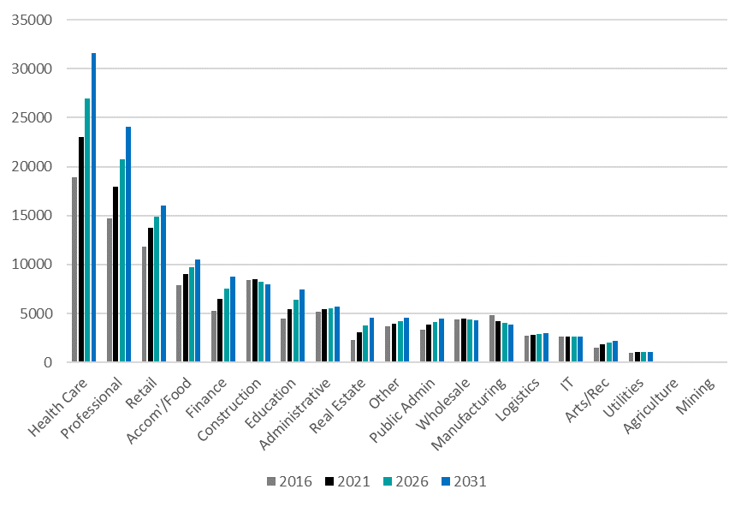

Source: SGS Employment Projections

Planning context
The State Government’s metropolitan planning strategy Plan Melbourne provides high-level direction on desired urban outcomes over the next 40 years, including housing and employment. Plan Melbourne reinforces the role of the central city and its inner-city sub-precincts as fundamental in driving economic growth and in supporting liveability. Several precincts within Yarra were identified as ‘Other urban renewal areas’ in early iterations of the Plan: Collingwood (Gipps Street precinct), the North Richmond to Victoria Park corridor, East Richmond Station-Cremorne, and Alexandra Parade. In the 2017 ‘refresh’ of Plan Melbourne this designation was removed. As a result, there is presently no specific guidance from the state government concerning the anticipated role of these areas. The Action Plan that accompanied the latest version of the Plan suggests the state government intends to pursue a series of short term actions that would provide more guidance for planning for employment lands, in particular for areas transitioning from industrial uses to alternative uses. Plan Melbourne recognises the health and education capabilities of Yarra in the updated Plan Melbourne, with Epworth recognized as a Health Precinct, and the St Vincent’s Hospital and Australian Catholic University Precincts recognised as a Health and Education Precinct.

It is understood that an ‘Inner Melbourne Framework Plan’ is being prepared by the Victorian Planning Authority (VPA) to provide guidance on the planning for Melbourne’s various inner city renewal areas. This process could reveal more about the capacity of these precincts to accommodate housing and employment, outline infrastructure needs, and identify the respective roles of the renewal areas identified in Plan Melbourne. The development and refinement of this plan would align with Action 1 in the Plan Melbourne implementation plan.

Past studies conducted by the City of Yarra, in particular the Business and Industrial Land Strategy (BILS), highlighted key economic trends and provide guidance for land use planning including recommendations for the development of specific plans or strategies across Yarra.

Within this broad framework, the SEES seeks to provide clarity on the future roles of health and education precincts, the urban renewal areas designated in early iterations of Plan Melbourne, and former industrial areas that are transitioning to alternative employment uses.

Capacity for employment growth
For the purposes of assessing capacity for additional employment floor space, employment precincts were developed based on the existing land use zones and the functional characteristics of Yarra’s activity centres and employment areas. There is currently an estimated 3.6 million sqm of employment floor space in Yarra. Based on a series of assumptions about development potential under current planning zones there is theoretical capacity for a total of 4.9 million sqm of employment floor space. This suggest the capacity for additional floor space is in the order of 1.3 million square metres. Across Yarra’s precincts, there is sufficient aggregate opportunity to accommodate projected growth. In particular, there is significant capacity for commercial employment, particularly in the Gipps and Cremorne precincts. There will be significant demand for institutional floor space and the expansion of Yarra’s health and education precincts. Conversely, demand for industrial land is decreasing.

The Spatial Strategy
Yarra’s stock of employment land is a strategic resource that accommodates a large and diverse range of businesses and jobs, and provides employment for an extensive and growing number of workers with a wide range of skills. The task for Yarra in managing its employment land is to consider prevailing economic trends that will see continued changes in the nature of inner city employment and strong employment growth. The main drivers of these changes include the growth of health sector employment; strong growth in knowledge intensive employment; continued decline in traditional industrial uses; and pressure for conversion of employment land to housing.

In response the following strategic directions are recommended for the management of Yarra’s employment lands over the next 10 to 15 years:
- Support employment growth in Yarra’s established Activity Centres. In addition to the five confirmed Activity Centres, Johnston Street East has been nominated as an emerging Activity Centre. Modest growth should also be supported in Yarra’s local centres.
- Preserve Yarra’s larger mixed employment precincts at Gipps Street and Cremorne/Church Street South to accommodate projected demand for commercial floor space. Retaining the employment role of these precincts is in keeping with their gradual transition from industrial areas to greater a mix of employment activity that includes professional services, creative industries, medical-related activities and small-scale manufacture.
- Identify preferred locations for housing growth to reduce pressures for ad hoc conversion of employment lands. Council should continue work to identify preferred locations for housing that compliment (rather than disrupt) employment activity and demonstrate sufficient capacity to accommodate housing demand in these locations.
- Anticipate demand for the expansion of health-related activities in and around the designated health precincts.
- Retain other C2 zoned precincts and sites to support a greater diversity of businesses and economic activity. Some exceptions existing where specific strategic planning work has been undertaken and supports a zone change.
- Retain Yarra’s existing industrial precincts for manufacturing and urban services. The projected demand for employment and housing for the next 15 years can be accommodate in existing centres and employment precincts. There is no need to reconsider the role of industrial precincts at this time. While the need for such a transition is not imminent, it may be prudent for Council to consider how alternative uses for these precincts might be determined, infrastructure requirements, and flag the potential for the inclusion of social and/or affordable housing.
Key implementation actions include:
- Refine the ‘economic structure’ plan to provide definite guidance on areas to be retained as employment uses, those where a mix of uses that include residential development are encouraged, and those that are likely to transition from employment to a mix of uses in the future.
- Undertake analysis to ensure adequate capacity for housing to meet demand in Yarra’s mixed use areas, Activity Centres and through infill development in residential areas.
- Implement the recommendation of existing structure plans and local area plans (Swan Street and Johnston Street) seeking to transition existing C2 zoned land to permit a wider range of uses and housing.

Yarra’s economic structure – major employment precincts
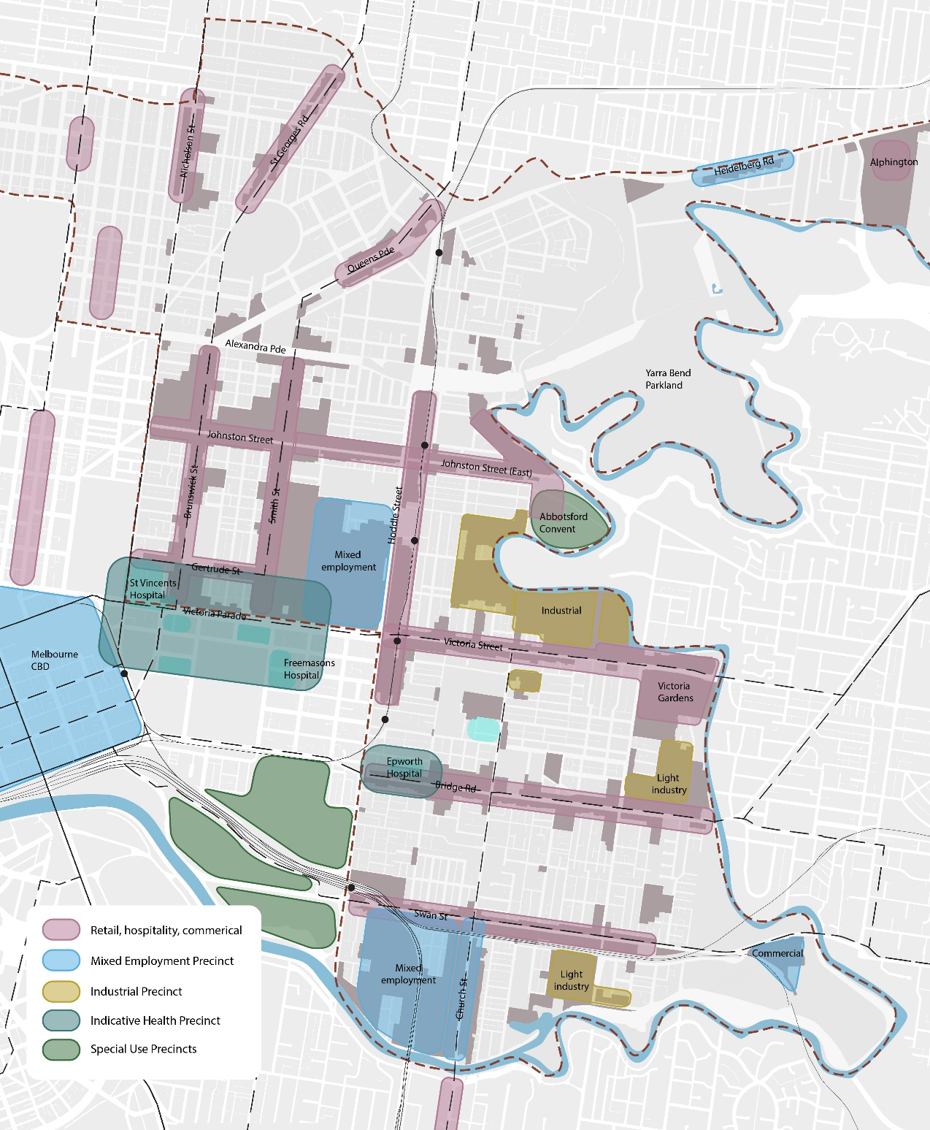
Source: SGSEP Pty Ltd, 2016.

Need to:
Make sure all of Alphington is included within the municipal boundary.
Mark the Alphington precinct on the Amcor site as a future centre to distinguish from the other centres.
Label the MCG, Tennis Centre,
Add ACU in the st Vincents health precinct. Change the legend to refer to Indicative Health and education precincts.
Add Melbourne University in Burnley
Add Melbourne Polytechnical
What is the distinction between light industrial and industrial on the map? Assume zones but Is it all just industrial?
The MUZ land included on the map is not labelled in the legend and should be.
Should the legend for the activity centres include reference to residential?
Cremorne precinct extend boundary to Punt Road
Swan Street eastern end extend to the railway line
Epworth Precinct shrink eastern boundary to align with Lennox Street

Introduction

Project context
The City of Yarra (Yarra) plays a vital role in the economy of Greater Melbourne. It sustains a diverse range of businesses that contributed $10,085 million Gross Value Add (GVA) constituting 4.3% of the Greater Melbourne economy in 2015. By way of comparison, Yarra comprises just 0.2% of Greater Melbourne’s land area and accommodates 2% of its population.

The City of Yarra (Yarra) has adopted an Economic Development Strategy (EDS), which along with the Council Plan, provides overarching direction for economic development in Yarra. The EDS highlights the importance of the creative and knowledge sectors to the future of Yarra’s economy.

The Yarra Business and Industrial Land Strategy (BILS), adopted in 2011, provides guidance on planning for Commercial and Industrial zoned areas. In broad terms, BILS suggests that Yarra’s stock of business and industrial land could accommodate greater diversity of employment activity. The recommendations of BILS have guided Council’s planning efforts for employment precincts.

Building on these documents, this Spatial Economic and Employment Strategy (SEES) sets out a vision for the future of Yarra’s economy building on existing policies, analysis of existing conditions and emerging trends, and addresses a number of specific policy issues.

As a preliminary exercise to the development of this Spatial Economic and Employment Strategy (SEES), SGS prepared an ‘Issues and Opportunities Paper’ that provided an evidence base by examining key trends, issues, opportunities and trade-offs relevant to the future of employment and economic activity in Yarra.

The SEES will help Council address a number of policy challenges through a rewrite of Yarra’s Planning Scheme. Figure 1 below details this broad work program with the Issues and Options Paper and the SEES highlighted.
Figure 1. Proposed planning scheme Review and Rewrite
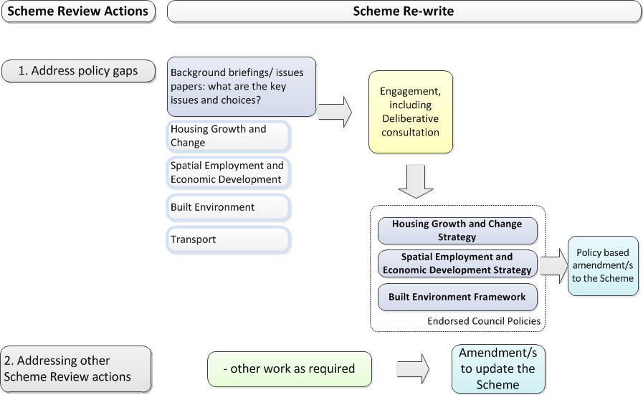
Stage 1
Stage 2 (this report)

Objectives of this Strategy
The purpose of this SEES is to provide guidance on managing growth and change in employment and economic activity. The objectives of the Strategy are to:

- Articulate the role of Yarra’s centres, precincts and other economic clusters a metropolitan context
- Articulate the role of Yarra’s employment areas, both for the local community and their wider economic role
- Set out projections for the likely land and floor space demand for employment
- Provide a spatial strategy to accommodating growth and change in economic activity to 2031
- Identify those locations that are best suited to accommodating growth and change
- Identify issues, challenge or opportunities for specific employment precincts or activity centres
- Identify actions that Council needs to undertake to support growth and change in employment and economic activity
- Identify new policy directions for the Yarra Planning Scheme
- Detail the logic and evidence base used to develop the Strategy.
Economic activity in Yarra is arranged spatially among a range of different types of employment precincts: activity centres, specialised medical facilities, industrial precincts, mixed employment precincts, educational institutions, and areas where the Comprehensive Development and Priority Development zones have been applied. Reference will be made to these different types of employment precincts throughout this document, acknowledging their differing and complementary roles.

Employment, economic activity and land use planning
Land use planning shapes employment and economic activity through regulations that influence the type, intensity and combination of land uses that are permissible on land. These regulations take the form of State Planning Policies, Local Planning Policies, land use zones, the application of special overlays, and location specific spatial plans such as Structure Plans, Local Area Plans and Urban Design Frameworks (an overview of the current planning framework is provided in Chapter 3).

The land use zones applied in Planning Schemes are set out in the Victorian Planning Provisions (VPP). The key employment zones in the VPP are the two commercial zones (Commercial 1 and Commercial 2 Zones) and the three industrial zones (Industrial 1, 2, and 3 Zones). The Mixed Use Zone also permits employment uses, however recent evidence suggest the majority of new development on land within these zones tends to be residential. The deployment of these employment zones is one of the primary means by which Councils influence the location and mix of employment. Some of the key recommendations of this Strategy address the need to retain or change the mix and location of zones to support the growth and change of employment and economic activity across Yarra.

In addition to determining the appropriate zoning to support employment, land use planning can also:
- Minimise the negative externalities associated with employment uses on adjoining and neighbouring land uses
- Maximise the potential for positive externalities (e.g. business clustering)
- Manage interfaces between land uses
- Establish a hierarchy for activity centres to assist decision making about the mix and intensity of retail activities, broadly defined, and also inform decision-making around infrastructure and service provision
- Shape policies relating to traffic generation, parking requirements, loading and servicing
- Outline policies relating to urban design, such as streetscape interfaces, urban character considerations and open space requirements.

The primary instrument that regulates development in the City of Yarra is the City of Yarra Planning Scheme. The recommendations of this Strategy will inform the re-writing of the Planning Scheme.

Structure of the SEES
The remainder of the report is organised as follows:

- Chapter 2: Trends and drivers summarises the key content from the Issues and Options Paper in relation to broader economic and spatial trends and sets out growth projections that establish projected future demand for employment floor space in the City of Yarra.
- Chapter 3: Planning framework describes the current planning framework and, with respect to the issues discussed in the previous chapter, highlights the limitations of current planning policies and approaches. This chapter also considers Council’s Planning Scheme Review and relevant previous studies.
- Chapter 4: Yarra’s precincts consider the trends and drivers, projections, and consultation findings to understand the spatial implications of forecast employment growth for specific employment precincts, activity centres, and Yarra’s activity centre hierarchy.
- Chapter 5: Strategy sets out the spatial strategy to accommodate growth and change in employment and economic activity in Yarra and identifies policy directions and implementation actions.

The appendices provide more detailed information on the employment forecast, the classification of retail centres and employment precincts, and the capacity analysis.

Trends and drivers
This chapter provides a brief history of the evolution of economic activity in Yarra and an overview of the strategic spatial context. It then describes key economic trends relevant to the future of employment and economic activity. It concludes with a series of employment and floor space projections across four broad industry sectors, which provide a foundation for the subsequent chapters of the Strategy.

Historical context
1830’s
1860’s
1920’s
1960’s
1990’s
Yarra has evolved significantly since settlement to the present day. The suburbs of Fitzroy and Collingwood were, and still are, a place of significance for Aboriginal people.

European settlement of the area saw the establishment of industries such as abattoirs, fellmongering, wool-washing, tallow manufacturing and later flour milling and other food processing, as well as agricultural machinery production. These activities were attracted to the City of Yarra due to its proximity to the Yarra River, the Central Business District and the Port of Melbourne.

Johnston and Smith Streets were established as important retail, civic and commercial strips during the 1860s. By 1880, Smith Street had several department stores including Foy and Gibson, Paterson’s, Henry Ackman and G. J. Coles.

By the 1920s, Melbourne’s economy had industrialised and manufacturing activity was prominent in Yarra; it included the manufacturing of footwear, clothing and brewing industries. Collingwood and Abbotsford developed first, followed by other suburbs such as Fitzroy and Richmond. Yarra was strategically located for manufacturing due to strong transport accessibility with rail and road access.

The 1960s and 70s were a period of change in Australia, characterised by the movement of industrial firms and residents away from the city centre and towards suburban areas. The subsequent industrial decline provided an opportunity for the revival of the inner city with former industrial sites being converted to cultural facilities, such as the Universal Theatre.

Most recently, gentrification and growth in the knowledge and service sectors has seen Yarra transition to a desirable residential address with increased residential development, including the conversion of former industrial warehouse buildings to apartments.

Changes in the Yarra economy have largely been driven by structural economic changes occurring at the city, state, national and even international level. These broader forces will continue to influence Yarra in quite profound and different ways into the future. Yarra’s ability to continually evolve and adapt to change, while leveraging its existing infrastructure, fine grain built form and rich culture has been key to its past success and will be critical to its future.

Strategic context
Yarra’s location within the metropolitan context and its relation to key infrastructure and institutions are important drivers of employment growth across the municipality. Yarra is situated immediately to the north and east of central Melbourne (see Figure 2). Established suburbs extend beyond each side of the municipality and are connected through a range of transport options. As a result, Yarra is one the most highly accessible locations in Melbourne from a labour market perspective. A range of businesses, especially knowledge intensive industries, find it an attractive location due to its proximity and connectivity to the CBD.
Figure 2. central Melbourne employment and urban renewal precincts
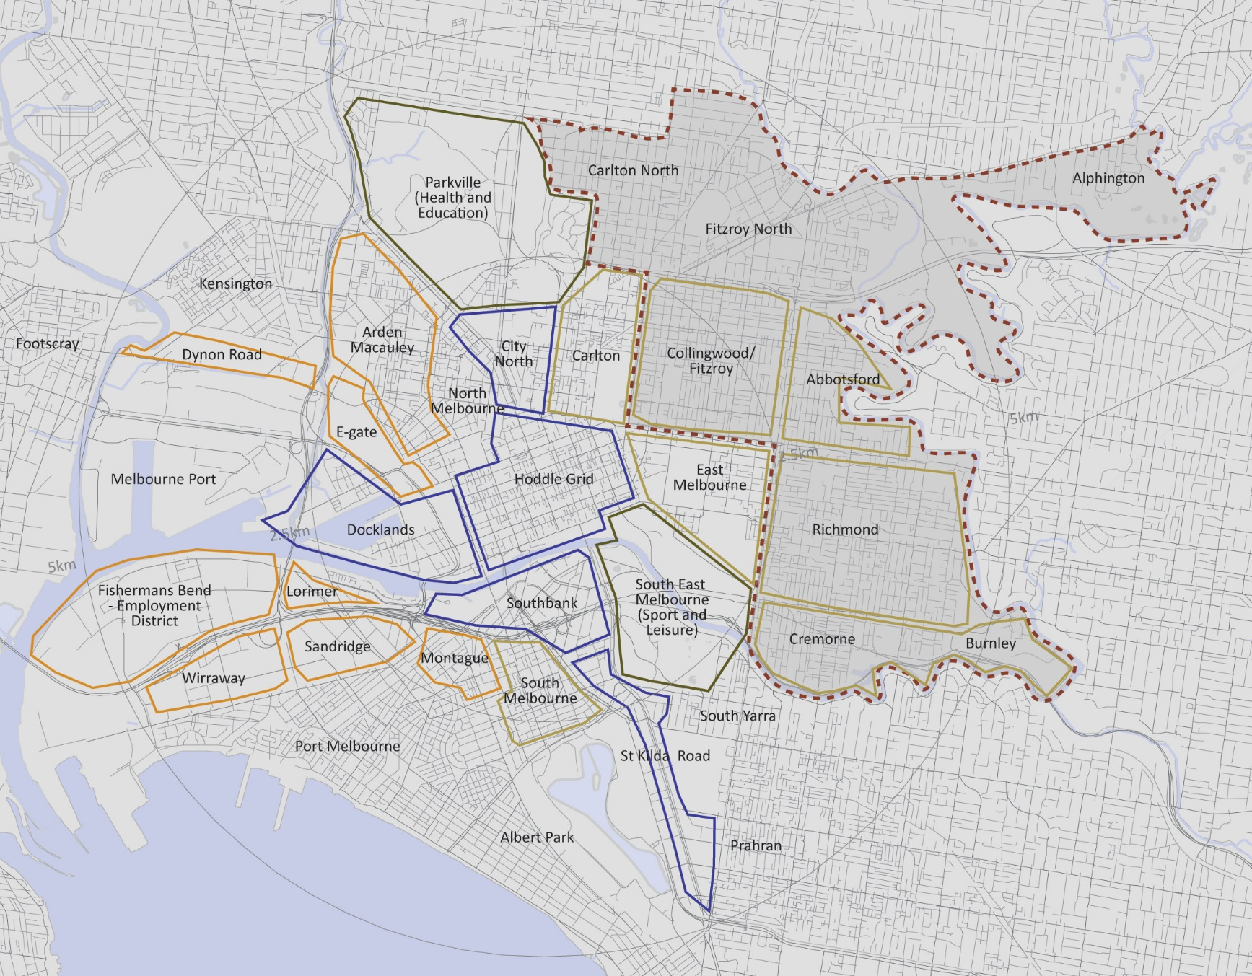
Source: SGS, 2015.

Key institutions and public assets
Key institutions and public assets (health, education, arts and commercial) in Yarra also represent key nodes in their own right. The western side of the municipality is adjacent to number of significant institutional assets, including the major health and education precinct around Parkville which extends along Victoria Parade and includes a number of major health and education facilities in Yarra and the neighbouring municipality of Melbourne. The western end of Swan Street has strong connections to Melbourne’s major sporting precinct which provides high volume demand to retail, hospitality and the tourism sectors during major events. The southern end of Church Street also provides a ‘boutique’ restricted retail offer which has leveraged strong connections into Forrest Hill and Chapel Street. The north of the municipality has strong links to a number of activity centres: High Street, St Georges Road, Lygon Street and Sydney Road. The eastern edge of the municipality is generally defined by the Yarra River, over which there are limited crossings creating a natural break from Melbourne’s eastern suburbs and also providing access to open space and recreation assets.

Transport connections
Yarra enjoys a relatively high degree of both private and public transport accessibility; it is traversed by numerous major freeways, arterial roads, train lines, tram and bus routes. Yarra is intersected or bordered by a number of major road corridors, including Punt Road/Hoddle Street, Eastern Freeway, Heidelberg Road, Nicholson Street and CityLink. These corridors play an important cross-city traffic role, however in some instances they are barriers to mobility and integration between areas within the municipality. Bike and pedestrian routes add to this rich transport network and extend across Yarra.

The key shaper of Yarra’s retail precincts has been the tram network. This will continue to be the strongest influence from a transport perspective on retail development. In particular, the five major retail strips Brunswick Street, Smith Street, Victoria Street, Bridge Road and Swan Street have benefited from this infrastructure. Compared to Hoddle and Johnston Streets, Yarra’s main streets with tram line have a more fine-grained urban structure, less intrusive traffic and better performing retail precincts.

A number of major railway stations serve the north and south of the municipality. Stations at Richmond, East Richmond and Burnley are located in established retail strips and present opportunities for consolidation and densification of commercial, retail and residential land uses. Stations at Victoria Park, Collingwood and North Richmond all serve the Hoddle Street precinct. This precinct also presents opportunities for intensification of land uses that would benefit from proximity to existing fixed rail services. Intensification around this transport assets is consistent with the directions of Plan Melbourne.

At a metropolitan scale Yarra is highly accessible from the north, east and south (as evidenced in the journey to work data) and a convenient location for a diverse workforce to access employment opportunities in the CBD. Locally, there is also a high level of accessibility to employment, retail and services via public transport, walking and cycling, and private vehicles.

Key trends affecting Yarra
This section highlights some of the key economic trends that have affected the broader metropolitan economy in recent decades, including the growth and spatial distribution of employment and economic activity in Yarra. These macro-scale trends are generally beyond the influence of governments be they local, state and federal. However, they are fundamental considerations in understanding how employment and economic activity will continue to evolve and the need for land use planning strategies and policies to respond to pressures for change.

Structural economic change
The last 30 years have seen significant shifts in the nature of economic activity in Australia. As demonstrated in Figure 3, the share of the economy derived from knowledge intensive services has increased significantly while the share in manufacturing has seen a profound decline. The factors driving these changes are likely to continue to influence employment and economic trends across metropolitan Melbourne and Yarra.

Economic activity in Yarra has responded to theses shifts and continues to adjust. Yarra is now host to a post-industrial economy which features a diverse range of industry sectors, producing high value outputs, with an increasing emphasis on professional services, health care and education, creative industries and a diverse retail and hospitality offer.
Figure 3. Share of GDP for Selected Industries in Australia
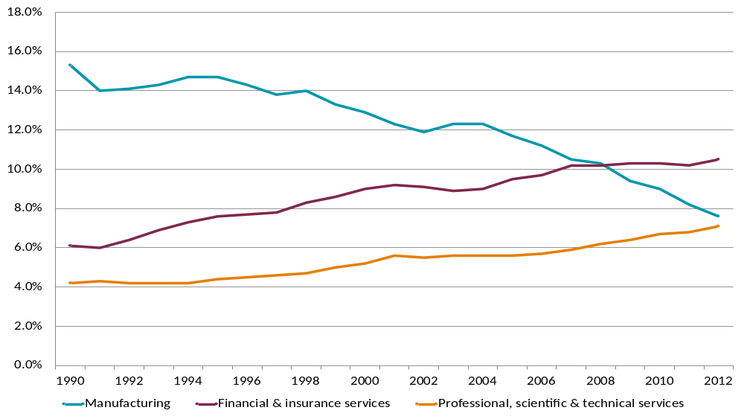
Source: Australian Bureau of Statistics – National Accounts

Innovation, knowledge services, agglomeration
The long-term competitiveness of Australia’s economy will be underpinned by its ability to continue to innovate. Innovation is essentially the reshaping of existing products and services for existing customers and the development of new products and services leading to the creation of new markets. As local and global economies continue to evolve rapidly, innovation is essential for businesses to remain relevant and competitive.

Melbourne’s diverse and skilled labour force will increasingly be leveraged to support innovation and growth across all sectors of the economy. While economic growth has been concentrated in the financial and professional services sectors, all sectors – retail, health, hospitality, agriculture, mining and construction – can leverage analytical and creative services to boost productivity. The massing and clustering of professional services – also described as ‘agglomeration’ – improves their ability to innovate, boosting their productivity and, in turn, that of their customers. Agglomeration benefits are one of the main attractions for the growing professional services industries to locate in central city areas and near major transport nodes.

After the City of Melbourne, Yarra has next highest concentration of knowledge sector employment with significant proportion of workers engaged in knowledge intensive sectors of health and education, architectural and engineering services, finance, advertising and information technology. Knowledge sector jobs grew by 17% (more than 5,000 additional jobs) between 2006 and 2011. Yarra also hosts a significant share of creative industries with an estimated 11% of workers and 21% of businesses in Yarra involved in the creative sector.

Development of mixed employment precincts
Yarra has two significant ‘mixed employment’ precincts: the Gipps Street precinct in the south eastern corner of Collingwood and the Cremorne precinct south of Swan and east of Church Streets. Both precincts have a long history of employment uses and as a result contain a mix of industrial buildings, warehouses, and newer office buildings. They also contain some housing that pre-dates the introduction of distinct residential and industrial land use zones. Their proximity to the central city makes them an attractive location for business seeking affordable accommodation, but still in close proximity to a large number of other firms, customers and clients. Examples of the types businesses in these precincts include light industrial uses, architecture and design firms, small-scale manufacturing and property services.

The precincts host a diversity of building stock in terms of age, type and size, providing a range of tenancies for small to medium size firms with a range of floor space needs. The diversity of lot sizes and built forms are the product of decades of evolution and change and are unlikely to be reproduced through deliberate urban renewal efforts such as those pursued at Southbank and the Docklands or envisaged for other renewal precincts including Fishermans Bend. Yarra’s mixed employment precincts are unique locations that make an important contribution to the economic landscape of Yarra and the metropolitan region.

Urban economists, past and present have suggested that the density and diversity of economic activity in cities drives innovation (Jacobs, 1970; Glaeser, 2011; Florida, 2012). However the questions of how and where innovation occurs in cities are not easily answered. Density and proximity contribute to the likelihood of business to business interactions that lead to innovation. The diversity of businesses, skills, networks, buildings and tenancies within an employment district is also a contributing factor. And finally, connectivity and networks to facilitate relationships between people, firms and places form a third element that underpins idea generation, innovation and commercialization efforts.

The unique qualities and mix of businesses in Yarra’s mixed employment precincts and their contribution to the contemporary urban economy and role as sites for innovation have been a focus of research (Hutton, 2008; Wood and Dovey, 2015). Research on ‘urban makers’ by Melbourne University has considered how “small, high-value-add, highly-innovative urban manufactures” benefit from locations like the Gipps and Cremorne precincts (Day et al, 2015). An issue identified early on in this research was the challenges of using existing employment data sources to determine the location, number and contribution of these firms to the Victorian economy. Without this data it is difficult to understand the size and scope of the ‘urban making’ economy, or the impact that planning or other changes would have on the viability of these employment activities.

The Gipps and Cremorne precincts were identified in Plan Melbourne ‘other urban renewal areas’ in Yarra, with the Alexandra Parade and Hoddle Street precincts (see section 3.2 below). This designation was removed from the latest version of Plan Melbourne released in March 2017.
Figure 4. diversity of built form in mixed employment precincts
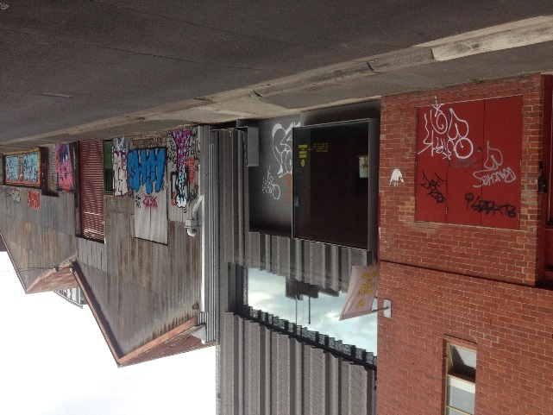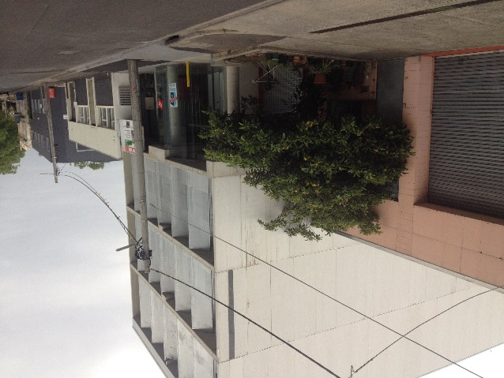
Source: SGS, 2015.

Growth in new niche manufacturing and logistics
Despite the loss of much of the manufacturing activity that formerly underpinned the Yarra economy, subsectors of manufacturing still remain and are growing. These are broadly focused on the manufacture of perishable products and more advanced/innovative manufacturing where skilled labour is required.

While there are still some remaining large-scale industrial uses – the Carlton United Brewery stands out as the largest site – most precincts are experiencing a decline in the quantity of industrial floor space as they transition to commercial, retail or residential uses. The industrial firms that remain in Yarra are generally small-scale manufacturers in sub-sectors such as food production, textiles, bespoke furniture and printing. These firms generally produce boutique, custom-made products that require the input of specialised designers. The need to be close to clients and business collaborators, who are concentrated in inner city locations, is thought to be a key driver for the continued existence of such firms in Yarra.

Another attraction of Yarra for small creative firms is the presence of older warehouse buildings as collaborative workspaces, design and development spaces. These spaces are often cheaper and more flexible than purpose-built office developments which make them particularly desirable to this creative/ innovation sector.

With the benefit of a deep water port, Melbourne has experienced strong growth in the freight and logistics sector as volumes of inbound and outbound trade has grown. Logistics firms are increasingly clustering in larger industrial nodes with good access to arterial roads and freeways. With increasing property values, traffic management issues and conflict with non-industrial land uses, Yarra is unlikely to attract substantial growth in freight and logistics businesses in future.

Growth of the health care sector
Growth in the health sector will result from a population that is both ageing and growing, as well as through technological advancements. These factors will combine to broaden the sector with increasing employment in allied and support services along with higher levels of specialisation. Growth in the health sector can be broken down into two main areas (see Figure 5). Regional services (e.g. hospitals) which will be increasingly clustered around existing nodes as specialisation drives innovation; and the growth of local health services (e.g. general practitioners) which are more dispersed and follow broad patterns of population growth. Yarra will experience both types of growth, however the former is of considerable significance given the presence of the St Vincent and Epworth hospitals.
Figure 5. Health sector structure
Hospitals
Medical specialists
Allied health services
General Practitioners
Support services
Health research
Health manufacturing
Catchment size
Local
Metropolitan
Source: SGS Economics and Planning

Growth in education
The rapid growth of Melbourne’s resident population, particularly in inner city regions such as Yarra, has increased demand for school places. In recetn times, a major shortage has been reported (Cook, 2017), with demand in Yarra amongst the highest in the metropolitan area (school age student growth of 52% anticipated in the next 10 years).

New education facilities are planned in Yarra. A new year 7 to 12 high school is being developed on land adjacent to the Richmond Bowling Club and Richmond Town Hall. The Development Plan for the Amcor site also “allows for and encourages the establishment of a new early years Government Primary School campus within the site”.

Future planning should consider whether population growth and demographic change could generate demand for additional facilities in the medium to longer term, and, if required, where the facilities might be best located.

Yarra hosts a number of tertiary education institutions, which can be drivers of employment growth and attractors for retail, housing and ancillary activities. The Australian Catholic University has a campus on Victoria Parade in Fitzroy and this will grow as an employment hub. In addition, the Kangan Institute in Cremorne is an important training and education facility on an underutilised site. It specialises in traineeships, diplomas, advanced diplomas and tailored programs in fashion and creative industries. Education jobs will grow rapidly alongside health sector jobs in the St Vincent and Epworth hospital precincts because of their teaching role. Melbourne University’s Burnley campus hosts teaching and research in environmental and ornamental horticulture.

Competition between housing and employment in land markets
The growth in demand for housing in accessible locations in and around the central city has important implications for employment land. Residential development is typically the most profitable redevelopment proposition on land that is zoned commercial and mixed use. This has been the case in Yarra with the majority of recent developments on mixed use zoned land being predominantly or entirely residential.

Under these market conditions residential uses ‘outbid’ all other uses. Land owners seeking optimal returns are likely to pursue residential conversion or sell to residential developers (who will likely be the highest bidders), displacing existing employment uses. Even in areas where residential uses are not permitted due to zoning restrictions, there is often still significant pressure for residential conversion.

There are benefits to accommodating additional housing in established urban areas with good access to employment, transport and services. Additional housing in and near activity centres increases retail expenditure and can act as a catalyst for new economic activity. It also provides opportunities for people to live in locations with good access public and active transport infrastructure.

The downside of this residential development includes the displacement of existing economic activity and indirect pressures for displacement due to conflicts between housing and employment uses. Employment precincts that are outside activity centres can provide a diversity of employment floor space types, accommodating a variety of employment uses. They can also provide a reserve of land for the growth and expansion of employment activity through redevelopment to higher intensity uses.
Figure 6. recent examples of higher density housing in yarra
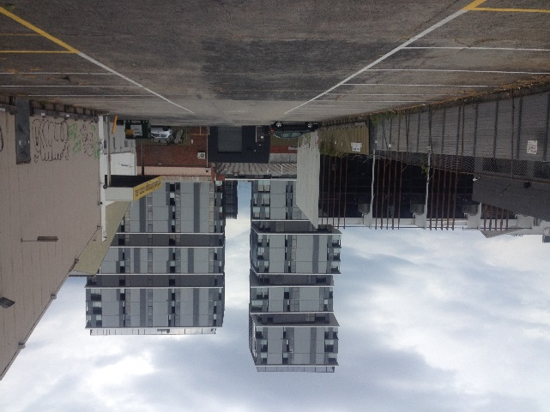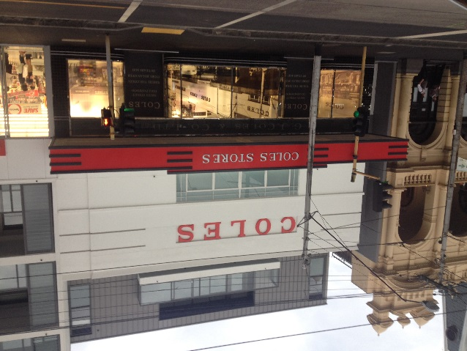
New residential development on mixed use land near Gipps Street. The ‘new’ Coles supermarket – part of the Smith & Co. development on Smith Street. (Source: SGS, 2015)

Continued growth in retail and hospitality
Acting as a primary shaper of local activity, the retail and hospitality sector will likely continue to evolve in response to wider trends and changes in local residents’ tastes and preferences. The format of retailing will also continue to evolve beyond a simple ‘shop-front’ model to formats that also promote on-line retail options.

Yarra is a regional destination with many of the City’s retailers attracting shoppers from beyond local retail catchments. Consultation with Yarra’s retailers has indicated that approximately 20% of trade is derived from local residents with the remaining 80% sourced from workers, tourists and visitors. Yarra’s broad range of retail and related activities are often quite distinct from retailing that is more oriented towards a local population. As a result the viability of many of Yarra’s Activity Centres is less contingent on the presence of supermarket or other anchors. Yarra also supports a vibrant night time economy sustained in large part by visitors from outside of the municipality.

As the output of this sector continues to grow, it has also constantly evolving in response to consumer preferences, product innovation and technology. This has a number of significant implications for the sector:
- The simple ‘shop-front’ which on-sells goods from wholesalers is being superseded by multi-channeled retail, a format that synthesises both a shop front and online presence.
- Physical retailing will increasingly become services-based, with strong growth expected in hospitality along with other non-retail services (i.e. health, financial) within retail strips.
- The highly competitive supermarket sector will continue to innovate and find ways to dominate the local retailing space (e.g. smaller formats and tailored offerings based on local environment).

The ultimate impact of online retailing on ‘bricks and mortar’ retailers is as yet unknown. Although online was initially seen as a direct competitor to store based retailing, many traditional retailers have adopted online technologies to enhance a evolving business model that is still oriemted around store-based retailing. By way of example, for many clothing and personal item retailers a physical store might still be necessary to demonstrate the brand or retailers unique points of difference.

The Victoria Gardens Shopping Centre provides diversity to Yarra’s retail offer with a larger format, multi-anchor centre that combines supermarkets, conventional retail and bulky goods retail. Although a break from the traditional main street retail formats, the centre provides a complimentary offer and serves a catchment that extends well beyond Yarra.

Broadly, population growth across Greater Melbourne will generate increased demand for retail and hospitality in high amenity and accessible locations with Yarra’s Activity Centres likely to experience continued pressure to accommodate this growth. A trend favouring Yarra-based retail and hospitality businesses is the continued harmonisation and homogenisation of CBD retail, which contributes to demand for a differentiated, alternative retail offer in accessible non-CBD locations.

A new neighbourhood centre is proposed as part of the Amcor development seeking to fill a retail network gap in the Alphington/Fairfield area.

Spatial implications
The spatial implications of Melbourne’s changing economic landscape is summed up in figures below that show Figure 7 divergent trends of business openings and closures. The red dots represent a net loss of businesses from a postcode area while the blue dots represent net increases. The size of each dot represents the relative magnitude of change, with larger dots signaling a large increase/decrease in number of businesses. The figure highlights the decline of manufacturing in the inner and middle suburbs, while manufacturing hubs in the outer west, north and southeast have experienced net increases in the number of businesses. Conversely, growth in professional services business has centred on the central city and inner suburbs, with a small amount of growth also seen in some greenfield areas.
Figure 7. Net change in business establishments by postcode 2001 to 2011
Manufacturing | Professional services
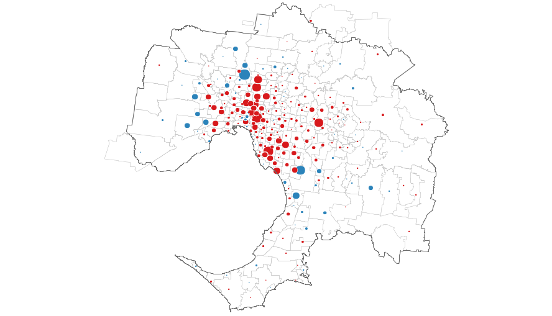 | 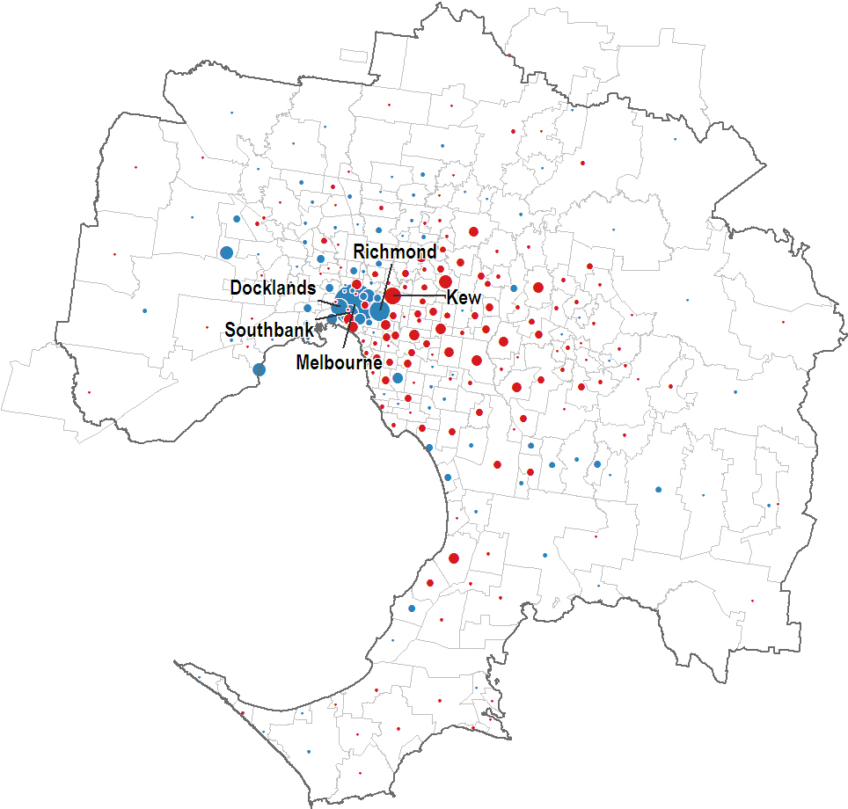
Source: DSDBI

Employment growth projections

Metropolitan Melbourne employment trends
Recent and projected employment growth by industry for metropolitan Melbourne to 2031 are shown in the chart below. The chart shows that health care and professional services will be the two strongest employment growth sectors in coming decades. Economic output associated with manufacturing will remain relatively stable, however the number of people employed in the sector will continue to decline. Population serving sectors such as retail, education and construction will maintain their share of employment.

The changes in the mix of employment illustrated by the figure below underscore the significant restructure that is likely to continue to take place across metropolitan Melbourne.
Figure 8. Metro Melbourne employment PROJECTIONS by industry, (‘000)
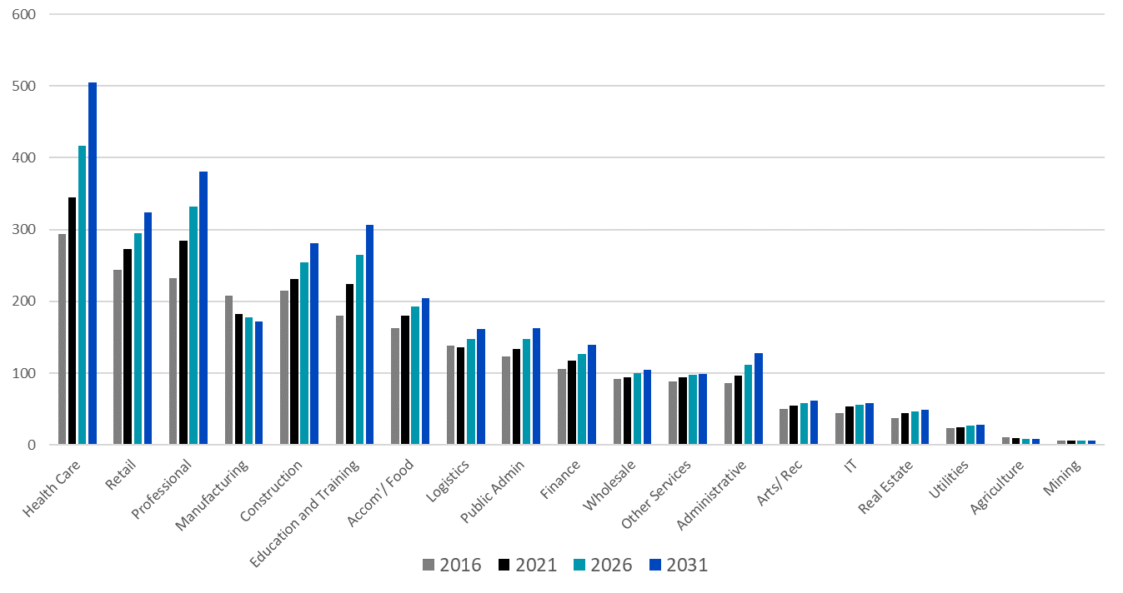

Source: SGS derived from ABS Census and other public datasets. Metropolitan level employment forecasts draw on official Australian Treasury macroeconomic modelling along with a number of official Victorian and regional level employment, economic output and population datasets from ABS and state departments. Analysis of structural economic changes, subsector economic drivers and labour force composition are also factored into the analysis.

Trends for Melbourne’s regions
Due to the uneven distribution of industries across Melbourne, the spatial implications of structural economic change will vary by region. Recent and projected employment growth for the five broad regions in Melbourne is shown in Figure 9.

Yarra is located within the Inner Metro region which also includes the local government areas of City of Melbourne and Port Philip. Based on current projections, the Central region will capture around a quarter of Melbourne’s employment growth over the next 15 years: an estimated 180,000 additional jobs. A significant proportion of metropolitan employment growth will also be captured in the Inner South East, with the rest spread relatively evenly across metropolitan Melbourne’s regions.
Figure 9. Metro Melbourne employment PROJECTIONS by region (‘000)
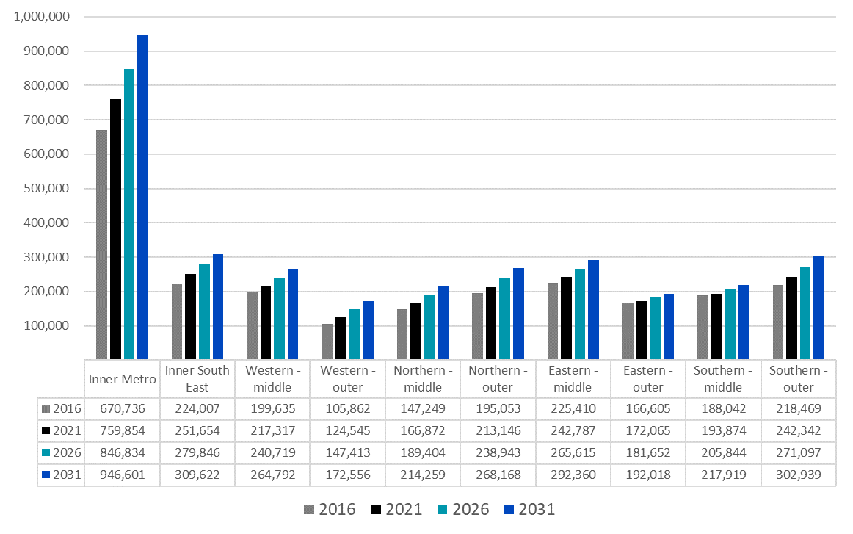
Source: SGS derived from ABS Census and other public datasets

Projected employment growth in the City of Yarra
Yarra plays a vital role in the economy of Metropolitan Melbourne. It sustains a diverse range of businesses that contributed $10,085 million Gross Value Add (GVA) – equivalent to 4.3% of the Melbourne’s total economic output - over 2015. By way of comparison, Yarra accounts for just 0.2% of Greater Melbourne’s land area, yet accommodates2% of its population.

Drawing on a combination of metropolitan projections and local trends, SGS has forecast strong growth in demand for commercial office floor space, assuming a continuation of favourable conditions that underpin the continued supply of employment floor space.

Employment is expected to grow significantly across most industry sectors. Over the past decade employment in Yarra has grown by 2,500 jobs per annum with an estimated total of around 99,000 jobs in 2016 (SGS Employment Projections). This level of net employment growth is projected to increase with forecasts suggesting growth of 3,000 jobs annually over the next fifteen years. Retail trade, professional services and health care are projected to grow most rapidly (Figure 10) while stagnant of negative employment growth in the manufacturing and wholesale trade sectors is projected to continue.
Figure 10. Yarra employment PROJECTIONS by industry, (‘000)
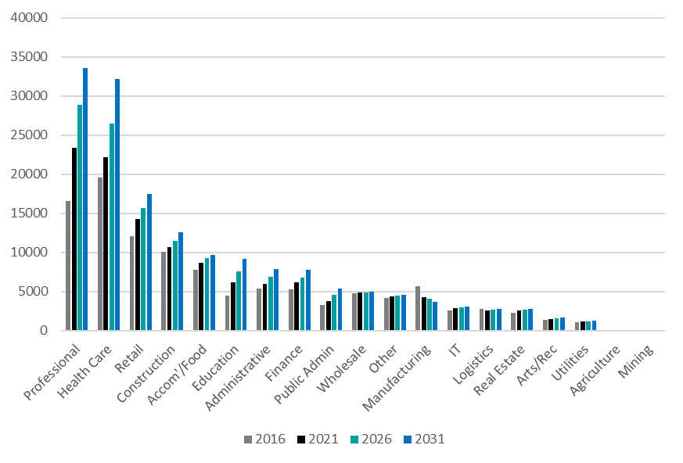
Source: SGS Employment Projections

Yarra’s employment growth challenge
Growth in the Inner Metro economy – of which Yarra is an important part – is critical to the ongoing success of the broader metropolitan economy. Knowledge based service sector businesses gain significant benefits from clustering in job-rich, inner-city areas. These are areas that provide the most opportunity for business-to-business interactions and the best access to Melbourne’s labour markets.

Providing opportunities for businesses to grow in existing and accessible employment nodes will ensure Melbourne remains competitive nationally and across Asia. The ability of Melbourne’s inner city to grow its share of total employment has been a key contributing factor to the city’s superior growth performance in recent years. In this regard, Yarra plays a key role in supporting metropolitan wide employment growth. An ongoing challenge for Yarra, however, will be adapting while accommodating employment growth. Understanding the types and quantum of employment floor space that the City of Yarra might expect to accommodate in the next 15 years is the starting point for responding to this challenge.

Employment floor space demand
The following section provides an indication of the type and mix of employment floor space required to accommodate the projected employment. Detailed industry categories have been aggregated into four broad floor space categories to facilitate this broad analysis (Figure 11). It should be noted that in practice individual business requirements are extremely varied, even within the same industry sector. For this reason, the following high level analysis provides an ‘order of magnitude’ estimate for strategic planning purposes only.
Figure 11. employment general concordance
Broad category | ANZSIC 2006 industry classification
Commercial | Information Media and Telecommunications, Financial and Insurance Services, Rental, Hiring and Real Estate Services, Professional, Scientific and Technical Services, Administrative and Support Services, Public Administration and Safety
Retail | Retail Trade, Accommodation and Food Services, Arts and Recreation Services, Other Services
Institutional | Education, Health Care and Social Assistance
Industrial | Agriculture, Forestry and Fishing, Mining, Manufacturing, Electricity, Gas, Water and Waste Services, Wholesale Trade, Transport Postal and Warehousing
Note: Construction has been excluded from any ‘broad category’ as it is largely a transient.

Current floor space and forecast floor space demand have been estimated by broad categories as follows:
- Current floor space ratios by broad type, (that is, the amount of floor space per job) was estimated by aligning current employment to total floor space by broad category. Current floor space has been derived from an analysis of Council rates and Expanded Urban Development Program employment floor space data.
- Floor space ratios were reviewed against other jurisdictions, industry research and spot checks of selected sites within Yarra. Estimates where adjusted accordingly.
- Floor space ratios were projected into the future. This was undertaken to account for changing industry composition and improved efficiencies occurring within each broad category.

Figure 12 and Figure 13 below provide a summary of the floor space demand analysis.

Total employment is projected to increase from 99,000 jobs in 2016 to 149,000 in 2031 – an estimated increase of around 49,000 jobs (see Figure 12). Over this period employment in the commercial and institutional sectors will increase the most, with growth of 25,000 and 17,000 jobs respectively. Industrial sector employment is projected to experience a slight decline.

The floor space implications of these employment trends vary as a result of differing job to floor space ratios, and changes to these ratios over time. In spite of rapidly increasing employment, total employment floor space is projected to grow slightly from 3.59 million square metres in 2016 to 3.86 million square metres in 2031. Although the take-up of floorspace will grow strongly for the commercial and institutional sectors in particular, these increases will be offset by lower demand for floorspace from the industrial sector as a result of a combination of decreasing employee to floorspace ratios and declining overall employment.

This summary highlights the structural changes that have occurring within the Yarra economy. While total employment will continue to grow over the next 15 years, total floor space demand will grow at a lower rate as each new job will require less floor space than existing or exiting jobs. However, the type and location of this floor space will need to change to align with future requirements of each sector.
Figure 12. Yarra employment PROJECTIONS by Broad industry, (‘000)
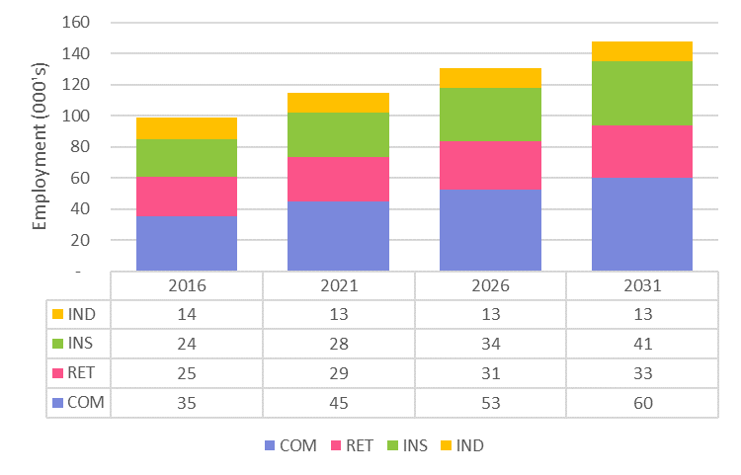

Source: SGS derived from City of Yarra Rates Database (2014). SGS Employment Projections, SGS floor space projections

Figure 13. Yarra floor space PROJECTIONS by broad industry, (‘000)
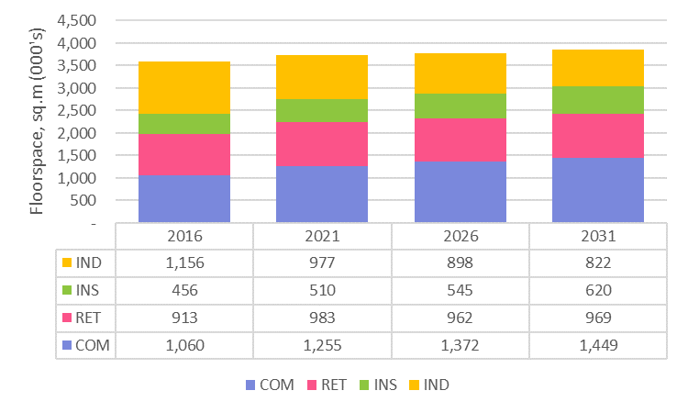
Source: SGS derived from City of Yarra Rates Database (2014). SGS Employment Projections, SGS floor space projections

The key patterns within each broad sector are described below, drawing on additional consultation, research and analysis completed in the supporting Issues and Options paper.

Commercial sector
While commercial employment has been steadily increasing in importance across Yarra, the average amount of floor space per job has been declining. This trend is likely to continue and is the result of a range factors, including trends towards open plan and more space efficient offices and shared workspaces; increases in home-based businesses which do not require formal offices for operations; and higher occupancy rates as a cost savings measure given increasing office rents in accessible inner-city employment locations.

Recent additions to commercial office supply have been focussed on the CBD and city fringe locations, including Southbank, Docklands, St Kilda Road and South Melbourne. In contrast, smaller scale suburban office users have increasingly located in eastern suburbs like Camberwell and Hawthorn which feature buildings with larger floor plates, proximity to skilled worker pools, and good regional road connections.

Until relatively recently, Yarra was not seen as a city fringe office market by major commercial office tenants, occupying a unique niche between the CBD and suburban office market. In comparison with the City of Melbourne, professional service firms in Yarra are more oriented towards creative industries including architecture, design advertising and engineering and auxiliary finance and investment services.

There is however some evidence of a shift in this perception. Some larger commercial tenancies have located in Yarra, notably, Car Sales and realsetate.com in Cremorne and the recently relocated David Jones head office at the Botanica Business Park in Burnley. The development pipeline for new office developments has seen a recent spike in actvity. In 2016, 23 planning applications for office development were submitted for a total of 63,000 sqm of floor space. In 2017, 33 office permits were submitted totaling 202,000 square metre. To put these figures in perspective, Yarra currently has in the order of 1,060,000 sqm of commercial floor space, and the forecast demand over the next 15 years is for an estimated 389,000 sqm of additional commercial floor space. The approved development plan for the former Amcor site in Alphington allows for up to 11,500 square metres of additional commercial office floor space.

Retail sector (including hospitality and recreation)
The retail, hospitality and recreation sector in Yarra has also experienced growth in both total employment and floor space, while at a lower rate than that of the commercial sector. This growth was largely comprised of a number of smaller scale retail developments, with 95% of new retail developments between 50 and 300 sqm. However, there was also a small number of large-scale retail developments including the Victoria Gardens and Hive developments on Victoria Street, Richmond. There is evidence that Yarra is likely to experience changing patterns of supermarket distribution with new store formats in new developments being used to gain market share.

Yarra currently supports in the order of 910,000 square metres of retail floor space with an additional 55,000 square metres of floorspace projected over the next 15 years. An additional 13,500 square metres of retail floor space is provided in the approved development plan for the former Amcor site in 2015.

Institutional sector (includes health, education and social services)
This sector’s growth has largely been driven by growing employment in health care sector, although employment in education and social services are also expected to grow at modest rates. Despite significant increases in demand, there has been little change in terms of total floor space. This is largely a result of significant reductions in job to floor space ratios in the health care sector. These reduced ratios have been driven by supply-side factors including increased operation hours and shift work and more efficient operations, as well as by strong growth in demand.

Yarra currently supports in the order of 460,000 square metres of institutional floor space. Projected demand over the next 15 years is for an additional 165,000 square metres.

A large portion of this is linked to the health care sector. There will be a tendency of new additions to be clustered within close proximity to existing health care precincts. It is possible that the projected demand for health sector floor space might not be met due to constraints on the expansion of existing facilities. The main hospital sites are effectively ‘land locked’ by residential areas limiting opportunities for physical expansion. Consultation conducted during the development of this Strategy confirmed this finding with the hospitals acutely aware of the potential mismatch between demand and supply.

The Australian Catholic University, located on Victoria Parade, have plans for a campus expansion that would see an additional 20,000 square metres of institutional floor space added to that facility. The new secondary school in Richmond will meet a share of the surging demand for school places. Additional primary and secondary school facilities may be required in the medium to long term.

Industrial sector
The reduction in floor space dedicated to industrial uses across Yarra reflects a long term decline in traditional manufacturing industries. As these uses migrate out of old industrial zoned land, a diverse urban economy which spans both services and old industrial sectors has emerged. This new sector comprises a range of activities from traditional manufacturing (e.g. clothing and medical manufacturing) to the latest in technological innovation (e.g. computer system design). These new ‘industrial’ businesses are typically more labour intensive and as a result typical job to floor space ratios will continue to reduce over time.

Examples of the sorts of manufacturers that will drive demand for industrial floorspace in Yarra in the future include:
- KeepCup, which creates reusable coffee cups, started in Fitzroy and now sell cups across the world. The firm integrated marketing, design, sales and manufacturing skills to create a unique offer.
- Graphic designers who work for advertising consultants, architectural consultants and printers.
- Software developers who create virtual tools and applications for engineers, health professionals, finance professionals or even clothing manufacturers.
- Niche manufacturing in sectors such as food products, clothing and bespoke furniture manufacturing is also growing by focusing on bespoke customised products that required specialised inputs.

Yarra currently supports in the order of 1,150,000 square metres of industrial floor space. Over the next 15 years, a significant reduction in the quantity of industrial floorspace in Yarra is expected, with the total floorspace within the municipality expected to nearly a third.

Summary
Yarra’s economy has evolved through several significant shifts from early settlement to the present day. These changes have been driven by broader structural economic changes. This history of continual adaptation and change has resulted in a rich character and diverse land use structure across the municipality.

The national and metropolitan economies will continue to shift toward knowledge-intensive and services-based economic activities. Traditional industrial sectors are declining or finding highly specialised niches.

Financial and professional services are increasingly driving innovation, efficiency and growth in the economy. Health care is expanding rapidly to address demand from a growing and aging population. The education sector is growing rapidly as it contributes to skills development and training for workers in the new knowledge-oriented economy. Retail and hospitality is continuing to evolve and adapt to the latest consumer preferences and advances in technology.

Yarra is ideally placed to benefit from this changing macro-economic context in terms of increasing employment and provide flexible and adaptable employment lands that are suited to the needs of a range of mostly high value industry sectors. The availability of land in Yarra for employment purposes is a key strength that has allowed for evolution and adaptation of economic activity.

Established suburbs extend in all directions from the municipality which is connected via a range of transport options, making Yarra one of the most highly accessible locations in Melbourne for both businesses and employees.

Yarra’s diverse built form, industrial legacy, established institutions and diverse mix of uses throughout various employment precincts mean the municipality is well positioned to support future economic and employment growth.

Employment growth and floor space demand forecasts suggest that, in aggregate terms, Yarra will not need significant additional floor space to accommodate future employment growth. However, there will be significant changes in the mix and type of floor space that is required, necessitating redevelopment and renewal in existing employment precincts. Accompanied with this structural shift is a strengthening of the locational drivers for new businesses seeking well connected, high amenity areas.

Yarra’s ability to continually evolve and adapt to change, while leveraging its existing infrastructure and rich culture has been key to its past economic success and will be similarly critical to its future.

Planning Framework
This chapter provides a high-level review of the current planning and policy framework relevant to Yarra’s employment lands. It highlights key issues and gaps in the current policy which the SEES, in part, seeks to address.

Overview
Figure 14 highlights the main elements of the planning framework relevant to the SEES. The SEES draws from these policies and plans and will inform future iterations of the local policies and strategies.

The SEES provides a localised spatial understanding of the State’s and Yarra’s overarching employment objectives. This will help provide context for existing local area plans and direction for locations which currently do not have a local plan.
Figure 14. City of yarra Planning framework
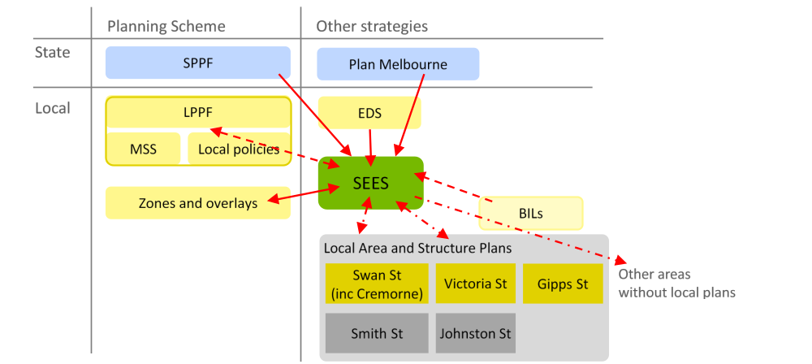

Plan Melbourne

Plan Melbourne (2014)
Plan Melbourne is the Government’s metropolitan planning strategy, which aims to guide Melbourne’s grow and change over the next 40 years. Plan Melbourne takes a more holistic view than previous metropolitan plans, ostensibly addressing a broader range of planning issues including employment, housing, transport, liveability and the environment. There is a strong focus in Plan Melbourne on the central city area which includes Yarra. The importance of planning for employment received also renewed emphasis with a stronger economic narrative and the identification of a range of State Significant employment precincts.

Several precincts within Yarra were identified in the 2014 document as ‘other urban renewal areas’ including Collingwood (Gipps Street), the North Richmond to Victoria Park corridor, East Richmond Station and Cremorne, and Alexandra Parade (these areas are shown in the pink shaded areas in Figure 15). This designation was distinct from ‘Expanded central city urban renewal areas’ (shown in purple in Figure 15). The anticipated role of the ‘other’ renewal area was not clearly articulated: the document suggested they ‘presented opportunities’, may be ‘underutilised’ and might take ‘pressure off existing neighbourhoods and allows people and jobs to be located close to public transport’. These observations could be interpreted as suggesting renewal would be residential-led or employment-led, or a combination of both.

The cluster of the St Vincent’s Hospitals (public and private) and the Australian Catholic University was identified in as a health and education precinct and the Epworth Hospital identified as a health precinct.
Figure 15. Plan Melbourne (2014) identified urban renewal areas
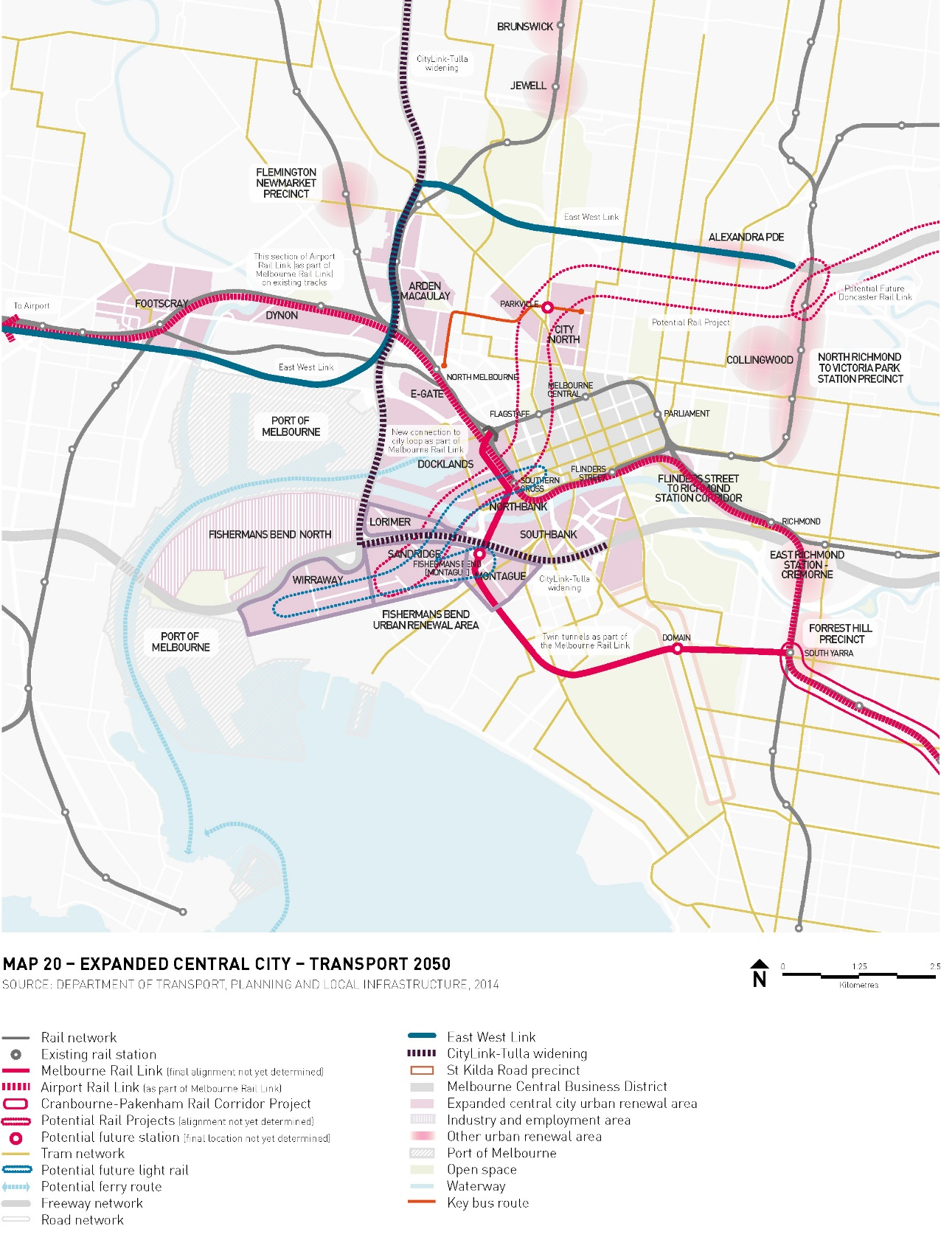
Source: Plan Melbourne (2014)

Plan Melbourne Refresh Discussion Paper (2015)
A Plan Melbourne Refresh document was published in 2015 and sought feedback on a range of issues with a view to a ‘refreshed’ version of Plan Melbourne being released later in 2016. The ‘Refresh’ discussion paper maintains support for an expanded central city concept, advocating for the preservation of commercial development opportunities and the early delivery of key transport infrastructure. It did not provide any further directions specific to the ‘other’ renewal areas.

Plan Melbourne ‘Refreshed’ (2017)
In March 2017 the ‘refreshed’ Plan Melbourne was released, accompanied with a five-year implementation plan. The pivot role of the central city as a location for employment and housing remains in this iteration of the Plan. The St Vincent’s and Australian Catholic University cluster and the Epworth Hospital retain their designations as precincts of state significance. However, the designation of ‘other renewal area’ have been removed and, as a result, this most recent iteration of the Plan doesn’t directly acknowledge many of Yarra’s employment precincts (see Figure 18).

This change may suggest the State has decided to focus its efforts on the designated major renewal precincts at Docklands, Fishermans Bend, Arden, Macauley, E-Gate, Dynon, and the Flinders Street to Richmond Station corridor. There is a suggestion that the emphasis of these renewal efforts will be on accommodating housing. Direction 1.3 (‘Create development opportunities at urban renewal precincts across Melbourne’) states that renewal precincts will ‘ease pressure on established areas’ and ‘offers the opportunity to improve local amenity, accommodate more housing and offer a greater mix of uses to support local communities’ (p.38, emphasis added).

The Action Plan document contains a series of action relevant to land use planning for Yarra’s employment area. In particular, Actions 1, 2, 6, 8 and 12, which are reproduce in below.

Action 1 (‘Land-use framework plans for each of the metropolitan regions’ – see full text below) suggests that future strategic land use decisions for existing employment precincts should be informed by these regional framework plans, when they are prepared. Yarra is located within the Inner Region that include the City of Melbourne and the City of Port Phillip. This action is listed as having a medium-term timeframe for implementation with DELWP as the lead agency and Councils, the VPA, DEDJTR, DHHS and DET as implementation partners.

Action 2 (‘Central city planning’) will focus on the renewal precincts highlighted above, however the text associated with this action indicates that other ‘special’ areas might be identified and acknowledged. Planning that ‘determines the specialised economic functions of individual precincts across the central city’ and ‘identifies opportunities to establish and expand creative industries, small businesses and tourism’ is as relevant to Yarra’s established activity centres and employment precincts, as it is to the designated renewal precincts.

Without defining ‘regionally significant industrial precincts’, Action 8 suggests an awareness of the potential for contribution of ‘redundant’ industrial land to support alternative employment uses. Yarra’s larger employment precincts are already experiencing changes that could be described as ‘renewal of older industrial areas that are no longer well suited to industrial activities for alternative employment activities such as offices, creative industries and other employment-generating activities’.

Action 12 (‘Planning for future employment growth’) is also of relevance to Yarra, suggesting DELWP will provide direction on ‘assessing the ongoing suitability of established industrial and commercial areas for different types of employment purposes’ and ‘when such areas should be retained for employment purposes and when they should be considered for rezoning to mixed-use or residential.’
Figure 16. Extracts from PLan Melbourne (2017) Action Plan

Action 1: Land-use framework plans for each of the metropolitan regions (medium)
In consultation with the Metropolitan Partnerships, the metropolitan regional planning groups will prepare a land-use framework plan for each of the six metropolitan regions. The land-use framework plans will include strategies for population growth, jobs, housing, infrastructure, major transport improvements, open space and urban forests.

The plans will identify:
- land to be set aside primarily for business and employment-generating purposes
- precincts and activity centres where a mix of higher-density residential, commercial and other activities are encouraged
- urban renewal precincts and sites where medium- and higher-density housing and mixed-use development will be encouraged
- transit-oriented development opportunities that arise from major transport infrastructure projects such as the Metro Tunnel, level crossing removals and the Regional Rail Link
- an access framework that ensures that activity centres and urban renewal, employment and tourism precincts are supported by walking, cycling, public transport and night travel options
- additional regional-scale community, health, education, recreation, sporting and cultural facilities additional regional open space networks and enhancements and greening initiatives.

Action 2: Central city planning (short term)
In consultation with the Cities of Melbourne, Port Phillip and Yarra, develop a whole-of-government approach to planning for the central city that:
establishes a program for the timing and staging of development across different urban renewal precincts within the central city to identify the particular investments required to support such growth, and the timeframe anticipated for its delivery
outlines an access framework that connects all employment precincts to the CBD and to the wider metropolitan transport system. The framework will identify new, strategic transport connections and identify transport-management strategies including walking, cycling, public transport and night-time travel options
determines the specialised economic functions of individual precincts across the central city and the infrastructure necessary to support growth
identifies opportunities to establish and expand creative industries, small businesses and tourism
identifies opportunities to improve the public realm, open space, social, cultural and recreational facilities that support the central city’s economic functions
recommends utility improvements to accommodate growth
makes recommendations about whether special governance arrangements will be necessary to coordinate matters such as investment facilitation, infrastructure delivery and development approvals.

Action 6: Health and education precincts (short to medium term)
Review planning provisions for health and education precincts to support their continued effective operation and their future growth and expansion, including in the case of health precincts, for associated allied health services.
Many health and education precincts are within NEICs, metropolitan or major activity centres, so may be included in planning for these locations.

Action 8: Significant industrial precincts (short term)
Work with local government to strengthen regionally significant industrial precincts in established urban areas for employment-generating activities by:
ensuring that sufficient land is zoned for employment purposes and that sensitive land uses such as housing are not permitted to be established in them
retaining larger industrial precincts for local manufacturing, service industries, warehousing and distribution
promoting the renewal of older industrial areas that are no longer well suited to industrial activities for alternative employment activities such as offices, creative industries and other employment-generating activities
facilitating improved information and communications technology infrastructure, access and amenity within these areas
reviewing planning, building and environmental regulations to ensure that these are not barriers to the affordable conversion of designated industrial areas for alternative employment-generating activities
identifying areas no long required for employment activities.
Figure 17. Extracts from PLan Melbourne (2017) Action Plan

Action 12: Planning for future employment growth (short term)
Assist councils to plan for future employment needs by:
addressing how metropolitan regional employment demand forecasts can be translated into floorspace requirement, land-use and zoning frameworks
providing direction for assessing the ongoing suitability of established industrial and commercial areas for different types of employment purposes
providing direction about when such areas should be retained for employment purposes and when they should be considered for rezoning to mixed-use or residential.
Figure 18. Plan Melbourne (2017) urban renewal areas
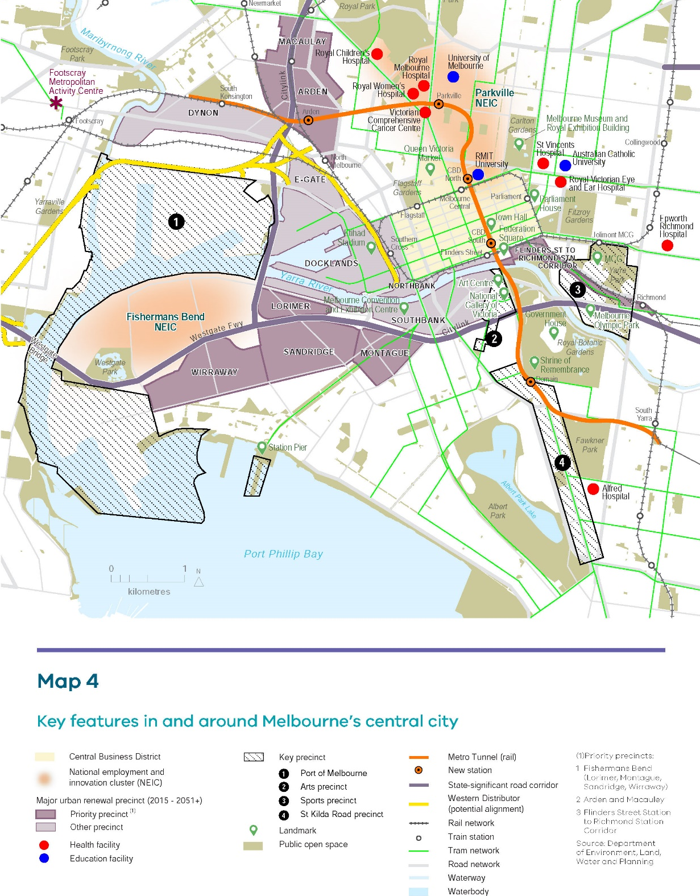
Source: Plan Melbourne (2017)

Inner Melbourne Framework Plan
It is understood that an ‘Inner Melbourne Framework Plan’ was being prepared in 2016 by the Victorian Planning Authority to provide more specific guidance on the planning and redevelopment of Melbourne’s multiple inner-city renewal areas. This plan, when complete, should reveal more about the capacity of these precincts to accommodate housing and employment, infrastructure needs, and the role for the ‘other’ inner city renewal areas as identified in earlier iterations of Plan Melbourne. Further development and refinement of this plan would align with Action 1 in the Plan Melbourne implementation plan.

Summary
The key issues (and omissions) identified in these documents of relevance to the SEES include:
- The concept of an expanded central city is a core principle in Plan Melbourne. Yarra is included in the definition of this expanded central city area.
- Yarra’s health and education precincts are nominated as precincts of State Significance in the Plan. The Action Plan includes an action to reviewed planning for health and education precincts to support their effective operation, growth and expansion.
- The most recent version of the Plan Yarra’s employment areas are no longer explicitly nominated as ‘other renewal areas.’ However, the accompanying Action Plan suggests that the government will pursue a series of short term actions that would provide more guidance for planning for employment lands, particular for areas transitioning from industrial uses to alternative uses. These actions could provide guidance for Yarra’s other employment districts.
- Despite a greater focus on employment than the previous metropolitan strategy, Plan Melbourne is largely silent on the matter of inner city employment land, and in particular, the issue of increasing pressure for residential conversion.

Yarra Planning Scheme

Local Planning Policy Framework
The Local Planning Policy Framework (LPPF) in the Yarra Planning Scheme sets out the strategic goals for employment land uses in Yarra. The land use vision for Yarra has a particular focus on activity centres and on increasing opportunities for employment and providing for the retail needs for both local residents and people across Melbourne.

Planning zones for employment
The current distribution of land use zones in Yarra is shown in Figure 19. The specific zones that contain the majority of employment activity are the Commercial 1 and Commercial 2 zones (C1Z and C2Z), the Industrial 1 and Industrial 3 zones (IN1Z and IN3Z) and to a lesser extent the Mixed Use zone (MUZ).

Mixed Use Zone (MUZ) | Commercial Zones (CZ) | Industrial Zones (INZ)
The MUZ allows residential, commercial, industrial and other uses and as such allows the widest variety of land uses of any zone. However, in recent years the MUZ in Yarra has tended to function as a quasi-residential zone with the majority of development being higher density residential. This trend is likely to continue while the demand for housing is strong and the financial returns from residential development are higher than those of alternative land uses. | The C1 zone is the most conducive zone to retail and commercial activity and planning permits are not required for shops, food and drink premises, or office uses, and there are no floor space limits for these uses. | The IN1 zone encourages manufacturing, storage and distribution, and associated uses. Its use is restricted to a few consolidated areas in the suburbs of Abbotsford and Richmond.
 | The C2 zone also seeks to promote commercial activity, particularly for offices, with some manufacturing and industrial uses where appropriate. There are limits on the floor space of retail uses in this zone. Whereas offices have no maximum floor area restrictions. Smaller supermarkets of less than 1,800 square metres are also permitted without the need to seek planning approval. | The IN3 zone is intended to support lower impact industrial and other land uses and in Yarra is used as a buffer between IN1 zoned land and residential of commercial areas, or for those industrial areas that are wholly enclosed by more sensitive land uses.

In addition to these standard zones the Comprehensive Development Zones (CDZ) and Priority Development Zones (PDZ) apply to specific precincts. The CDZ applies to land at the eastern end of Victoria Street and Victoria Gardens. This CDZ seeks to encourage the redevelopment with a mix of uses that will complement and enhance the Yarra River environment. The second CDZ applies to the ‘Maltings’ site bounded by Gough, Balmain, Dover and Bent Streets in Cremorne. Its purpose is to ensure that land is planned and developed as a whole in a form that is responsive to area character and amenity, site characteristics and opportunities. The PDZ1 is applied to an area bounded by Walmer Street, Victoria Street, Flockhart Street, land immediately north of Shamrock Street, and the Yarra River. The area is planned as a mixed use precinct as part of the Victoria Street Major Activity Centre.

The main issues with respect to the zoning of employment land in Yarra are as follows:

- Achieve employment growth in activity centres to accommodate retail and other functions in response to local demand and demand that originates outside of Yarra
- Supporting employment growth on other employment lands and managing pressure to rezone for residential
- Determining whether there is any need to rezone employment land to allow other land uses
- Ensuring there are no planning barrier to meeting the floor space needs of the health and education institutions
- Planning for the activity centres to guide development outcomes.
Figure 19. Yarra’s current planning scheme zones
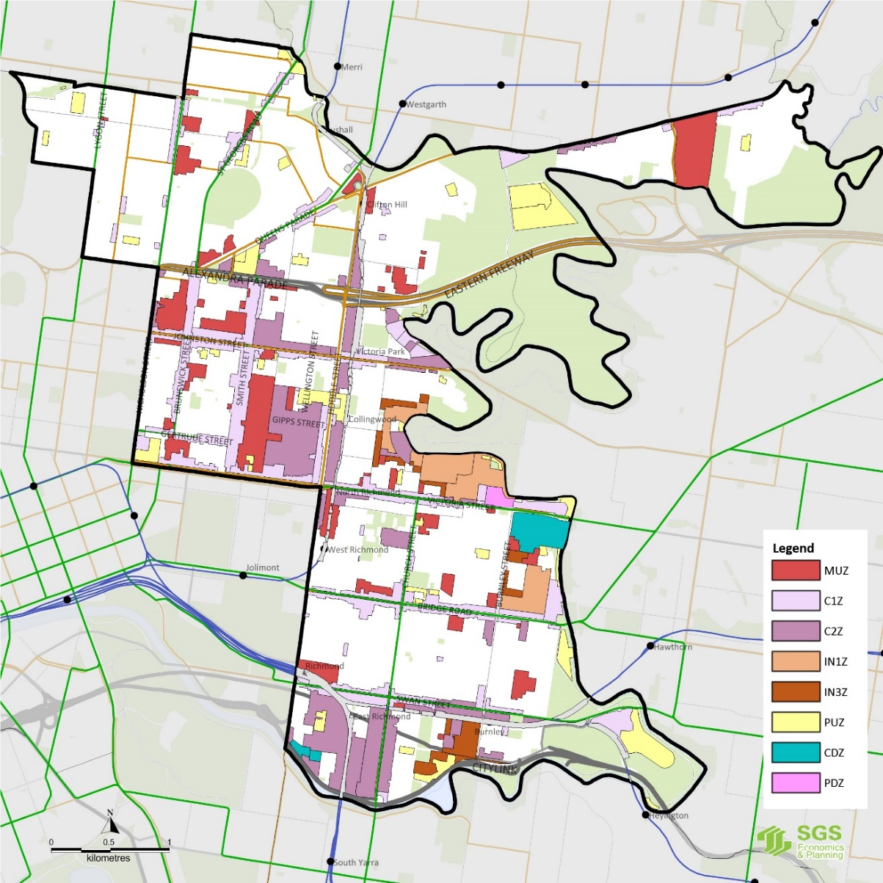
Source: City of Yarra (2015)

Structure Plans and Local Area Plans
A series of Structure Plans and Local Areas Plans have been prepared to guide and manage growth within Yarra’s key activity centres and employment precincts. Such plans are developed to manage the future of an area and provide direction on preferred land use and built form, pedestrian access and movement in the area, and identifying zones and other planning controls required.

The use of structure plans and local area plans in Yarra has proven challenging. The time taken to prepare and adopt structure plans has been lengthy, while their adoption and implementation has been difficult in some instances due to questions about the lack of strategic justification or supporting evidence.

There are currently five structure and local area plans in Yarra with varying status levels:
- The Smith Street Structure Plan was adopted by Council 2008 but the subsequent Design and Development Overlay was abandoned June 2012
- The Swan Street Structure Plan was adopted by Council in December 2013 and is being implemented through a Planning Scheme Amendment
- The Victoria Street Structure Plan was adopted by Council in 2010
- The Johnston Street Local Area Plan was adopted in December 2015 and will be implemented through a Planning Scheme Amendment, and
- The Gipps Street Local Area Plan was adopted by Council in April 2011.

Other studies and strategic developments

Yarra Economic Development Strategy 2015-2020 (2013)
The Yarra Economic Development Strategy (EDS) highlights three significant industries that will be the focus of economic development over the next five years being health, professional services, and retail, accommodation and food services. Supporting and facilitating the existing knowledge economy is a key strategy within the EDS with a particular focus on four identified specialised economic clusters (see Figure 20):
- The Fitzroy health/education cluster: includes St Vincent’s Hospital and ACU
- The Richmond health/education cluster: a state significant precinct which includes Epworth Hospital
- The Collingwood creative cluster: concentration for creative businesses, and
- The Cremorne creative cluster: major creative services cluster, particularly design.
Figure 20. specialised economic clusters
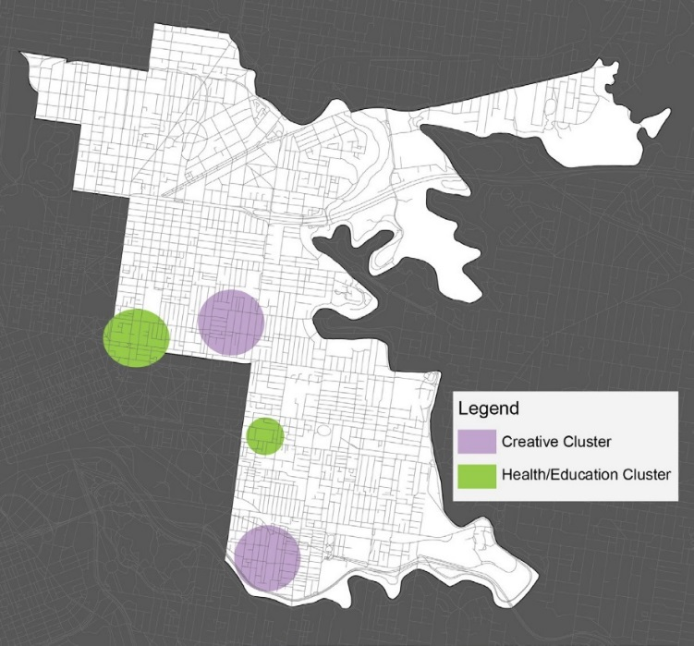
Source: City of Yarra, 2014

The strategic framework for the EDS contains three parts which are outlined in Table 1 below.
Table 1. Yarra EDS strategic framework
Strategic goal | Vision | Directions
Smart city | Yarra will be recognised for its highly skilled, innovative, artistic and competitive business environment. It will support and attract a range of businesses, entrepreneurs involved in knowledge-intensive industries, and the creative sector. | - Cluster development  - Partnerships and collaboration  - Industry development and support  - Organisational delivery
Vibrant and thriving precincts | The City of Yarra will continue to strengthen its precincts as vibrant hubs for retail, entertainment, arts, cultural and business activity to service the local population and develop as destinations of national and international recognition. | - Infrastructure and maintenance  - Positioning and activation  - Destination development
Locally engaged business community | The City of Yarra will continue to facilitate business growth and prosperity, intrinsically linked to the well-being of the local community. | - Local employment opportunities  - Local supply chains  - Sustainable business practices
Source: Adapted from City of Yarra, 2014

Of the priorities identified within the EDS, the following five are of particular relevance to this Strategy:
- Strengthening the role of Collingwood and Cremorne creative clusters
- Supporting expansion plans for St Vincent’s, Epworth Richmond and ACU
- Ensuring that the spatial strategies contain adequate consideration of clusters
- Engaging with the Abbotsford Convent in relation to future development plans and potential to accommodate creative industries
- Activating precincts and provide business mix, and
- Understanding and supporting local supply chains.

Business and Industrial Land Strategy (2011)
The 2011 Yarra Business and Industrial Land Strategy (BILS) provide analysis and direction the land zoned Business and Industrial in Yarra. The vision set out is BILS is as follows:

Business and industrial areas in the City of Yarra play a vital role in sustaining the local and inner Melbourne economy and local communities. They will continue to change, with significant growth in the business sector and a decline in industry activity and employment. This Strategy will provide sufficient land to sustain growth in economic activity. In doing this, it will contribute to the economic strength of the region, and enhance its vibrancy and diversity.

BILS suggested that Yarra contains a significant stock of business and industrial land in the inner metropolitan context. Given a likely continuation of the decline in industrial activity and employment in the municipality, BILS recommended facilitating greater diversity of employment activity in both business and industrial areas. With employment in Professional, Scientific and Technical Services expected to grow, significantly more office-based employment was recommended.

The strategy recommended investigating land use change options for sites which interface with the regionally significant Yarra River corridor to maximise employment and improve amenity in this precinct. It also recommended the development of masterplans or local area plans for precincts where major change is likely, and where amenity, urban design and access considerations are needed.

The recommendations of BILS have been used by Council to guide Council’s planning efforts for employment precincts.

Review of the Yarra Planning Scheme (2014)
A review of the Yarra Planning Scheme was undertaken in 2014. The review suggested the current Yarra Planning Scheme lacked an overarching, evidence-based narrative for projected housing and employment growth in the municipality which might be used to assess the merits of individual planning proposals. As growth of both housing and employment continues, it is expected that there will be a competition for land and other assets in Yarra. The review noted that it is important to carefully manage and protect certain assets, and facilitate growth in locations that will provide benefit for current generations, but also be sustainable into the future.

The review identified a lack of local spatial plans, including plans for activity and neighbourhood centres, economic clusters, urban renewal locations and other commercial areas. It further suggests that the roles and strengths of activity centres in particular need to be defined, and strategies to meet the projected demand for retail and activity centre facilities need to identified.

The review notes that with the 2013 changes to the VPP zones by the State Government there is now greater flexibility in the location of commercial and retail activity in employment zones. In particular, there is greater opportunity for new retail nodes to develop in C2 zoned areas such as Hoddle Street, and this possibility should be considered in future policy development.

Redevelopment of the Alphington Paper Mill (Amcor site)
The 16.5ha former Amcor paper-mill site in Alphington was identified as a Strategic Redevelopment Site within the Municipal Strategic Statement. It was also identified as a priority Urban Renewal Area within the Central Sub-region of Plan Melbourne (2014). It is one of the largest urban infill sites in Melbourne.

In December 2015 Council approved a revised Development Plan for the Alphington Paper Mill. The approval allows for 2500 dwellings, and 11,500 commercial floor space and 13,500 retail floor space. It also secures 4.5% open space, 1700 square metres of community facilities and 5 percent affordable housing.

Night Time Economy Strategy 2014-18
Adopted by Council in June 2014, this strategy is intended to further improve the safety, vibrancy and functionality of night time activities in Yarra. The strategy was developed in response to media and community speculation about the impacts of alcohol use at night on residents, despite very little evidence of negative impacts. The strategy contains three objectives:

A safe night time economy: at night public spaces are well-kept and people behave respectfully
A vibrant night time economy: at night there are a range of people and ages, and a diversity of facilities and activities, not centred on alcohol, and
A functional night time economy: at night entertainment precincts accommodate people at peak times, attract people to walk, cycle or use public transport and have adequate public amenities (e.g. toilets) and infrastructure.

The strategy also includes a cost benefit analysis that suggested the benefit-cost ratio of the night time economy was 2:1.

Summary of existing policy and planning gaps
Yarra continues to be a strategically important location for employment. It hosts significant existing employment clusters, key assets of state significance, and sites with renewal potential have been identified in the earlier iterations of Plan Melbourne and current local planning policies.

While there are general statements in support of economic activity in Yarra, neither state nor local policy frameworks provide specific direction for the future employment role. The Swan Street Structure Plan includes a range of objectives and strategies related to employment uses in the various precincts within that plan.

Previous studies and the analysis presented in the preceding chapter suggest that industrial employment is likely to continue to decline, while employment in professional services, health and education, and retail and hospitality are all expected to grow. Rezoning of employment land to accommodate these changes may need to occur. However, recent changes to the VPP employment zones have already provided greater flexibility for the location of employment uses. Relatively recent changes to zoning in the Gipps Street precinct (from industrial to business/commercial) have taken some time for on-the-ground changes can be observed, but gradually new development is occurring and new businesses are locating to this area.

It is evident that a clear and robust evidence base is required to support the development and implementation of land use planning policy in Yarra. In an effort to address this gap, the next chapter provides analysis of capacity for employment floor space in Yarra and compares this to forecast floor space demand.

Yarra’s Precincts
This chapter considers the spatial distribution of Yarra’s employment and economic activity. It assesses the distribution of employment, the functionality of the various employment precincts and their future development potential. Demand for employment floor space is then aligned with capacity on a precinct-by-precinct basis drawing on a high-level analysis of the likely potential capacity for growth. By reconciling demand and potential supply this section ‘tests’ the extent to which Yarra can accommodate employment growth within its employment precincts. Detailed analysis of the capacity of individual precincts was not undertaken and as a result the findings of the high-level analysis presented below may not be entirely consistent with precinct-specific investigations.

The distribution of employment activity
The City of Yarra contains a range of precincts that host retail, commercial, industrial and institutional employment. An overview of the mix of employment by Travel Zone is presented in the map below (Figure 21). The pie charts illustrate the amount and breakdown of employment by broad industry sector in each Travel Zone (see Figure 11).

It is evident from this map that a significant proportion of Yarra’s employment is located in precincts to the south of Alexandra Parade. Commercial employment is focused around Gipps Street, Cambridge Street, Easey Street (near Smith Street), and the Kerr Street precinct (between Smith and Brunswick Streets). Retail employment is spread more evenly throughout Yarra, although there are concentrations at the northern end of Brunswick Street and the southern and central parts of Smith Street. Concentrations of institutional employment – the green portion of the pies – are noticeable in the south of the suburbs of Fitzroy and Collingwood, and the North of Richmond, with large numbers of workers in the health sector worker in these localities.

The Travel Zones that comprise Cremorne and the southern end of Church Street show a balance of commercial, retail and industrial floor space types. The Travel Zone at the eastern end of Victoria Street and Bridge Road also features a mix of employment floor space types. The northern part of this Travel Zone hosts significant retail floor space while the southern portion feature industrial uses and restricted retail.

Abbotsford also contains significant employment clusters including one of the largest concentrations of industrial employment in the municipality. Abbotsford also hosts significant commercial employment particularly around Johnston Street and Trennery Crescent.

Development of the Amcor site in Alphington could bring about changes the network of activity centres potentially changing the role of the retail and commercial strips on Heidelberg Road.

Based on the data presented in Figure 21 and separate analysis of Australian Business Register (ABR) data, there is also evidence of the growing importance of home-based businesses across Yarra. The ABR records over 30,000 businesses with a registered address in a residential area, while there are only 8,000 businesses registered in employment zones (i.e. MUZ, C1Z, C2Z, IN1Z and IN3Z). There is very little data and research available to isolate the activity, however, it was also raised as an important issue in consultation. While little can definitively be stated about this ‘sector’ of Yarra’s economy, it has implications for how and where people work in the municipality.

Figure 21. broad mix of EMployment by Travel Zone (2011)
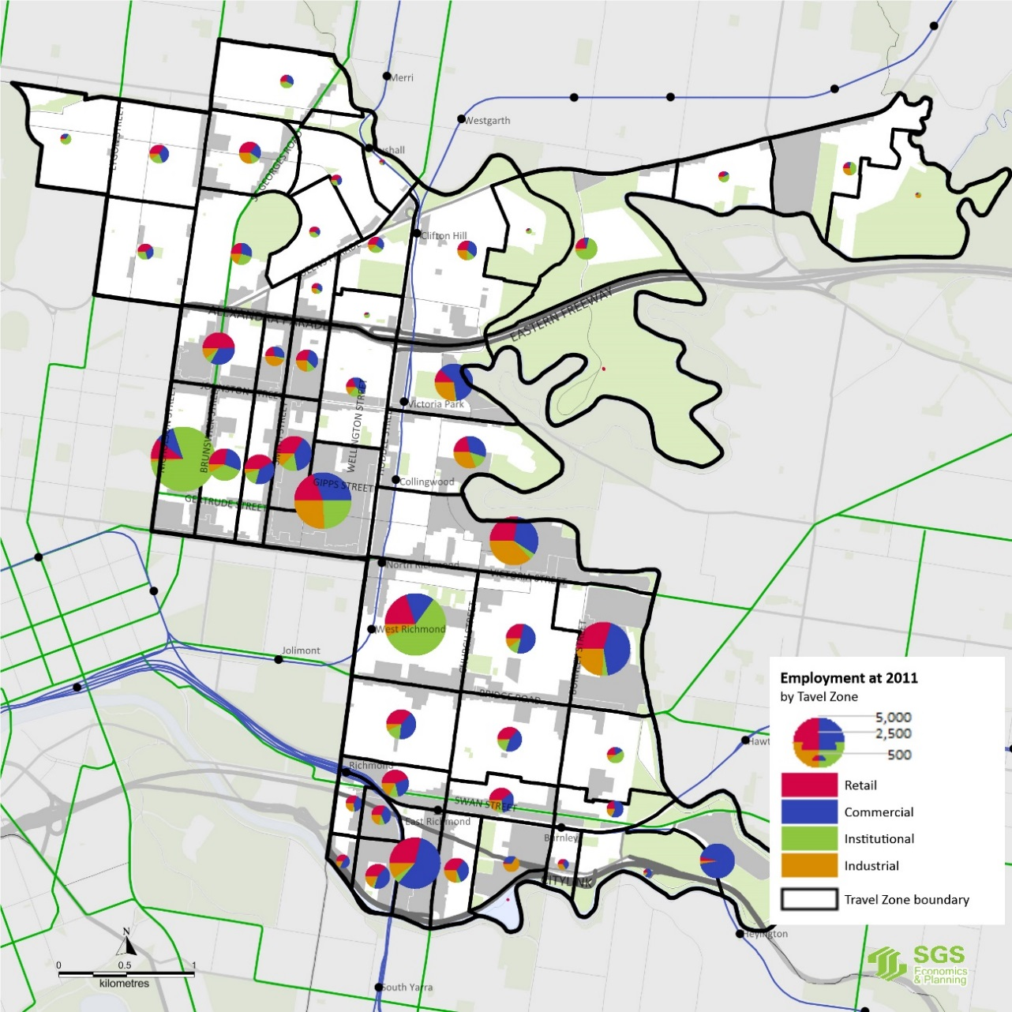
Source: SGS derived from ABS Census and other public datasets.

Defining and understanding the diverse precincts of Yarra
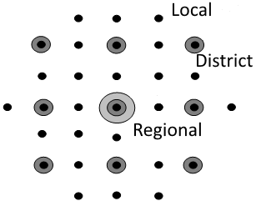
Understanding the spatial dynamics of Yarra’s employment and economic activity is important to planning for the future. The conventional approach to categorising activity centres and employment precincts is to define a hierarchy of distinct local, district and regional centres and precincts. Local centres cater for more frequent ‘low spend’ visits whereas less frequent high spend visits are made to higher order centres offering a wider range of goods and services. Typically, industrial uses and larger commercial buildings are located in separate precincts. The spatial arrangement of employment land across Yarra does not align with this conventional model. Rather, Yarra hosts a diversity of employment and economic activities in overlapping yet functional precincts. Employment areas are not clearly always defined but overlap with neighbouring precincts, contributingto a complex mix of commercial, industrial, institutional and retail uses, as well as areas set aside for housing and recreation.

Defining employment precincts for capacity analysis
For the purposes of assessing employment capacity and providing planning directions, a set of employment precincts were developed based on the existing land use zones and the functional characteristics of Yarra’s activity centres and employment precincts (See Figure 22).
Figure 22. yarra’s employment precincts
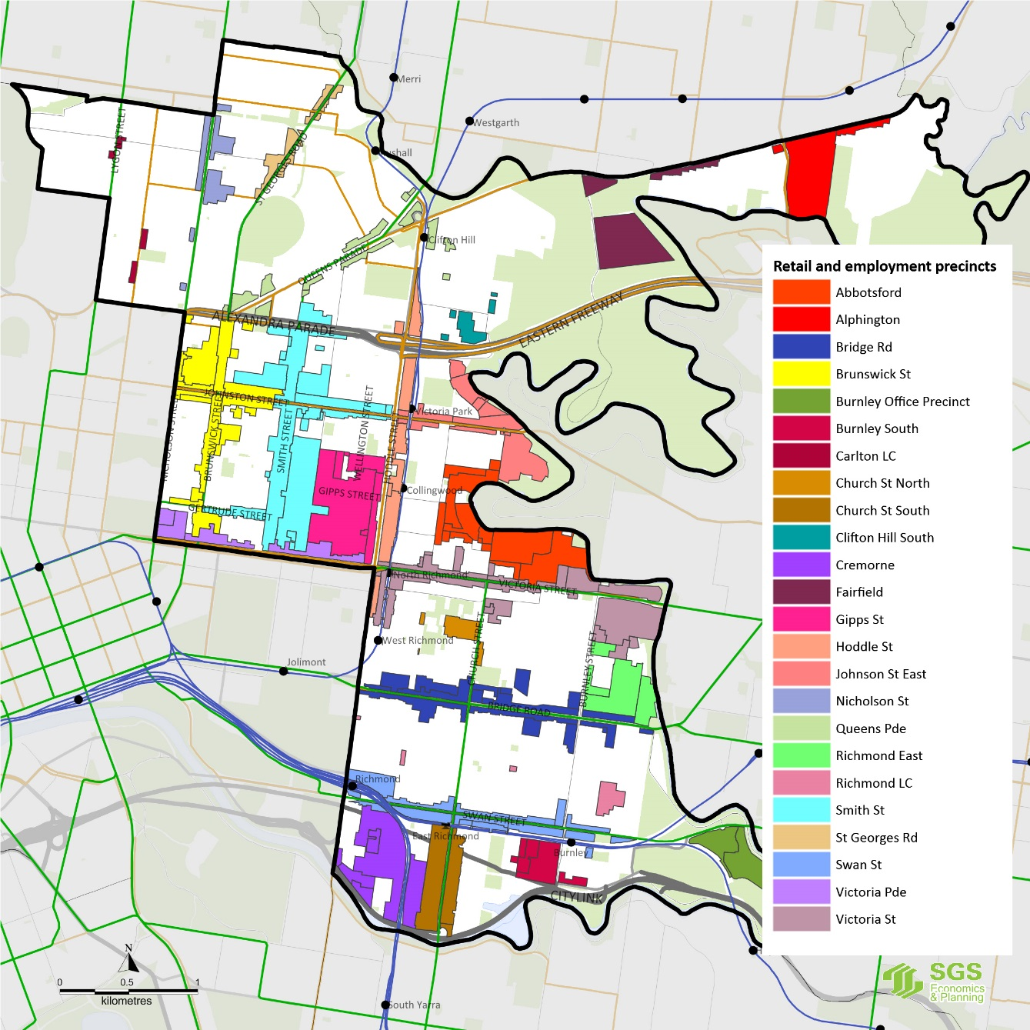
Source: SGS Economics and Planning

Employment precinct typology: retail precincts and other employment precincts
In the analysis that follows, a distinction has been made between ‘retail precincts’ – commonly referred to in planning policy as activity centres – and other ‘employment precincts’. Retail precincts are those established (or emerging) activity centres that are based around a main street supporting a combination of retail, commercial, residential and mixed use development. Employment precincts are typically more dispersed areas that support commercial and industrial employment with retail playing a relatively minor role.

A distinction has also been made between larger and smaller precincts; larger precincts are those that have more than 120,000 square metres of employment and retail floor space.

Figure 23 shows the broad floor space uses within each precinct, while Figure 24 plots each precinct by its total employment floor space and the ratio of retail employment floor space to total employment floor space.

Hoddle Street and Church Street South host slightly less than 30% retail floor space and consequently have been classified as ‘other employment precincts’ rather than aActivity centres. As both precincts contain significant quantities of restricted retail their classification and other employment precincts is appropriate. Conversely, while the Smith Street precinct contains significant professional and creative services, its strong retail role and main street configuration justify its designation as a retail centre.

Yarra’s activity centres are mostly long and narrow retail strips based along the main road and tram routes. In the case of Brunswick, Gertrude, Smith and Brunswick Streets these strips connect forming a network of retail strips. Victoria Gardens contrasts with these strip centres adopting a large footprint shopping centre format.

A complete classification of Yarra’s employment precincts by these metrics is provided in Figure 23 below.
Figure 23. Floor space by Use and precinct (SQM)
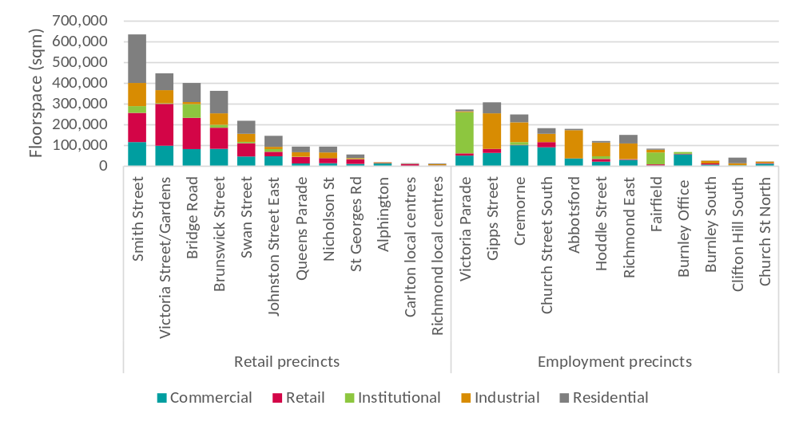
Source: SGS Economics and Planning based on Council Rates and Retail Centre Audit
Figure 24. employment Precincts by size and retail share of floor space
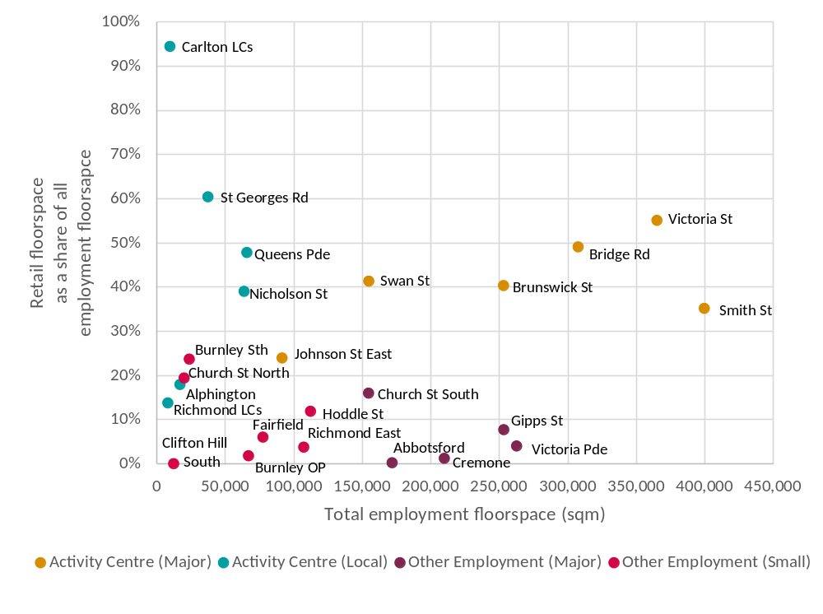
Source: SGS, 2015, based on Council Rates and Retail Centre Audit.
Table 2. yarra’s ACTIVITY CENTRES AND EMPLOYMENT PRECINCTS
 | Precinct name | Precinct type | Designation* | Notes
 | Bridge Road | Retail | Activity Centre (PM)
 | Brunswick Street | Retail | Activity Centre (PM) | Incl. Johnston west of Smith St
 | Johnston Street East | Retail | Activity Centre | Emerging Activity Centre
 | Smith Street | Retail | Activity Centre (PM) | Includes Gertrude Street
 | Swan Street | Retail | Activity Centre (PM)
 | Victoria Street | Retail | Activity Centre (PM) | Includes Victoria Gardens
 | Queens Parade | Retail | Local Activity Centre | Clifton Hill and North Fitzroy
 | Nicholson Street | Retail | Local Activity Centre | Carlton North/North Fitzroy
 | St Georges Road | Retail | Local Activity Centre | North Fitzroy
 | Alphington | Retail | Local Activity Centre | Will incl. AMCOR retail/comm.
 | Carlton | Retail | Local Activity Centre | Rathdowne Village and Lygon St.
 | Richmond | Retail | Local Activity Centre | Three small centres in Richmond
 | Abbotsford | Employment | Major | Predominantly industrial
 | Church St South | Employment | Major | Mixed employment
 | Cremorne | Employment | Major | Mixed employment
 | Gipps Street | Employment | Major | Mixed employment
 | Victoria Parade | Employment | Major (HEP) | Predominantly institutional
 | Fairfield | Employment | Minor | Predominantly institutional
 | Burnley Office | Employment | Minor | Predominantly commercial
 | Burnley South | Employment | Minor | Mixed employment
 | Church Street North | Employment | Minor | Mixed employment
 | Richmond East | Employment | Minor | Predominantly industrial
 | Clifton Hill South | Employment | Minor | Predominantly industrial
 | Hoddle Street | Employment | Minor | Predominantly industrial
Source: SGS, 2015. * Plan Melbourne designations: PM = Activity Centre; HEP = Health/Education precinct;

Assessing employment floor space capacity
There are no ‘greenfield’ opportunities in Yarra and relatively few major renewal sites available for development in the near term. In the past, however, through a constant process of incremental renewal and reinvention of spaces, employment has been able to evolve and grow significantly across the municipality in response to changes in the wider economy. Assessing the ability of Yarra employment precincts to accommodate growth is critical to robust strategic spatial planning for employment. The following section seeks to provide a high-level, order of magnitude assessment for understanding of the potential employment floor space capacity across Yarra’s retail and employment precincts.

The current employment floor space across all Yarra’s employment precincts has been estimated at around 3.59 million square metres. Using a series of broad assumptions (Table 3) about the likely scale and intensity of employment development in the various precincts, the total employment floor space capacity of the existing employment zones within Yarra is estimated at 4.9 million square metres. The difference between these figures – around 1.31 million square metres – provides an indication of the net additional capacity for employment floor space in Yarra.

It should be noted that the capacity estimates presented here assume all sites are redeveloped to the limits described in Table 3. In reality, not all sites can be redeveloped within the timeframe of this Strategy. Moreover, those sites that are developed might achieve higher or lower densities than the averages assumed. The exercise of estimate floor space capacity should therefore be treated as indicative only; the development potential of each individual site, and the likelihood of the site developing within a discrete timeframe, cannot be known definitively.

If the theoretical capacity in a precinct exceeds demand this does not suggest there is excess capacity. For land markets to work efficiently it is preferable to have some latent or reserve capacity to prevent a situation where land owners have a quasi-monopoly on a limited supply of potential development opportunities relative to projected demand.

The quantum of existing employment floor space and estimated capacity for additional floor space, by employment precinct, are shown in Figure 25. The capacity for additional employment floor space is the difference between the existing floor space and the floor space capacity, represented by the white area at the top of each bar.
Figure 25. employment floor space estimates: existing vs Capacity
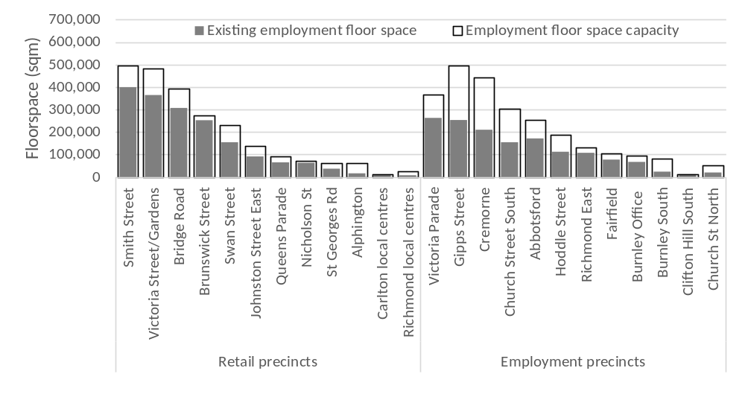Source: SGS Economics & Planning.

Table 3. employment floor space capacity assessment assumptions
Zone | Location | Site cover | Floors of employment floor space | Notes
C1Z | All | 70% | 2
C2Z | Gipps and Cremorne precincts | 70% | 3 | A higher density of development has been assumed in these key employment precincts
C2Z | All other C2Z land | 70% | 2
MUZ | All | 70% | Min. 0.5;  Max. 1.0 | Assumes some mixed uses zoned areas will lose employment floor space; but will hosts not less than half of one storey.
IN1 | All | 70% | 1.2 | Current average is 1.0. Assumes some opportunity for intensification.
IN3 | All | 70% | 1.2 | Current average is 0.9. Assumes some opportunity for intensification.
PUZ2 | Public Housing, (Collingwood); University of Melbourne (Burley) | No capacity | No capacity | Assumed no capacity.
PUZ2 | Kanga TAFE | 70% | 2.0
PUZ2 | Carpark, Gym and Police Station (Bridge Road); Fitzroy Public School; Neighbourhood Justice Centre;  Melbourne Polytechnic (Collingwood Campus);  Collingwood English Language School. | No capacity | No capacity | Assumed no capacity across this range of facilities. Melbourne Polytechnic already quite dense.
PUZ3 | St Vincents Hospital | 70% | 9 | Currently supports average of 6.3 employment floors.
PUZ3 | Aged Care Facility; Riverside House Nursing Home; Thomas Embling Hospital | No capacity | No capacity | Assumed no capacity across this range of facilities.
PUZ4 | Queens Pde (com uses on Transport Zone) | 70% | 0.5
PUZ6 | Yarra City Council (Bridge Road); Collingwood Town Hall; Richmond Rec Centre; Fitzroy Swimming Pool | No capacity | No capacity | Assumed no capacity across this range of facilities.
PUZ7 | Fire Station (Church Street) | No capacity | No capacity | Assumed no capacity.
PDZ1 | Green Square Development | 70% | 0.5 | Lower employment capacity as mostly residential development
CDZ1 | Ikea and Bus. Park | 70% | 3.3 | Currently supports average of 53% and 3.3 employment floors.
CDZ3 | Nylex Site | 70% | 1.0 | Assumed one level of employment.
SUZ5 | Epworth Hospital | 70% | 7.0 | Currently supports average of 4.8 employment floors
SUZ4 | Abbotsford Convent | No capacity | No capacity | Assumed no capacity.
Source: SGS Economics & Planning.

The data presented in Figure 25 suggests that of the retail precincts, Smith Street, Victoria Street, Bridge Road and Swan Street have the most potential for growth. Brunswick Street appears to have limited capacity, which suggests there might be constraints to realising additional floor space. The Fairfield precinct on the other hand has significant capacity which will be realised through the redevelopment of the former AMCOR Papermill site.

Several of the employment precincts have significant capacity for additional floor space, assuming they transition from industrial or other lower-density employment uses to higher-density employment uses. The Cremorne/Church Street South and Gipps Street precincts have been identified as having significant floor space capacity if existing lower scale development is replaced by multi-storey development. Other employment precincts identified as having capacity for additional employment floor space include Victoria Parade, Hoddle Street and Burnley South.

Alignment of employment floor space demand with capacity
Having established the notional capacity for additional employment floor space, the next step is to compare this capacity with forecast employment growth and the associated demand for floor space . Aligning employment demand and employment floor space capacity provides an understanding of the opportunities and constraints for employment growth. This analysis considers both the overall Yarra-wide demand and capacity (the ‘overall alignment’) and the capacity of selected precincts (a ‘precinct alignment’). This analysis will inform the understanding of the potential role for each precinct to accommodate future employment.

Overall alignment
The following chart compares aggregate floor space capacity for employment uses to floor space demand by sector. Current floor space represents 73% of potential capacity. By 2031, it is estimated that this proportion will have grown to 80% with just under 3.9 million square metres of employment floor space. Moderate projected growth in aggregate demand for employment floor space obscures significant changes in the make-up of demand, with demand for commercial, retail and institutional floor space growing at the expense of industrial.
This high-level capacity analysis suggests that Yarra will not require additional land zoned for employment to accommodate the projected growth to 2031. However changes in the mix of employment floor spaces will be required to accommodate shifts in demand.
Figure 26. floor space capacity and demand to 2031 for all precincts
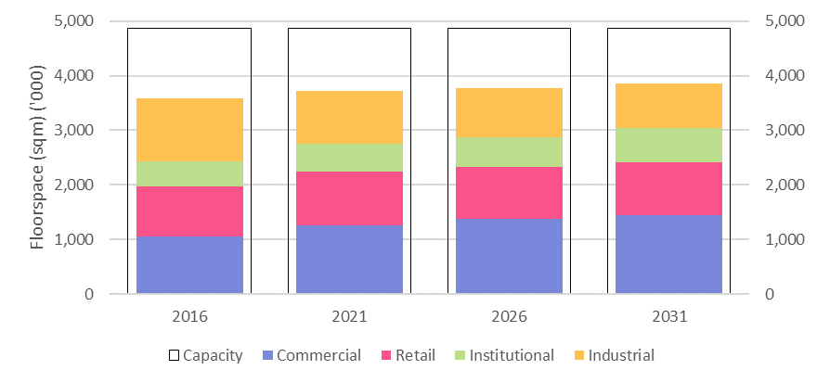

Source: SGS Economics and Planning
Table 4. Floor space demand and job/floor space ratios: 2016 to 2031
 | 2016 |  | 2021 |  | 2026 |  | 2031 |  | Change 2016-31
 | Floor  space  (sqm) | Sqm  per  job | Floor space  (sqm) | Sqm  per  job | Floor  space  (sqm) | Sqm  per  job | Floor space  (sqm) | Sqm  per  job | Floor space  (sqm) | Sqm  per  job
Commercial | 1,060,000 | 30 | 1,255,000 | 28 | 1,372,000 | 26 | 1,449,000 | 24 | 389,000 | -6
Retail | 913,000 | 36 | 983,000 | 34 | 962,000 | 31 | 969,000 | 29 | 56,000 | -7
Institutional | 456,000 | 19 | 510,000 | 18 | 545,000 | 16 | 620,000 | 15 | 164,000 | -4
Industrial | 1,156,000 | 80 | 977,000 | 75 | 898,000 | 69 | 822,000 | 64 | -334,000 | -16
Total | 3,586,000 |  | 3,725,000 |  | 3,777,000 |  | 3,860,000 |  | 275,000

Precinct alignment
From these broader municipal-scale projections, employment and floor space demand was allocated to Yarra’s larger employment precincts to better understand the potential constraints or opportunities within specific locations. This precinct specific alignment was limited to those larger employment precincts where the majority of employment growth and change will be accommodated.

Smith Street and Brunswick Street Activity Centres
Smith Street and Brunswick Street (and the intervening sections of Gertrude and Johnston Streets) form a networked retail core in the suburbs of Fitzroy and Collingwood. Smaller employment areas behind these strip centres also provide a mix of retail, commercial and residential uses.

Retail activity on Brunswick Street is concentrated between Gertrude Street to Alexandra Parade with a focus around the intersection with Johnston Street, where the only full line supermarket is located (Coles on Johnston Street). In addition to its extensive hospitality offer the strip also hosts a significant amount of retail floor space dedicated to personal goods. The precinct has very limited opportunity to increase floor space beyond what is already available. Lower order uses will need to transition out to allow for growth in retail or higher order commercial services.

Smith Street has rapidly gentrified in recent years. Its food and drink offer is currently considered some of the most attractive in metropolitan Melbourne. It also contains the largest supermarket in this area, with a second full line supermarket recently opening, creating two foci of local activity. The north end of the street hosts a significant concentration of household goods and outlet stores. The precinct still has some capacity to develop, however these opportunities will increasingly need to take the form of multi-storey developments to realise this potential. Predominantly residential developments could potentially reduce the employment floor space capacity depending on the mix of employment and residential floor space in new mixed-use developments.
Figure 27. Brunswick Street - floor space capacity and demand to 2031
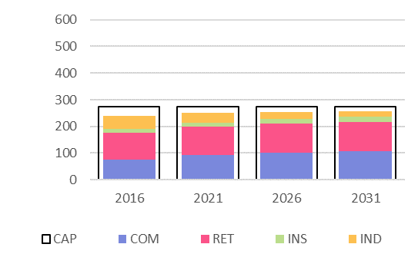

Figure 28. smith Street - floor space capacity and demand to 2031
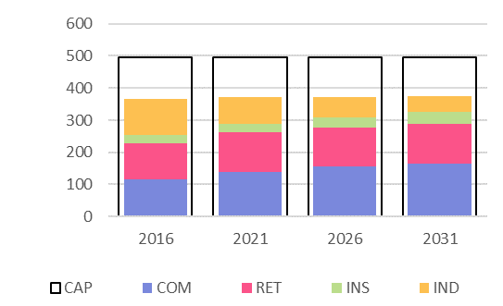

Victoria Street Activity Centre
A large proportion of floor space in this precinct is accounted for by the Victoria Gardens and the Hive shopping centres which contain 52,000 sqm and 8,000 sqm of floor space respectively. Victoria Gardens is more like a traditional suburban shopping centre with a large car park and minimal activation at the Victoria St ground level. Conversely, the Hive engages more at the street level and provides a focus for local retail activity on this part of Victoria Street. The remainder of the precinct hosts a mix of cultural activities, with a concentration of Vietnamese businesses focused on hospitality. There is significant potential capacity for the precinct to further develop and provide additional employment opportunities.
Figure 29. victoria Street - floor space capacity and demand to 2031
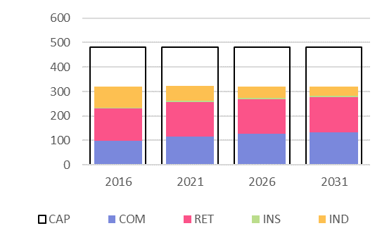

Bridge Road Activity Centre
Bridge Road contains the Epworth Hospital, and the Melbourne Clinic is also nearby on Church Street. Recently, the south side of the strip, between Church and Burnley Streets, has begun to develop a vibrant hospitality offer. There is also a full line supermarket (4,570 sqm) on the corner of Church Street and Bridge Road which provides a focus for local grocery retail. Residential development is also occurring in this area. The eastern end has developed largely as a restricted retail shopping strip with a mix of discount furniture, homewares and some clothing.

Epworth Hospital is within the activity centre and is identified as a health precinct in Plan Melbourne. The hospital is relatively constrained and it is unclear how future growth of the hospital can be accommodated. An option would be to identify opportunities to provide capacity at the western end of Bridge Road as part of broader work to define the health precinct. Expansion of health-related activities on Bridge Road would also generated demand for associated commercial services, supporting local retail by providing additional local demand. The capacity analysis suggests that there may be some difficulty accommodating rapid growth in this precinct, with strong forecast demand for institutional floorspace in particular.
Figure 30. bridge road - floor space capacity and demand to 2031
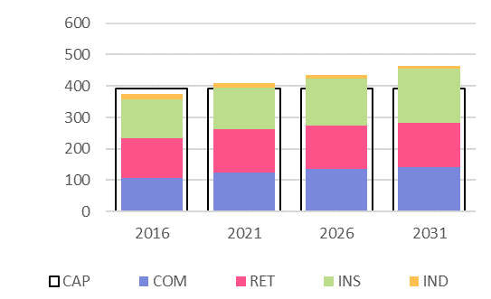

Swan Street Activity Centre
The western end of Swan Street contains a vibrant mix of retail activities including hospitality, entertainment, a new full line supermarket (4,030 sqm) and other forms of retailing. Redevelopment of the former Dimmeys site, which includes the relocation and expansion of a full line supermarket, has helped to revitalise the provision of local convenience retail. The eastern end of the strip is partly zoned C2Z and supports restricted retail and commercial functions. Compared to the major retail strips Swan Street has significantly less employment floor space capacity. Based on the analysis it still has some latent capacity with the current zoned land. The Swan Street Structure Plan proposes zone changes and intensification of development around the Burnley Station, potentially providing additional capacity.
Figure 31. swan Street - floor space capacity and demand to 2031
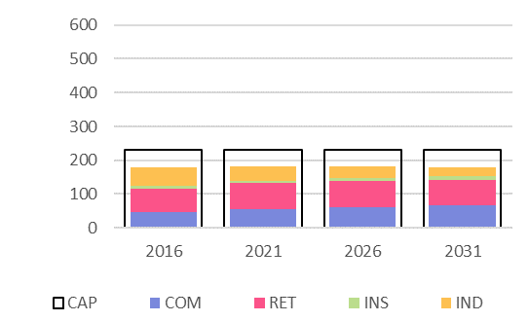

Johnston Street East Emerging Activity Centre
Council has recently prepared and adopted the Johnston Street Local Area Plan (JLAP) for the section of the Johnston Street east of Smith Street, and adjoining areas to the north and south of Johnston Street. The plan sets out a land use framework that includes eight precincts. Two community based arts and education precincts are identified: The Abbotsford Convent and the Collingwood Arts Precinct. Rezoning of C2 zoned land is most precincts is recommended to encourage investment and to permit residential development on upper floors. Land adjacent to Hoddle Street and the rail line is identified as an opportunity for substantial change, whereas moderate or minimal change is suggested for the other precincts. The C2 zoning is to be retained in the Easey Street precinct to support the retention and intensification of the existing employment uses.

The figure below suggests that the Johnston Street East Precinct is already somewhat constrained, with increasing demand for commercial floor space in particular. The Gipps Street precinct may absorb forecast demand that cannot be accommodated in the Johnston East precinct.
Figure 32. Johnston Street EAST - floor space capacity and demand to 2031
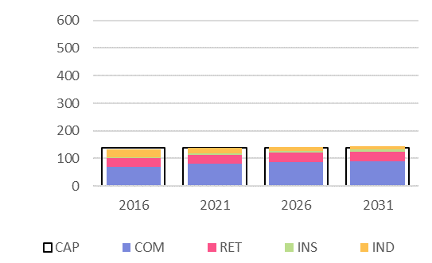

Victoria Parade Activity Centre
The north side of Victoria Parade falls within the City of Yarra. The road is a major traffic route into the city but also has some important institutional assets. These include the St Vincent’s Hospital, the Australian Catholic University, and a number of associated research and health services. This precinct has seen some of the strongest employment growth in Yarra, linked to the health sector in particular. The Australian Catholic University has plans in place to expand its campus by 20,000 square metres.

This health precinct will likely capture a significant proportion of health sector employment. The capacity analysis suggests projected demand for additional floor space to 2031 exceeds the estimated floor space capacity. The amount of institutional floor space alone is projected to grow by 78,000 sqm where the capacity for additional floor space is in the order of 104,000 sqm. The precinct will also generate demand for other employment floor space. This limited floor space capacity relative to projected demand suggests the precinct could come under development pressure in the medium term. The potential for growth in adjoining areas in the City of Melbourne could meet some of this demand.
Figure 33. victoria parade - floor space capacity and demand to 2031
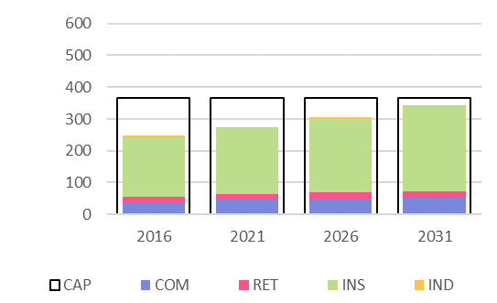

Gipps Street Major Employment precinct
Located between Smith, Johnston, Hoddle Streets, and Victoria Parade, the Gipps Street precinct is an evolving former industrial precinct. The data and site visits highlight that employment in the precinct is shifting to a more diverse commercial employment base focused around creative industries, service industries and hybrid office/industrial businesses.

The precinct hosts a diversity of built form that includes warehouses that have been adapted for various employment uses, newer office buildings, and industrial buildings, older and newer. The variety of lots size and built form contributes to a unique urban environment with diverse character yet a coherent and robust public domain structure, formed by buildings built to lot boundaries and a regular gridded street network.

Given its highly accessible location the Gipps Street precinct it is a desirable location for both employment and housing, where it not prevented by the C2 zoning. Assuming the retention of this precinct for employment uses, the capacity analysis has identified capacity for up to 500,000 sqm of floor space. The precinct currently contains in the order of 250,000 sqm of floor space and an additional 50,000 sqm is projected to be required by 2031. Although the notional capacity exceed demand in the medium term, the Gipps Precinct will provide a reserve for employment growth in the longer term, beyond the 15 years considered in this Strategy.

Given the potential for residential development to bid up land prices and disrupt the employment role of the precinct, retaining the employment only zoning would appear the most prudent course of action for this precinct.
Figure 34. gipps street - floor space capacity and demand to 2031
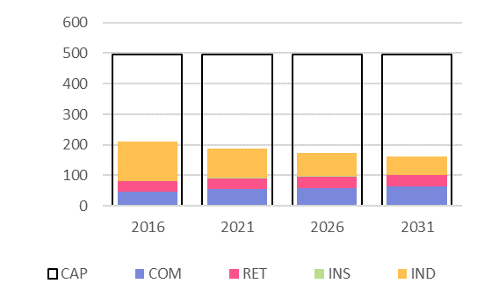

Cremorne and Church Street South Major Employment precinct
These two precincts complement each other to provide a unique retail and commercial offer.

The Cremorne Major Employment precinct has embraced the rich new creative economy. It has transitioned from an industrial past to become a significant creative commercial node with small innovated manufacturers (e.g. vW Maps who convert spatial data into 2/3D maps) to major head offices (e.g. CarSales and realestate.com). The precinct also has significant transport connections, both road and public transport, and is ideally situated to access the large labour markets in Melbourne’s east and south, and other businesses in the CBD. It also has a significant institutional asset in the Kangan Institute (9,000 square metres). With a unique and diverse existing employment base, Cremorne is well placed to attract employment growth.

The precinct is estimated to have a total floor space capacity of 440,000 square metres of which approximately 200,000 square metres is current utilised. Demand to 2031 is likely to remain steady, leaving theoretical capacity for further growth beyond the medium term.

The Church Street South Major Employment precinct is focused around a north-south tram corridor and connects into the rapidly developing Chapel Street. The strip has a focus on restricted retail, however, unlike other homemaker-oriented shopping centres, it provides a unique offer of a number of high end retailers. It also has a number of high quality cafes, restaurants and bars. A significant proportion of employment floor space is this precinct is commercial office. The Swan Street Structure Plan identifies a number of Strategic Redevelopment Sites and Further Investigation Areas.

There is a small amount of capacity for this precinct to evolve and grow into the future. Of a total estimated capacity of 300,000 sqm approximately 246,000 square metres is currently utilised and it is estimated that an additional 315,000 will be required by 2031.
Figure 35. cremorne - floor space capacity and demand to 2031
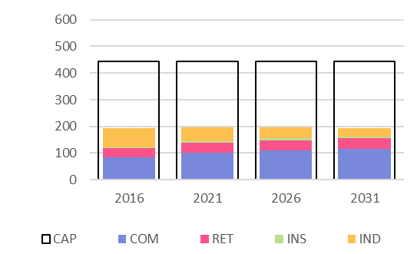

Figure 36. church street south - floor space capacity and demand to 2031
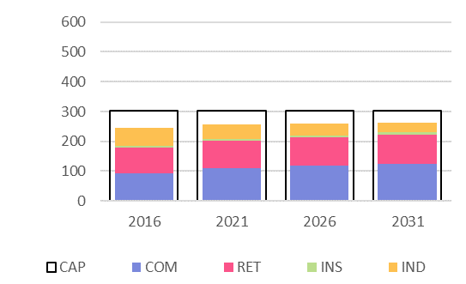

Abbotsford Major Employment precinct
The Abbotsford precinct contains the largest remaining manufacturer, Carlton United Brewery (CUB), along with a number of other more traditional manufacturing employment.

There is no change envisaged for this precinct in the short term given the CUB operation appears to be viable and will remain in the precinct in the foreseeable future. Demand for floorspace in this precinct may decline as the number of Yarra-based industrial workers falls, and as floorspace/worker ratios decline. The Abbotsford precinct could provide opportunities for employment, retail, community uses and/or housing in the longer term, beyond the 15 year planning horizon of this strategy. .
Figure 37. abbotsford - floor space capacity and demand to 2031
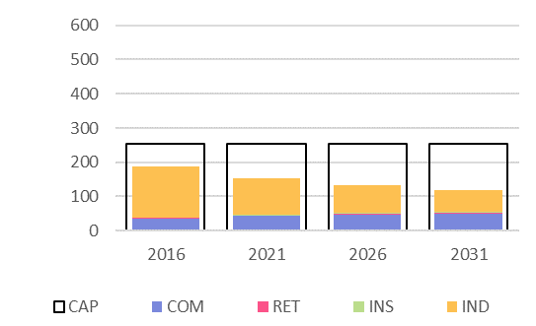

Hoddle Street Minor Employment precinct
The land along the Hoddle Street corridor (both north and south of the JLAP study area) presents an opportunity to accommodate additional employment and residential development. (It was identified as an ‘other urban renewal area’ in earlier iterations of Plan Melbourne.) Sites between the Hoddle Street and the rail line might be developed to higher densities with minimal impact on existing lower scale development to the west of the rail. For sites immediately adjacent to Hoddle Street the amenity issues associated with traffic volumes and noise will need to be taken into consideration. Retail and commercial uses that benefit from the exposure provided by a busy arterial route are likely to be more appropriate than residential uses.

The higher level precinct capacity analysis suggest there is capacity for growth. As this is a relatively complex precinct in terms of existing built form, lots sizes, and interfaces, a more detailed review of opportunities and constraints is be required to confirm the validity of these capacity findings.

Figure 38. hoddle street - floor space capacity and demand to 2031
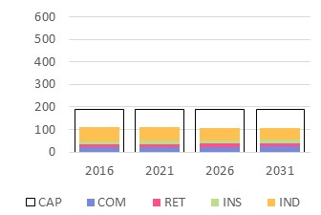

Burnley Office Minor Employment precinct
The Burley Office precinct in unique in Yarra in that it hosts mostly commercial floor space. The precinct contains the Botanica Business Park and the Burnley campus of Melbourne University. Demand for employment floor space in the precinct is projected to increase. The high level capacity analysis suggests there is a modest but sufficient capacity to accommodate this growth (see Figure 39).
Figure 39. burnley office - floor space capacity and demand to 2031
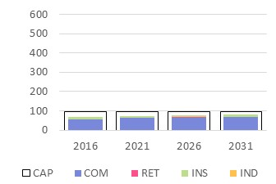

Summary: floor space demand and capacity analysis
The analysis of capacity and demand has found that there are sufficient opportunities for retailers in Yarra’s Commercial and Mixed Use zoned areas to accommodate projected growth. There is also significant capacity within Yarra to accommodate growth in commercial employment. This is particularly the case in the Gipps Street and Cremorne/Church Street South precincts and, to a lesser extent, in the established shopping streets where the floor space immediately above ground floor retail can support office-based employment.

Significant demand for institutional floor space is projected as a result of growth in health-related employment. Given pressures to accommodate a large proportion of this floor space in and around existing major medical institutions, floor space demand in the identified health precincts is likely to be significant. Although at an aggregate level there is sufficient floor space across Yarra, the extent to which projected demand for employment in health care and related sectors can be accommodated in close proximity to the major hospitals is unclear. Existing institutions may accommodate growth through redevelopment of existing facilities to accommodate more floor space – through upward rather than outward expansion. The Gipps Street precinct may be close enough to the Victoria Parade health precinct to accommodate some such growth.

Given demand for the expansion of health and medical services has metropolitan in scale, it is also conceivable that projected growth will be accommodated elsewhere in the inner metropolitan region if opportunities in Yarra are limited.

Demand for industrial land is decreasing in Yarra and therefore it is unlikely that the current planning framework is a constraint on these employment activities.

Although in aggregate terms the capacity for additional employment floor space exceeds demand in the medium term, this does not necessarily suggest employment zoned land should be rezoned, unless there is a clear case that the land is required for alternative uses.

To sum up the following consideration are relevant to decisions about the future of employment land in Yarra:

- Ensuring an adequate supply of employment land will support Yarra’s contribution to the metropolitan economy and provide a local supply of jobs and services for a growing inner-city population. Yarra is host to a diverse range of businesses that contribute to Melbourne’s creative economy and provides a unique physical setting for designers, manufactures, marketers and customers to interact in dense industry clusters.
- Retaining employment zoning (e.g. the Commercial 2 and Industrial zones) provides the greatest flexibility for future land uses. These zones allow for a range of employment activities – particular after the 2013 zones reforms – and are less likely to encourage developments that result in land fragmentation or strata-titled development (commercial, residential or mixed-use).
- The transition and intensification of existing employment land will occur over an extended period of time. In this context reserve capacity in excess of immediate demand is required to ensure efficient and competitive markets to supply additional employment floor space. Beyond the 2031 planning horizon considered in this Strategy there will be further demand for employment floor space that will draw on the additional floor space capacity that has been identified.
- Retention of the Gipps Street and Cremorne/ Church Street South Major Employment precincts for employment uses only would protect their potential for employment growth, acknowledging their unique character and role as creative industry hubs in inner Melbourne.
- The Abbottsford and Burnley industrial precincts host existing major industrial uses that are unlikely to change in the near future. If they were to change they are of sufficient scale that they would form major redevelopment sites in themselves, requiring precinct plans and masterplans.
- Consideration might be given to rezoning of C2 zoned land that is adjacent to Activity Centres to expand retail/ commercial opportunities and support residential growth in accessible, high amenity locations.
- Other smaller and more isolated employment zoned sites might be considered for rezoning. In considering such proposals Council should considered appropriate ‘tests’ that require applicants to demonstrate the re-zoning will generate a net community benefit, These could insist that any development maintain a similar level of employment or economic activity on the site.

Spatial strategy
This chapter sets out the spatial strategy for accommodating growth and change in employment in Yarra for the next 15 years.

Approach
The material presented in the preceding chapters and the findings in the Issues and Options report form the basis for strategic advice and recommendations in this section. The Strategy includes a vision and objectives for Yarra’s future employment lands, and strategic directions focused on strategic land use, built form and high-level zoning considerations.

Vision and objectives for Yarra’s employment lands
As the economy continues to evolve governments are challenged with the task of ensuring planning for employment provides sufficient land, appropriately zoned, that can facilitate the growth and change. This following vision has been developed by drawing on a review of existing policy, data analysis and community consultation from the ‘Liveable Yarra’ process. The vision focuses on leveraging the existing structure and diversity of Yarra’s employment land, but also recognises a constantly evolving economic landscape and requires careful planning.

The vision for Yarra’s employment lands:

Yarra’s employment lands play a vital role in the economy of Metropolitan Melbourne. They support a diversified and modern economy across a variety of retail, mixed employment, industrial, and health and education precincts. Yarra provides employment and services that are local, metropolitan and global in their reach; and vital to the Melbourne’s brand as a creative urban economy.

Despite successive waves of economic change, Yarra’s economy has continually adapted and evolved. Yarra’s employment lands support both emerging and established businesses alike. By virtue of its central location, accessibility and amenity, Yarra’s employment lands will increasingly attract high value adding economic activities. They are drawn to its established inner city employment precincts for their agglomeration benefits, their unique character, and the diversity of built form.
The objectives for Council to achieve this vision for Yarra’s employment lands are to:

Provide sufficient employment land and capacity to supported projected growth
Minimise pressures for residential conversion of employment precincts
Promote Yarra’s Activity Centres as the preferred locations for retail, services and facilities, and entertainment opportunities for Yarra’s residents and visitors alike.
Promote Yarra’s major employment precincts as locations for a wide variety of businesses and services that are a vital part of Melbourne’s inner city economy.
Support the growth of Yarra’s two health and education precincts.
Manage the transition of larger industrial uses, if and when these transitions occur.

Strategies
The main employment precincts that are the structural foundation for economic activity in Yarra are shown on the economic structure map on the following page (Figure 40). In response to the vision and objectives outlined above five strategies are proposed. These are summarised below and explored in more detail in the following sections.

Strategy 1: Support employment growth in Activity Centres
Yarra’s established and emerging activity centres already host a vibrant and constantly evolving range of retail, entertainment, hospitality and commercial services meeting the needs of visitors and the local population. They are also generally well served by public transport. Building on these existing strengths, growth in employment should be encouraged. Yarra’s Local Centres are also appropriate locations for intensification of employment activities.

Strategy 2: Retain and grow Yarra’s Major Employment Precincts
To accommodate projected demand for commercial floor space Yarra’s two large consolidated employment precincts at Gipps Street and Cremorne/Church Street South should be retained for employment activities. These areas have made a gradual transition from predominantly industrial uses to a wider mix of activities that include professional services, creative industries, medical-related activities and small-scale manufacture. Zoning should continue to exclude residential development to retain the core employment function of these precincts.

Strategy 3: Identify preferred locations for housing growth
Strong demand for housing in accessible location can have negative impacts for employment outcomes. To reduce pressures for ad hoc conversion of employment lands to residential Council should continue work to identify preferred locations for housing that compliment (rather than disrupt) employment activity (e.g. Activity Centres, Mixed Use Areas and dispersed infill in residential areas). Demonstrating sufficient capacity to accommodate housing demand in these locations will support the strategy to retaining Yarra’s larger consolidated employment precincts.

Strategy 4: Support the expansion of health-related employment and services in Yarra’s health precincts
The health sector is projected to experience significant growth in Melbourne and Yarra is host to two significant health precincts in the metropolitan area. Additional space around the two hospitals would be beneficial for this sector and could involve the conversion of existing commercial or residential land for health sector uses. Furthermore, the health precincts would benefit from land use diversification that supports their primary function, for example with health-related businesses, education, short-term accommodation and convenience retailing. The St Vincent’s health precinct includes the Australian Catholic University (ACU) Melbourne Campus.

Strategy 5: Retain other C2 zoned precincts (unless strategic planning support change)
Yarra’s C2 zoned land forms part of larger employment precincts, supports a diversity of businesses and economic activity and, in general, is not required to support housing. Unless strategic planning work supports a change of zone, existing C2 precincts and sites should be retain for employment uses. Future strategic planning work may identify opportunities for change, however this are not a priority for Council at this point in time.

Strategy 6: Retain Yarra’s existing industrial precincts for manufacturing and urban services
The projected demand for employment and housing for the next 15 years can be accommodate in existing centres and employment precincts. There is no need to reconsider the role of industrial precincts at this time. While the need for such a transition is not imminent, it will be prudent for Council to consider how alternative uses for these precincts might be determined, infrastructure requirements, and flag the potential for the inclusion of social and/or affordable housing.

Figure 40. Yarra’s economic structure – major employment precincts
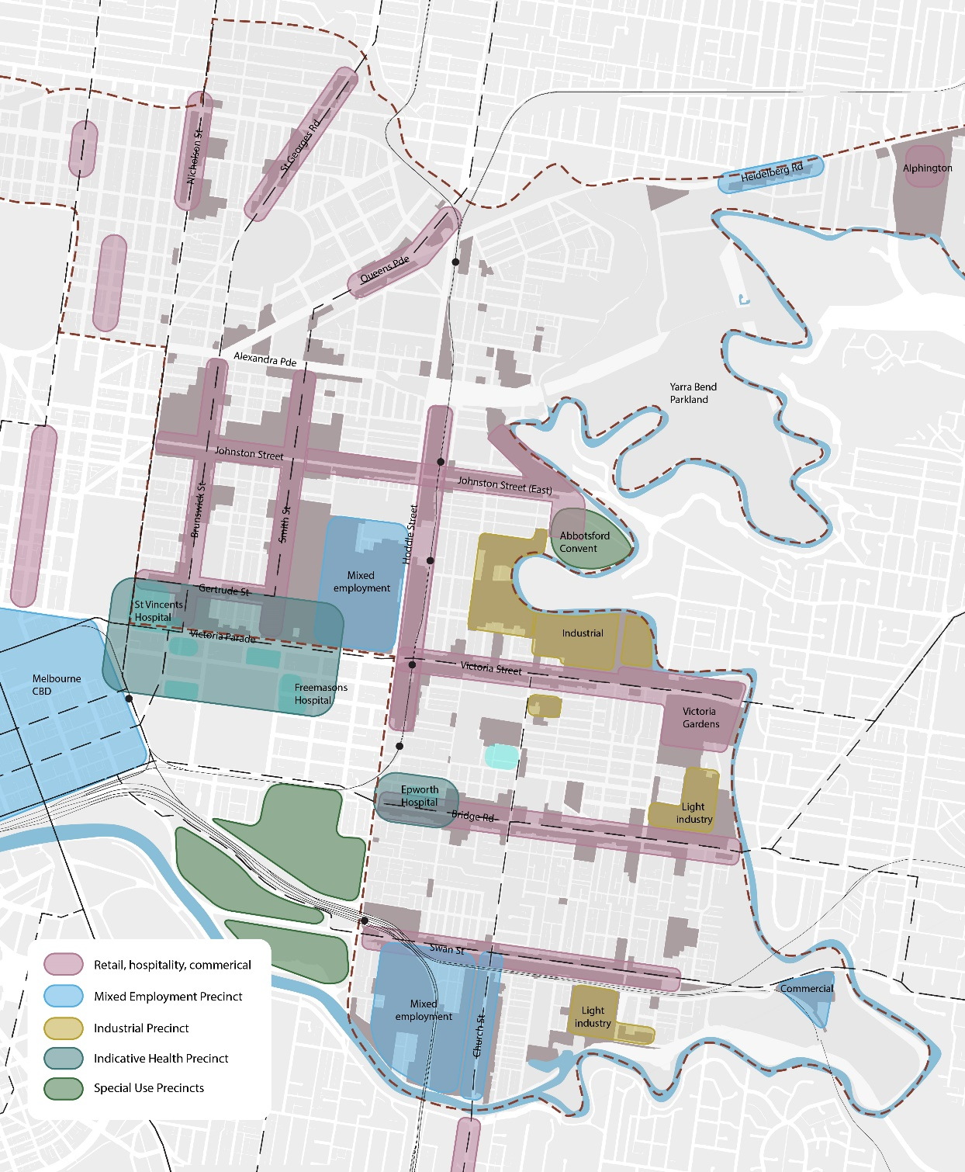
Source: SGS, 2015.

Strategy 1: Support employment growth in Activity Centres
Yarra features a series of established Activity Centres that host retail, hospitality, entertainment uses, and other services, for residents and visitors. They are a signature element in Yarra’s economic and social landscapes. They are highly accessible and rich in established physical and social infrastructure. Future planning should support and encourage employment growth in these centres.

In addition to the five existing Activity Centres identified in Plan Melbourne, Johnston Street East has been nominated as an emerging Activity Centre that includes the eastern end of Johnston Street, the Trenerry Crescent area and the Abbotsford Covent. Council has undertaken recent planning work including the preparation and adopting of a Johnston Street Local Area Plan to support the emergence of this centre.

Yarra’s Activity Centres are also appropriate locations for new housing. Housing growth supports economic activity by increasing the local population and, when provided in a mixed use building can be developed with an increase in the quantum of employment floor space. Residential developments can impact existing business if the new residents are affected by noise or other perceived nuisance. These potential conflicts should be managed, particularly in vibrant service and entertainment precincts, ensuring established businesses can continue to operate.

Yarra’s local Activity Centres include:

- Queens Parade, Clifton Hill
- Saint Georges Road, North Fitzroy
- Alphington, Heidelberg Road
- A new neighbourhood centre at the former AMCOR Paper Mill site
- Nicholson Street North, Carlton North and North Fitzroy
- The Rathdowne Street and Lygon Street villages in Carlton
- Three small centres in the suburb of Richmond.

Yarra’s smaller retail centres are largely oriented towards the retail, entertainment and service needs of a local population. Future planning should support and encourage employment growth in these locations that also serves these functions. These centres vary considerably in size from small collections of local shops through to the Queens Parade supports in order of 50,000 square metres of floor space. These local Activity Centres are attractive locations for housing in mixed use developments and are appropriate locations for higher density housing.

Role in accommodating projected growth
Yarra’s Activity Centres are likely to accommodate significant growth in retail, commercial and institutional floor space. It is anticipated that an estimated 134,000 sqm of additional floor space will be added to Yarra’s larger Activity Centres between 2016 and 2031 for commercial, retail and institutional uses (an increase of around 10%). Based on the capacity assessment set out earlier, the extent of Yarra’s Activity Centres currently zoned for employment is likely to be sufficient to accommodate this growth. A diverse cross section of employment uses should be supported in centres, including health related businesses that might seek to locate in centres that overlap with and adjoin the designated health precincts.

Yarra’s local centres are likely to accommodate modest growth in retail and commercial floor space largely linked to local population growth. The land currently zoned for employment within these smaller centres is considered sufficient to accommodate projected growth to 2031.

Strategic directions
- Support growth in retail and other employment uses in Yarra’s Activity Centres in a way that encourages existing trends, supports major employment sectors and provides opportunities for innovative businesses to flourish in Yarra, building on the unique, creative local character.
- Designate Johnston Street East as an emerging activity centre that includes Johnston Street between Hoddle Street and the Yarra, Trenerry Crescent and the Abbotsford Covent. Encourage the evolution of this emerging centre by rezoning C2 land to allow a wider range of retail uses and residential development on Johnston Street and nearby precincts.
- Implement recommendations of the Swan Street Structure Plan to rezone areas of C2 land in the western end of the precinct to support mixed use outcomes.
- Support the provision of housing in Activity Centre in mixed-use developments. The scale and form of new development should seek to enhance the amenity of the centre and avoid introducing potential land use conflicts between residential development and employment activity.
- Undertake structure planning for the remaining Activity Centres to guide future development.

Precinct specific directions

Victoria Street, Richmond
Victoria Street provides vibrant street-based retail and hospitality businesses. Expansion of these activities to the east towards a growing residential precinct is a logical extension of this centre.
Victoria Gardens is an attraction for a sub-regional population and serves a large and growing local community. The centre provides a different retail format and experience to the street-based offer of the western end of Victoria Street. The eastern end of Victoria Street would benefit from a cohesive and pedestrian friendly public realm.
Land to the south of the Victoria Gardens presents opportunities for higher density employment and housing, in the medium to longer term.

Bridge Road, Richmond
Changes in fashion retailing and retail conditions generally have resulted in high vacancies at the western end of Bridge Street in contrast to Yarra’s other Activity Centres. The expansion of medical related activities could revive the area. Likely alternative land uses could include medical consulting rooms and ancillary uses like short term accommodation. Residential intensification would increase demand for local services.
The central and western portion of Bridge Road have been more successful in making the transition to local population service retail and hospitality. The new secondary school in this area will bring more activity, reinforcing the civic character of this central Bridge Road precinct. Local population growth will further enhance the viability of this part of the centre with opportunities for mixed use development on C1 zoned land. The isolated parcels of C2 zoned land to the south of Bridge Road might also be considered for transition to mixed use development in the future given the capacity for employment growth in Yarra’s large consolidated mixed employment precincts.

Swan Street, Richmond and Burnley
Swan Street primarily serves a local resident and worker population and benefits from its proximity to Melbourne’s premier sporting precinct. Demand for additional retail floor space and residential development can be accommodated by expansion of the C1 zone to those areas zoned C2Z towards the east of the precinct. This change has been recommended in the adopted Swan Street Structure Plan.
Richmond Station has been identified as a potential development site although the high costs associated with redeveloping an operating station are a significant challenge. The C1 zoned land to the south of the station appears to be a more likely development opportunity in the near term and is identified in the Swan Street Structure Plan as having the potential for 3-4 storey development.

Brunswick Street, Fitzroy and Smith Street, Fitzroy/Collingwood
Brunswick Street and Smith Street offer a consolidated core of retail and hospitality for the suburbs of Fitzroy and Collingwood and a wider catchment beyond. The C1 zoning throughout this area allows a range of employment and housing in mixed use developments. The development of the Community Arts Precinct (on Johnston Street) is an emerging trend, supported by state.

Johnston Street East, Collingwood and Abbotsford
Johnston Street East benefits from heavy rail, retail, open space assets and the Abbotsford Convent. It is well suited to accommodating growth in both employment and housing.
Council has recently prepared the Johnston Street Local Area Plan which, with the exception of the Easey Street Precinct, recommends changes to C2 zoned land (on Johnston Street and between Hoddle Street and the rail line) to allow for mixed use redevelopment with residential on the upper levels.
The Abbotsford Convent is a unique community asset and visitor destination. It has the potential to be better integrated with the emerging Activity Centres as it evolves following the proposed zone changes.

Yarra’s local Activity Centres
Expansion of retail and other employment uses should be supported in Yarra’s local centres. Given the diversity of these centres in size, proposals that could impact on the character, amenity or function of centres will need to be assessed on their individual merits. For example, developments that generate significant traffic movements or significant amenity impacts in adjoining residential areas might not be suitable (and are more appropriately located in Yarra’s Activity Centres). Structure planning studies for local activity centre could identify preferred built form outcomes and provide local plans and policies for inclusion in the Planning Scheme.

Strategy 2: Retain and grow Yarra’s Major Employment Precincts
The Cremorne/Church Street and Gipps Street Major Employment precincts are unique mixed employment areas that host a diverse range of activities including traditional industrial uses, commercial offices and creative industries. As demand for industrial land in the inner city has declined in recent decades these areas have transitioned from predominantly industrial uses to precincts that host a mix of alternative and diverse economic functions.
The precincts are characterised by a variety of lot sizes, a diversity of building stock and building condition, and variable public realm quality. This physical diversity and urban character are important elements in attracting and supporting a diversity of economic activities. This older morphology – which includes many buildings that might be described as ‘life-long-loose-fit’ – is conducive to attracting innovative businesses, a deeper mix of businesses, and a degree of informality that is lacking from other existing and emerging (and potential) employment precincts in inner Melbourne.

Although the C2 zoning in these precincts prevents residential development, these areas will be subject to pressure for residential conversion. This may have been exacerbated by their designation in earlier iterations of Plan Melbourne as ‘Other Renewal Areas’ with little guidance on the nature or type of renewal envisaged (see Figure 15).

Precincts such as Cremorne/Church Street South are attracting major businesses and investment … The recent surge in planning applications and approvals for office developments has occurred in major employment precincts on C2 zoned land.

Compared to other Councils within the inner city region, Yarra has a large amount (total area m2) of C2 zoned land dispersed across most of the municipality which is being used for a variety of commercial and business purposes. The C2 zoning provide opportunities for a different range of uses and businesses than occurs in Yarra’s activity centres which are predominantly based around retailing and services.

Existing land use and development examples in Yarra suggest that once areas or sites are zoned to permit residential uses and development – through the C1 or Mixed Use zones – the economic function and capacity of these areas is limited as residential development is the ‘highest and best use’. In the case of areas zoned C1, ground floor commercial and retail uses is usually accommodated but the dominant use is residential unless circumstance allow Council to negotiate the inclusion of additional commercial activities through the process of zone change or planning permit assessment. For MUZ land, new developers typically included very little or no employment floor space. Given a stated purposes of the MUZ is to support higher density residential development, the zone is a de facto a high density residential zone.

While zone changes can be considered and may be supported as part of Council’s overall strategic land use planning, once the land is rezoned to C1 or MUZ its potential to provide for economic purposes and business is typically lost.

Retaining C2 zoned land has supported change within the local economy with C2 zoned areas evolving and consolidating their economics role and providing further opportunities for development and intensification of Yarra’s economic and businesses growth.

Major employment areas, such as the Cremorne/Church Street South and the Gipps Street precinct, are highly sought after and highly valued as business locations due to their location and proximity to central Melbourne, access to transport, business synergies and the vibrancy of Yarra. They have proven particularly attractive to creative- and technology-oriented business that a non-but-near-CBD location.

Given their proximity to the central city and access to transport and social infrastructure, it could be argued these precincts are suited to both employment and residential land uses. However, it is recommended that they are retained for employment uses for the following reasons:

- The precincts have evolved into a unique mix of employment and economic activity; the result of decades of continuous employment use.
- Given strong demand for commercial floor space in Yarra there is insufficient capacity to accommodate all such projected growth in Yarra’s Activity Centres.
- The diversity of lot size and building stock in these precincts provides a unique environment for established and emerging business that are unlike the majority of existing (and potential) employment lands in Inner Metropolitan Melbourne.
- The precincts have already transitioning from lower-value to higher-value employment uses. This transition is likely be interrupted by allowing residential uses and detrimental to Melbourne’s inner city economy.

Retaining an employment zoning for these precincts for the foreseeable future provides for longer term flexibility if conditions for employment change. Providing clarity and certainty for land owners and businesses about the future employment role of these precincts is key to attractive investment and growth.

Future planning for these precincts might follow approaches commonly applied to Activity Centre structure planning that includes consideration of preferred built form outcomes, open space and public domain structure, movement and access, and the need for infrastructure upgrade and investments.

The smaller Burnley Office Employment precinct also support a cluster of well-located commercial office floor space that should be retained and grown where possible.

Role in accommodating projected growth
Strong growth in demand for commercial and retail floor space is projected for Yarra. The quantum of growth is likely to exceed the capacity of Yarra’s Activity Centres. Yarra’s mixed employment precincts are well suited to hosting office-based employment, creative industries and support services (e.g. catering, printing, small-scale specialised manufacture, and so on). The continued shift in economic activity in these precincts from lower density industrial uses towards alternative employment would provide this required additional capacity.

Based on the distribution of employment floor space demand described in chapter 4, demand for approximately 140,000 sqm of additional floor space has been forecast for both the Gipps Street and Cremorne and Church Street precincts – an increase of almost 25% on the 2016 floor space.

Alternative locations for accommodating projected residential growth in Yarra should be identified to further support the retention of these established employment precincts for employment uses (see Strategy 3).

Precinct specific directions

Gipps Street precinct
Gipps Street precinct is strategically located with respect to public transport, arterial roads and Melbourne’s CBD. Given projected demand for employment floor space, and office floor space in particular, the precinct should retain its employment focus. Recent zoning changes have already provided greater flexibility in the range of permissible employment land uses.
Although there are many retail and hospitality business beyond the immediate Gipps Street precinct, the lack of retail within the precinct could be a barrier to attracting new businesses. The collection of smaller business on Glasshouse Road at the western edge of the precinct might be interpreted as evidence of the attractiveness of the more vibrant quarters of the precinct.
More detailed built form guidance would provide greater clarity about opportunities for additional development and the scale and form envisaged (e.g. similar to that provided for the Easey Street precinct in the Johnston Street Local Area Plan).

This precinct could accommodate future demand for floor space generated by the Victoria Parade health precinct, where capacity for growth is more constrained.

Cremorne precinct
The Cremorne precinct is also strategically located with respect to public transport, the arterial road network and CBD. While identified as an urban renewal opportunity in earlier versions Plan Melbourne, given its current employment focus and the projected demand for employment floor space, retention and intensification of employment should be the focus of renewal efforts. Growth of the Kangan Institute, which specialises in fashion and retail training, should be supported for adding to the diversity of employment but also to underpin a competitive strength for creative firms in this precinct.

Church Street South hosts complementary land uses with a focus on restricted retail. The retention of the employment focus of this precinct is also warranted given its unique role. There are currently opportunities for residential development within the local area on Swan Street and, further potential housing opportunities in the vicinity of Burnley Station are identified in the Swan Street Structure Plan.

Circumstances when residential developments might be considered
The Swan Street Structure Plan identifies strategic redevelopment sites in the ‘Cremorne Mixed Commercial Precinct’ and ‘Cremorne South Precinct’ where opportunities for mixed use development might be contemplated. Two ‘investigation areas’ have been identified in the ‘Cremorne South’ precinct where the structure plan suggests the zoning required further investigation.

In general, the interest of providing clear direction to the market about the intended role of these precincts, residential developments should not be contemplated. An exception might be made for interfaces with residential areas, where rezoning to allow mixed employment and residential uses would help address an existing or potential land use conflicts (e.g. by providing an appropriate and enduring buffer between residential and non-residential uses).

TEXT BOX: GIPPS STREET PRECINCT – FROM CONSULTATION REPORT

TEXT BOX: CREMORNE PRECINCT – FROM CONSULTATION REPORT

Strategy 3: Identify preferred locations for housing growth
Although this study is primarily concerned with employment and economic activity, the impacts of strong demand for housing on employment lands is an important consideration. Land speculation and opportunistic efforts to rezone employment can create uncertainty and disruption to the orderly and efficient use of employment lands.

Yarra is an attractive location for residential development. Under current market conditions residential developments typically generate higher returns than employment related development, resulting in significant incentives for land owners and developers to seek zoning changes that will to allow residential. This does not necessarily mean there are insufficient opportunities for housing on land already zoned for that purpose.

Some potential zone changes to allow residential development on employment land have been identified in structure plans and local area plans.

To reduce pressures for conversion of employment land for housing, Council has undertaken work to ensure sufficient capacity to accommodate housing demand in appropriate locations (e.g. Activity Centres, Mixed Use Areas and dispersed infill in residential areas). Council is currently preparing a housing strategy that will provide directions on how future housing demand will be met. The Urban Development Program (UDP) currently indicates that there is sufficient supply ‘in the pipeline’ to accommodate demand for the next 15 years. This potential supply is mostly located known strategic redevelopment sites and projects being considered, likely to occur, or under construction.

Current structure planning and built form framework projects being undertaken by Council for activity centres and mixed use zoned land around activity centres will enable Council to develop estimates of the potential capacity for additional housing in of these areas, in additional to the forecasts in the UDP. It is therefore assumed that Yarra can rely upon this existing capacity and does not need to undertake any significant changes to rezone employment land (apart from the zoning proposals already approved or proposed by Council) to provide for additional housing supply.

Housing demand and capacity
Between 2004 and 2011 an additional 3,415 dwellings were built in Yarra –around 500 per annum.
45% of new dwellings were constructed on land zoned Mixed Use, Comprehensive Development and Priority Development accommodated supply; 25% were built on commercial zoned land and 28% on residential land.

VIF forecasts suggest the growth in dwelling for Yarra between 2016 and 2031 of 15,000 additional dwellings or 1000 additional dwellings per year. The forecast dwelling growth is evident significantly higher than the trend from 2004 to 2011.

Analysis of the capacity for housing on land zoned Mixed Use, Comprehensive Development and Priority Development found capacity in the order of 15,000 dwellings. The capacity of commercial and residential zoned land in Yarra to contribute to new dwellings is not known. For the purpose of this SEES it has been assume that there is sufficient capacity to accommodate residential demand for the foreseeable future. Further investigation would be required to determine the capacity for residential development across Yarra’s Activity Centres and residential neighbourhoods, and likelihood of this capacity being realised, based on consideration of character, zoning, lot size, height/density limits, and financial feasibility.

Strategy 4: Support the expansion of health related employment and services in Yarra’s health precincts
The economic structure map for Yarra strategy highlights two health precincts, both of which are identified in Plan Melbourne. The first precinct includes the hospitals and health related activities located near Victoria Parade: a precinct which spans the City of Yarra and the City of Melbourne and includes the St Vincents Public, the Royal Victorian Ear and Eye Hospital, the Epworth Maternity and Epworth Clarendon Street and St Vincent Private Hospitals and the Australian Catholic University Melbourne Campus. The second precinct is located at the western end of Bridge Road and includes the Epworth Hospital.

The services provided by the hospitals and others in these precincts reach a wide catchment that extends well beyond Yarra. Growth in demand for these services is the result of population growth across the broader metropolitan area and a general trend towards the increasing consolidation of medical services.

Hospitals generate demand for a range of other services including consulting rooms, laboratories and short term accommodation. These activities are attracted to locations in close proximity to the hospitals creating considerable demand in a small area.

Within this precinct the Australian Catholic University is planning an extension to accommodate 3000 additional students and 400 new staff to 2020, with new buildings proposed at 115B Victoria Parade (on the corner of Napier Street) and 81-89 Victoria Parade (on the corner of Brunswick Street). A vision and supporting precinct and site planning has been undertaken (see Australian Catholic University, 2015).

The high level capacity analysis carried out for this Strategy suggested that the projected demand for the Victoria Parade Precinct to 2031 will almost reach the estimated floor space capacity. Demand for a further 78,000 sqm of institutional floor space is projected and total demand across all sectors is for an additional 91,000 sqm. The estimated spare capacity in the precinct is 104,000 sqm. (It should be noted that is making the capacity estimate the site-specific opportunities for expansion, redevelopment and intensification on the existing hospital sites was not known.) Adjoining areas in the City of Melbourne might meet some of this demand. Further analysis is suggested to determine an appropriate policy response. Synergistic uses in the precincts and surrounds should be supported, such as education, short-term accommodation or medical consulting suites.

Role in accommodating projected growth
Health related employment is projected to grow substantially, and proximity to established hospitals is an important factor for the location of a large proportion of these jobs. Yarra’s health precincts will be under pressure to accommodate considerable growth to 2031. An additional 119,000 sqm of additional floor space would be required across Victoria Parade and Bridge Road to accommodate projected growth (a 45% increase). A total of 147,000 sqm of additional institutional floor space is projected to 2031.

Precinct Specific Directions

Victoria Parade
Growth in demand for health related floor space is significant but there appears to be limited land in the City of Yarra to accommodate a significant expansion. Given the major medical facilities in close proximity in both Yarra and the City of Melbourne, a coordinated approach to the management of this health precinct is recommended that involves State Government, both Councils and the relevant institutions.

Further analysis could be undertaken to identify opportunities to enhance the capacity for health precincts to accommodate projected growth. This work will help identify options to accommodate growth (e.g. expansion and intensification of existing hospitals; expansion to adjoining land; new facilities in alternate locations that will reduce pressures for growth). This work could involve the multiple stakeholders (City of Yarra, City of Melbourne, VPA and the Department of Health and Human Services).

An integrated precinct plan could be developed that addressed development capacity, access and movement, and land use planning issues specific to the needs of a large cluster of health, medical, education and supporting services. This might include strategies that support the conversion of existing residential and commercial land uses.
The eastern end of Victoria Parade and the Gipps Street precinct could provide opportunities for the expansion of health related activities.

Bridge Road
Epworth hospital is currently undergoing expansion however the site is constrained for further expansion and has sensitive interfaces with residential areas and heritage. There are high vacancies of retail properties at the western end of Bridge Street and expansion of health and medical services and associated activities to this area could be a potential solution to both problems. Further investigation is required to determine if this form of expansion of the health precinct would be viable. The extent of an expanded health precinct might be more clearly defined to provide greater clarity and certainty.

Strategy 5: Retain other C2 zoned precincts (unless strategic planning support change)
In addition to the major employment precincts of Gipps Street and Cremorne/Church Street South identified in Strategy 2, Yarra contains a variety of other precincts and sites zoned C2. Planning directions for these precincts and sites should be guided by existing strategic land use planning work and consideration of the opportunities this zoning offers for further economic and business growth.

C2 land in BILS
The adopted Business Industrial Land Strategy (BILS) contains Council’s existing strategic directions for C2 zoned areas. BILS largely stipulated that what is now C2 zoned land be retained for employment, noting that, at the time of BILS adoption, the previous VPP business zones were in use. The strategy did recommend zone changes for some sites that would permit residential uses. Some employment zoned land included in the BILS was effectively rezoned to C1 due to the state government’s introduction of new commercial zones in 2013 (specifically, land zoned B1, B2 and B5 was migrated to new C1 zone). In addition to this change, Council has proposed changes to some precincts based on strategic planning work.

Since the adoption of the BILS Melbourne’s planning and economic development circumstances have changed. Metropolitan Melbourne is undergoing significant and sustained population and employment growth. Plan Melbourne has identified the important role inner city municipalities play in the metropolitan economy, supporting the economic role of central Melbourne. Furthermore, Yarra is experiencing significant overall economic and employment growth driven by the key C2 zoned areas, retail activity centres and industrial precincts. Sustained growth in demand for housing in Yarra is another key consideration in planning for the municipality. These changes warrant a reassessment of the strategic direction for Yarra’s C2 zoned land since BILS was developed and adopted.

As noted in Strategy 3 above, Council is currently preparing a housing strategy and is satisfied that there is sufficient housing supply in the development pipeline to meet demand for the next 15 years. Proposed changes to C2 land have been flowed from strategic planning work for the Swan Street and Johnston Street activities centres and these changes will provide further capacity for housing and retail/commercial development in these centres.

Planning strategy for other C2 zoned areas
As discussed above, once land is zoned to permit residential uses and development, its employment role is limited as residential development is the ‘highest and best use’. For this reason, a precautionary approach is recommended used when considering the future of C2 zoned land outside the major employment precincts.

Council can expect requests by property owners to change the zoning of properties to enable residential development. It will therefore be important to set clear strategic direction for C2 zoned areas to avoid this speculation and provide confidence to the market that existing C2 zones areas will be retained for commercial development and support for the evolution and development of economic activity in Yarra’s.

Strategic directions
Directions for C2 zones areas area described below and are summarised in Table 5.

Retain strategic C2 zoned land in larger employment precincts and with a significant employment role
It is recommended that the majority of C2 zoned land in Yarra, which generally forms part of broader employment precincts, is retained. This strategically located C2 zoned land provides the following functions:
- Supports established business areas and serve a useful economic and employment function
- Contributes to the economic diversity of the Yarra economy, and
- Offers locations for different land uses and businesses.
C2 zoned precincts that fall into this category includes areas adjacent Yarra’s three industrial precincts at Abottsford (Victoria Crescent/CUB), Richmond East (Palmer Street) and Burnley, and C2 zoned land at Church Street North.

These areas are part of broader employment precincts of sufficient size and importance that further strategic planning investigations and planning is required to determine if alternative land uses, economic activities and built form outcomes are appropriate. These strategic planning investigations would be required before any change of zone would be contemplated.

Rezone C2 land that is subject zoning changes arising from current strategic planning work
Some C2 zoned land has been identified for zone changes in current strategic planning work and planning scheme amendments. These locations are typically C2 land in activity centres that have bene deemed suited for residential development, based on policy and physical characteristics, and would still achieve an employment outcome though the requirement for active ground floor uses. These precincts and sites include:
- Queens Parade East (currently being considered as part of a built form framework and proposed DDO)
- Johnston Street East (part of Amendment C220), with the exception of the very eastern end of this precinct
- Johnston Street Central (part of Amendment C220), with the exception of the Easy Street precinct
- Two sites in Trenerry Crescent (subject to Amendments C218 and C219)
- Swan Street East and Swan Street West (part of Amendment C191).

The Johnstone Street Structure plan recommends that the Easey Street precinct and the eastern end of the Johnston Street East are retained as employment land with a C2 zoning.

Other C2 zoned land
Consistent with adopting a precautionary approach to the zoning of Yarra’s employment land, it is recommended that all other C2 zoned land retains this zoning unless and until future strategic planning work supports change. These sites and precincts include:
- Two areas of C2 zoned land on Nicholson Street, Fitzroy
- Site at Queens Parade West, North Fitzroy
- Site on the north and south sides of Alexandra Parade, North Fitzroy and Fitzroy
- A block on St Georges Road, North Fitzroy
- A precinct at Victoria Street West, Richmond
- A precinct at Heidelberg Road, Fairfield
- The C2 zoned land that run the length of Hoddle Street (which includes north, central and south sections).

Any future changes to these C2 zoned sites and precincts should be based on strategic considerations for the broader municipality, rather than on an individual sites basis. While some areas may appear to be suitable for residential, Council should consider the impact of the loss of C2 zoned land on the existing economy and businesses, and the potential for this land to provide for future economic and business growth.

Rezoning C2 zoned land to allow residential development will create a land value uplift and Council might consider negotiated value capture arrangements (via 173 agreements) to help fund local infrastructure or affordable housing. Inclusionary housing requirements (e.g. a proportion of affordable housing) could also be considered for larger sites where dwellings can be provided on the site. Council could develop a policy outlining these expectations, to create a consistent framework for managing changes of use across all smaller C2 zoned precincts.

Hoddle Street
Land in the Hoddle Street corridor presents an opportunity to accommodate additional employment and residential development with minimal impact on existing lower scale development to the east of the rail line. For sites immediately adjacent to Hoddle Street the amenity issues associated with traffic volumes and noise will need to be taken into consideration. Retail and commercial uses that benefit from the exposure provided by a busy arterial route are likely to be more appropriate than residential uses. (Annual average daily traffic volumes on Hoddle Street were in the order to 35,000 vehicles per day southbound and 40,000 per day northbound in 2015.) Under these circumstances commercial uses are more appropriate than residential for street facing frontages. Given the significance of Hoddle Street as a major arterial road and through route, the future of the existing C2 land along the corridor should be considered only once further strategic planning is undertaken to examine future opportunities and zoning options to achieve both employment and potential some housing outcomes.
Figure 41. strategies for C2 zoned land
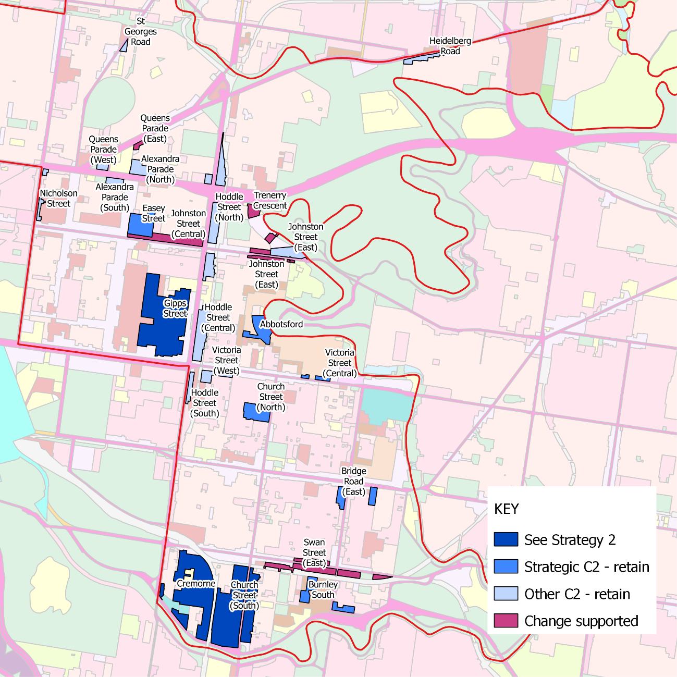
Source: SGS Economics and Planning

Table 5. GUIDANCE for c2 zoned land
Precinct | Recommendation | Justification
St Georges Road | Other C2 – retain | Supports employment diversity; not needed for housing.
Fairfield | Other C2 – retain | Supports employment diversity; not needed for housing.
Queens Parade (East) | Zone change may be contemplated in future | Currently considered as part of the Queens Parade Built form analysis study. The Strategic Development Site (former Gas and Fuel Site) is being consider by the State Government as a mixed use precinct. Future of the C2 zoned land considered as part of the broader strategic study and after the development framework for the G&F site is approved.
Queens Parade (West) | Other C2 – retain | Potential to support employment diversity; not needed for housing.
Alexander Parade (North) | Other C2 – retain | Supports employment diversity; not needed for housing.
Alexander Parade (South) | Other C2 – retain | Supports employment diversity; not needed for housing.
Nicholson Street | Other C2 – retain | Supports employment diversity; not needed for housing.
Easy Street | Strategic C2 - retain | Johnston Street Local Area Plan recommends retaining as C2. Part of Amendment C220.
Johnston Street (Central) | Rezone to C1 | Johnston Street Local Area Plan recommends rezoning to accommodate housing on upper levels. Part of Amendment C220.
Trenerry Crescent | Rezone | Johnston Street Local Area Plan recommends rezoning the remaining C2Z properties along Trenerry Crescent facilitate Mixed Use opportunities. Current planning scheme amendments C218 & C219.
Johnson Street (East) | Rezone to C1 | Johnston Street Local Area Plan recommends rezoning to accommodate housing on upper levels. Part of Amendment C220.
Gipps Street | Retain (see Strategy 2) | Major employment precinct.
Abbotsford | Strategic C2 - retain | Part of a broader employment precinct and generally surrounded by industrial zoned land. Retain for employment uses.
Victoria Street Central | Strategic C2 - retain | Part of a broader employment precinct and generally surrounded by industrial zoned land. Retain for employment uses.
Victoria Street West | Other C2 – retain | Supports employment diversity; not needed for housing.
Church Street North | Strategic C2 - retain | Larger modern employment precinct; not needed for housing.
Bridge Road East | Strategic C2 - retain | Strategic location near industrial land in Richmond East industrial precinct. Retain for employment uses.
Cremorne | Retain (see Strategy 2) | Major employment precinct.
Church Street South | Retain (see Strategy 2) | Major employment precinct.
Swan Street West | Rezone to C1 | Part of Amendment C191. Proposed rezoning to C1 zone and development controls for the activity centre.
Swan Street East | Rezone to C1 | Part of Amendment C191. Proposed rezoning to C1 zone and development controls for the activity centre.
Burnley South | Strategic C2 - retain | Part of a broader employment precinct and generally surrounded by industrial zoned land. Retain for employment uses.
Hoddle Street | Other C2 – retain | Corridor should be considered only once further strategic planning is undertaken to examine future opportunities and zoning options to achieve both employment and potential some housing outcomes. See commentary above for Hoddle Street.

Strategy 6: Retain Yarra’s existing industrial precincts for manufacturing and urban services
As industrial employment continues to decline demand for (traditional) industrial zoned land is likely to contract. Yarra currently hosts three larger precincts of industrial land, the largest being at Abbotsford which includes the Carton United Brewery, and two smaller consolidated industrial areas at Richmond East and Burnley South (Figure 42).

Each industrial precinct is different. In the case of the Abbotsford and Burnley precincts decisions by the major land use will determine their future. A decision by CUB and Citipower to vacant the either precinct would open up a new redevelopment opportunity. Richmond East is different in that it is made up of many relatively small businesses. The precinct is also likely to be subject to pressure for residential conversion.

The capacity analysis presented above suggests there is no immediate need for industrial zoned land to be converted to accommodate demand for alternative employment uses provided Yarra’s two larger mixed employment precincts are retained. Therefore, there is no need to reconsider the role of industrial precincts at this time.

Although the transition of these industrial areas to alternative uses is not imminent it would be prudent for Council to be pro-active in planning for this changes by considering:
The processes that will determine how appropriate alternative uses for these precincts might be determined
Likely demand for shared infrastructure that might be funded via DCPs
The potential for a proportion of social and affordable housing to be provided via value capture or inclusionary zoning mechanisms
The need for education or other social infrastructure to serve the redeveloped precinct or the wider Yarra and regional community
Opportunities to provide public infrastructure such as open space and community facilities.

Ultimately if and when these precincts transition they will be renewal areas that should make a major contribution to overall urban objectives for sustainability, liveability and productivity. Though much larger than these precincts the Fishermans Bend experience is instructive in this regard. Originally rezoned for residential and mixed use without regard to wider objectives or considerations about the infrastructure, services, housing mix and employment which would make the area an integrated community the area is now being re-planned and retrofitted having regard to such considerations. The headline targets have been identified (see Jewell, 2016) as:
Open space within 200 metres walking distance for all residents and workers
80% of transport movements to be made by public transport, walking or cycling
an integrated transport strategy including cycle paths, tram lines and an underground rail line
diverse and affordable housing opportunities

A more detailed list of targets is to be developed.

Similar outcomes, adapted for the smaller scale and different context, should be expected of these Yarra precincts if they transition. Council could work up an early statement of objectives and outcomes which would apply to these precincts for their future development in anticipation of a joint planning exercise with state government given its critical role in the planning and infrastructure provision process. Employment outcomes would be expected, consistent with and contributing to the complex and diverse emerging character of the Yarra economy. Council’s experience on the Alphington redevelopment site should also provide lessons for continual improvement in renewal area planning.

Role in accommodating projected growth
Given there is sufficient capacity for employment growth for the next 10 to 15 years (and assuming this is also the case for housing), there is no need to establish definitive alternate plans for Yarra’s industrial areas in the short term. These locations could support a range of alternative uses including higher intensity employment, retail, housing and social and community infrastructure, or an appropriate combination of such uses. It is conceivable that mixed-use outcomes for these precincts could provide for a net increase in total employment as lower density employment is replaced by more intensive employment activities: office, retail or other mixed employment activities. Expectations for the precincts should be established early via statements of objectives and intended outcomes.

Precinct specific directions

Abbotsford
The Abbotsford industrial precinct extends from Marine Parade in the north to Flockhart Street in the east. The current zones within the precinct provides buffers between the adjoining residential land uses and the brewery. In the near term the introduction of office or other employment uses might be contemplated to increase employment activity or complement existing facilities (e.g. the Convent), without causing conflicts with the existing employment uses.

The future of this precinct is largely dependent on the presence of the Carlton United Brewery which occupies around half its area. Were the brewery to relocate and the site developed for alternative uses, it would require the introduction of a more permeable street structure. The precinct is large enough to accommodate employment and housing, and community uses and education facilities should they be required. Integration with the Victoria Street Activity Centre and appropriate interfaces with existing residential areas are further considerations. Open space connections including enhancing the accessibility to and along the river should be included. A significant contribution to sustainability targets should be expected.

Given the significant land value uplift that would be associated with a change in zone to allow housing and higher order employment activity, opportunities for value capture arrangements and/or inclusionary housing requirements could be explored.

Burnley South
The Burnley South industrial precinct is an area of 6 hectares between Madden Grove and the Burnley Tunnel entrance in Burnley. This area is currently zoned IN3. Given its proximity to both Burnley Station, Swan Street and Citylink, it is the potential candidate for transition to a higher intensity of use, in the longer term. This precinct would also require the introduction of a more permeable street network. Opportunities for value capture arrangements and/or inclusionary housing requirements should also be explored for this precinct.

Richmond East
The Richmond East industrial precinct is an area of almost 10 hectares generally between Palmer and Appleton Streets and adjacent to land zoned Residential, Mixed Use and Commercial 1. The precinct enjoys access to Bridge Street, Victoria Gardens and the Yarra River. Compared to the Burnley South precinct the existing industrial uses are more local population serving in their orientation, providing an important role hosting local urban services. Lot sizes in these precincts are generally much smaller than those in the Burnley and Abbotsford precincts and would benefit from amalgamation to maximise development potential.
Figure 42. yarra’s industrial precincts
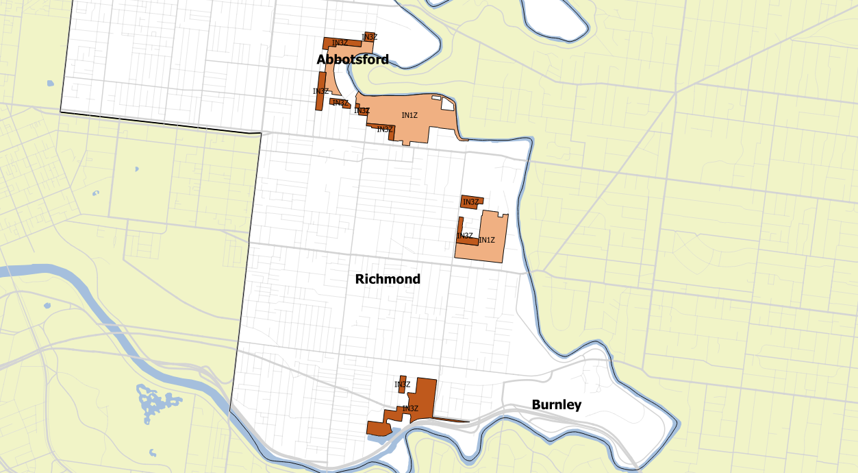

References
Australian Catholic University website (2017) The Plan, viewed 6/10/16
http://www.acu.edu.au/about_acu/campuses/melbourne/melbourne_campus_development/the_plan. Last updated 17/12/2015.

Cook, H. (2016) Schools shortage crisis hits Victoria, The Age, 17 January, viewed 6/10/16 at http://www.theage.com.au/victoria/schools-shortage-crisis-hits-victoria-20160113-gm4wzq.html

Day, J., Davies, B. and M. Spiller (2015) The Dilemma of Urban Employment Land: As approach to assessing the value of small urban manufacturing in Inner Melbourne. Economic Development Australia.

Florida, R. (2012) The Rise of the Creative Class.

Glaeser, E. (2011) Triumph of the City.

Hutton, T. (2008) The new economy of the inner city: regeneration and dislocation in the 21st century metropolis.

Jacobs, J. (1970) The Economy of Cities.

Jewell, C. (2016) Sustainability wins and cars lose in updated Fishermans Bend, Fifth Estate website, viewed 6/10/16 http://www.thefifthestate.com.au/innovation/design/updated-fishermans-bend-vision-a-win-for-sustainability-and-a-loss-for-cars/85340

Meltzer and Ghorban, 2015 Does Gentrification Increase Employment Opportunities in Low-Income Neighborhoods?

Lester, T. and D. Hartley (2014) The long term employment impacts of gentrification in the 1990s. Regional Science and Urban Economics 45: 80–89.

Wood, S. and K. Dovey, (2015) Creative Multiplicities: Urban Morphologies of Creative Clusters. Journal of Urban Design 20(1): 52-74.

Appendix A: Employment forecasts

Table 6. Metro Melbourne employment PROJECTIONS by industry, (‘000)
 | 1996 |  | 2011 |  | 2021 |  | 2031 |  | 1996-11 |  | 2011-31
Industry | # | % | # | % | # | % | # | % | # | % | # | %
Health Care | 132 | 8% | 245 | 11% | 380 | 15% | 508 | 17% | 113 | 19% | 264 | 29%
Retail | 174 | 11% | 232 | 11% | 266 | 10% | 317 | 10% | 58 | 10% | 85 | 9%
Manufacturing | 280 | 18% | 232 | 11% | 198 | 8% | 198 | 6% | -48 | -8% | -35 | -4%
Professional | 126 | 8% | 206 | 10% | 294 | 11% | 388 | 13% | 81 | 13% | 182 | 20%
Construction | 99 | 6% | 189 | 9% | 220 | 9% | 251 | 8% | 90 | 15% | 62 | 7%
Education | 107 | 7% | 176 | 8% | 221 | 9% | 276 | 9% | 69 | 11% | 100 | 11%
Accom'/Food | 85 | 5% | 135 | 6% | 155 | 6% | 182 | 6% | 50 | 8% | 48 | 5%
Finance | 73 | 5% | 112 | 5% | 117 | 5% | 148 | 5% | 40 | 7% | 36 | 4%
Logistics | 80 | 5% | 107 | 5% | 114 | 4% | 128 | 4% | 27 | 4% | 21 | 2%
Public Admin | 81 | 5% | 105 | 5% | 99 | 4% | 103 | 3% | 24 | 4% | -3 | 0%
Wholesale | 93 | 6% | 94 | 4% | 140 | 5% | 176 | 6% | 2 | 0% | 82 | 9%
Other | 78 | 5% | 85 | 4% | 100 | 4% | 113 | 4% | 7 | 1% | 28 | 3%
Administrative | 44 | 3% | 70 | 3% | 67 | 3% | 71 | 2% | 26 | 4% | 1 | 0%
IT | 46 | 3% | 54 | 2% | 55 | 2% | 56 | 2% | 8 | 1% | 2 | 0%
Arts/Rec | 24 | 2% | 48 | 2% | 56 | 2% | 66 | 2% | 24 | 4% | 19 | 2%
Real Estate | 16 | 1% | 38 | 2% | 42 | 2% | 48 | 2% | 22 | 4% | 10 | 1%
Utilities | 11 | 1% | 21 | 1% | 26 | 1% | 30 | 1% | 10 | 2% | 9 | 1%
Agriculture | 14 | 1% | 12 | 1% | 13 | 0% | 13 | 0% | -2 | 0% | 1 | 0%
Mining | 2 | 0% | 5 | 0% | 7 | 0% | 7 | 0% | 4 | 1% | 2 | 0%
Total | 1,561 | 100% | 2,163 | 100% | 2,567 | 100% | 3,074 | 100% | 603 | 100% | 911 | 100%

Table 7. Metro Melbourne employment PROJECTIONS by region, (‘000)
Industry | 1996 |  | 2011 |  | 2021 |  | 2031 |  | 1996-11 |  | 2011-31
 | # | % | # | % | # | % | # | % | # | % | # | %
Central total | 510 | 33% | 739 | 34% | 878 | 34% | 1,063 | 35% | 229 | 38% | 324 | 36%
Middle | 103 | 7% | 145 | 7% | 167 | 6% | 196 | 6% | 42 | 7% | 51 | 6%
Growth Area | 31 | 2% | 77 | 4% | 108 | 4% | 132 | 4% | 45 | 8% | 55 | 6%
Western total | 134 | 9% | 222 | 10% | 274 | 11% | 328 | 11% | 87 | 15% | 106 | 12%
Middle | 130 | 8% | 139 | 6% | 162 | 6% | 196 | 6% | 9 | 1% | 58 | 6%
Outer | 12 | 1% | 15 | 1% | 17 | 1% | 21 | 1% | 4 | 1% | 5 | 1%
Growth Area | 89 | 6% | 143 | 7% | 175 | 7% | 215 | 7% | 54 | 9% | 71 | 8%
Northern total | 230 | 15% | 297 | 14% | 355 | 14% | 432 | 14% | 67 | 11% | 135 | 15%
Middle | 237 | 15% | 301 | 14% | 356 | 14% | 420 | 14% | 64 | 11% | 119 | 13%
Outer | 131 | 8% | 164 | 8% | 184 | 7% | 213 | 7% | 32 | 5% | 49 | 5%
Eastern total | 368 | 24% | 465 | 21% | 539 | 21% | 633 | 21% | 96 | 16% | 168 | 18%
Middle | 135 | 9% | 157 | 7% | 181 | 7% | 210 | 7% | 22 | 4% | 53 | 6%
Outer | 141 | 9% | 198 | 9% | 233 | 9% | 277 | 9% | 57 | 9% | 79 | 9%
Growth Area | 41 | 3% | 84 | 4% | 108 | 4% | 130 | 4% | 43 | 7% | 46 | 5%
Southern total | 317 | 20% | 439 | 20% | 521 | 20% | 617 | 20% | 122 | 20% | 178 | 20%
Total | 1,560 | 100% | 2,162 | 100% | 2,567 | 100% | 3,073 | 100% | 601 | 100% | 911 | 100%
Source: SGS derived from ABS Census and other public datasets

Table 8 Yarra employment PROJECTIONS by industry, (‘000)
 | 1996 |  | 2011 |  | 2021 |  | 2031 |  | 1996-11 |  | 2011-31
Industry | # | % | # | % | # | % | # | % | # | % | # | %
Health Care | 9 | 14% | 15 | 18% | 23 | 20% | 31 | 23% | 6 | 27% | 16 | 31%
Professional | 5 | 8% | 12 | 14% | 18 | 16% | 24 | 17% | 7 | 28% | 12 | 23%
Retail | 6 | 10% | 10 | 12% | 14 | 12% | 16 | 12% | 4 | 17% | 6 | 11%
Construction | 3 | 4% | 7 | 8% | 7 | 6% | 6 | 5% | 4 | 17% | 0 | 0%
Accom'/Food | 4 | 6% | 6 | 7% | 8 | 7% | 9 | 7% | 2 | 10% | 3 | 6%
Finance | 1 | 2% | 5 | 6% | 8 | 7% | 11 | 8% | 4 | 18% | 5 | 11%
Manufacturing | 13 | 20% | 5 | 6% | 4 | 4% | 4 | 3% | -7 | -31% | -2 | -3%
Wholesale | 7 | 11% | 5 | 5% | 5 | 4% | 4 | 3% | -2 | -10% | 0 | 0%
Education | 2 | 4% | 4 | 4% | 5 | 5% | 7 | 5% | 1 | 6% | 4 | 7%
Other | 3 | 6% | 3 | 4% | 4 | 3% | 4 | 3% | 0 | -1% | 1 | 2%
Administrative | 2 | 3% | 3 | 4% | 3 | 3% | 4 | 3% | 1 | 5% | 0 | 1%
IT | 3 | 4% | 3 | 3% | 3 | 3% | 3 | 2% | 0 | 1% | 0 | 0%
Public Admin | 2 | 3% | 2 | 2% | 3 | 2% | 3 | 2% | 1 | 2% | 1 | 2%
Real Estate | 1 | 1% | 2 | 2% | 4 | 3% | 5 | 4% | 1 | 6% | 3 | 6%
Logistics | 2 | 3% | 2 | 2% | 2 | 2% | 2 | 2% | 0 | 1% | 0 | 1%
Arts/Rec | 1 | 1% | 1 | 2% | 2 | 2% | 3 | 2% | 1 | 3% | 1 | 2%
Utilities | 1 | 1% | 1 | 1% | 1 | 1% | 1 | 1% | 0 | 1% | 0 | 0%
Agriculture | 0 | 0% | 0 | 0% | 0 | 0% | 0 | 0% | 0 | 0% | 0 | 0%
Mining | 0 | 0% | 0 | 0% | 0 | 0% | 0 | 0% | 0 | 0% | 0 | 0%
Total | 63 | 100% | 86 | 100% | 112 | 100% | 137 | 100% | 23 | 100% | 51 | 100%
Source: SGS Employment Projections

Appendix B:
Capacity analysis
This appendix outlines the approach used for the capacity analysis used to inform the Strategy.

Purpose
The primary purpose of the capacity analysis is to determine the likely capacity for employment growth and changes in the employment zoned land in the City of Yarra, based on the current land use zones. It has also been used to assess the likely impact on employment capacity of zone changes.

Approach
The City of Yarra was divided into a series of 200 sub-precincts areas covering all employment zoned land, that is, land with the zoning C1Z, C2Z, MUZ, IN1, IN3, PUZ, SUZ or CDZ. The sub-precincts are shown in the map below.

Existing floor space estimates
The quantum of existing floor space in each sub-precinct was estimated using data from the Urban Development Program Data. This was cross-checked for accuracy against data from Council and aerial photography.

The mix of floor space in terms of broad land use type – retail, commercial, industrial and institutional – was estimated using Council data.

Capacity estimates
Estimating the capacity for each sub-precinct used a combination of data about the existing floor space and assumption about the average intensity of development that might be expected in the future. The key assumptions used to estimate capacity are listed in the table below. In the case of areas zones C1Z is assumed there is additional capacity for residential development above and beyond that assumed for non-residential development.

Table 9. employment floor space capacity assessment assumptions
Zone | Location | Site cover | Floors of employment floor space | Notes
C1Z | All | 70% | 2
C2Z | Gipps and Cremorne precincts | 70% | 3 | A higher density of development has been assumed in these key employment precincts
C2Z | All other C2Z land | 70% | 2
MUZ | All | 70% | Min. 0.5;  Max. 1.0 | Assumes some mixed uses zoned areas will lose employment floor space; but will hosts not less than half of one storey.
IN1 | All | 70% | 1.2 | Current average is 1.0. Assumes some opportunity for intensification.
IN3 | All | 70% | 1.2 | Current average is 0.9. Assumes some opportunity for intensification.
PUZ2 | Public Housing, (Collingwood); University of Melbourne (Burley) | No capacity | No capacity | Assumed no capacity.
PUZ2 | Kanga TAFE | 70% | 2.0
PUZ2 | Carpark, Gym and Police Station (Bridge Road); Fitzroy Public School; Neighbourhood Justice Centre;  Melbourne Polytechnic (Collingwood Campus);  Collingwood English Language School. | No capacity | No capacity | Assumed no capacity across this range of facilities. Melbourne Polytechnic already quite dense.
PUZ3 | St Vincents Hospital | 70% | 9 | Currently supports average of 6.3 employment floors.
PUZ3 | Aged Care Facility; Riverside House Nursing Home; Thomas Embling Hospital | No capacity | No capacity | Assumed no capacity across this range of facilities.
PUZ4 | Queens Pde (com uses on Transport Zone) | 70% | 0.5
PUZ6 | Yarra City Council (Bridge Road); Collingwood Town Hall; Richmond Rec Centre; Fitzroy Swimming Pool | No capacity | No capacity | Assumed no capacity across this range of facilities.
PUZ7 | Fire Station (Church Street) | No capacity | No capacity | Assumed no capacity.
PDZ1 | Green Square Development | 70% | 0.5 | Lower employment capacity as mostly residential development
CDZ1 | Ikea and Bus. Park | 70% | 3.3 | Currently supports average of 53% and 3.3 employment floors.
CDZ3 | Nylex Site | 70% | 1.0 | Assumed one level of employment.
SUZ5 | Epworth Hospital | 70% | 7.0 | Currently supports average of 4.8 employment floors
SUZ4 | Abbotsford Convent | No capacity | No capacity | Assumed no capacity.

Base precincts
For the capacity analysis, Yarra’s employment lands were classified into precincts.
Figure 43. base precincts for capacity analysis
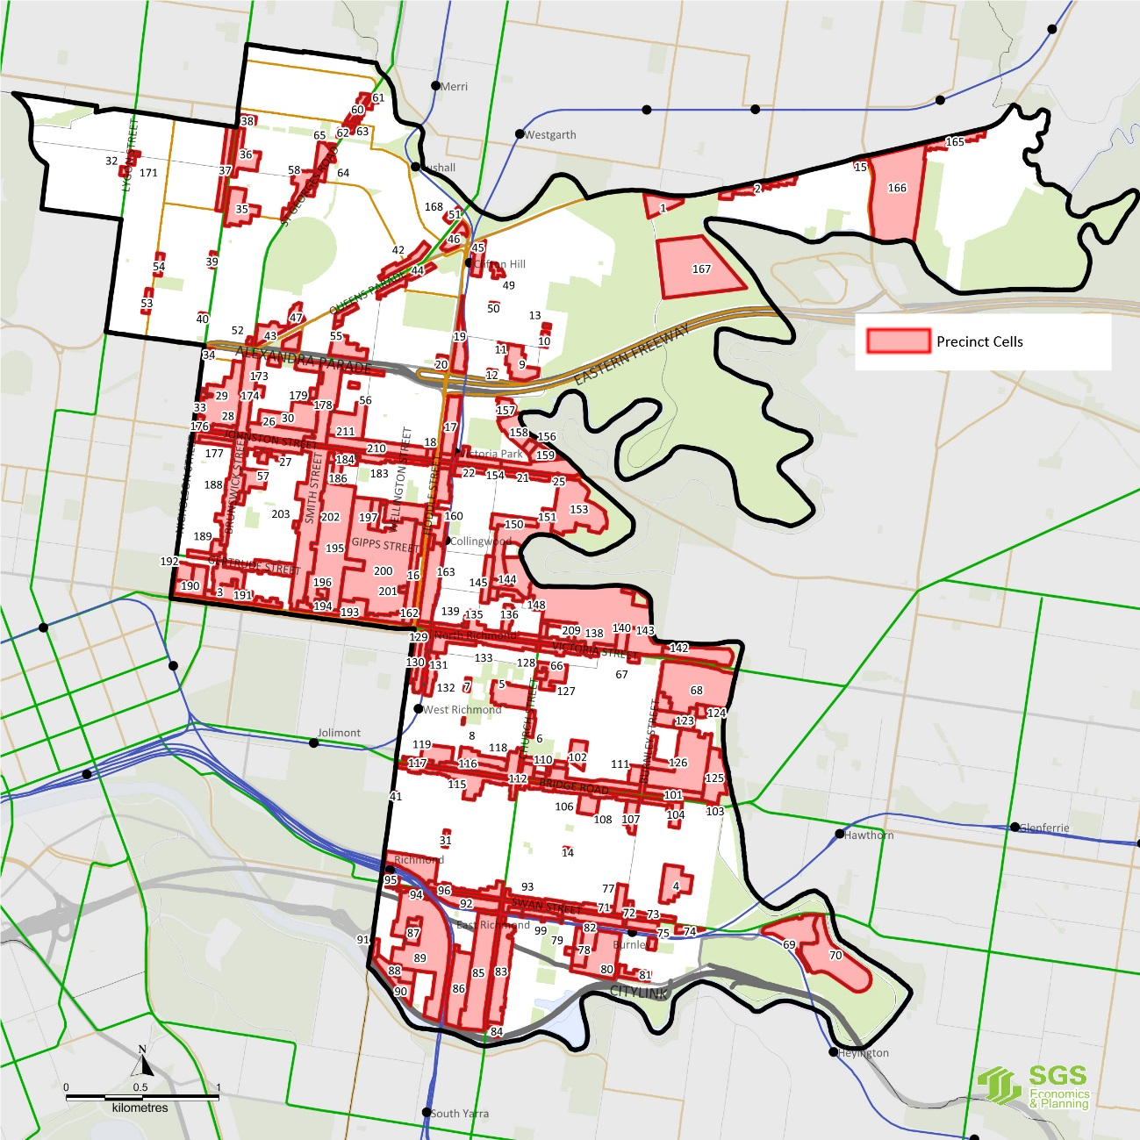
Source: SGS Economics and Planning

Aggregation to employment precincts
The precincts were grouped into their larger precinct areas that correspond to City of Yarra’s Activity Centre and other employment precincts.
Figure 44. yarra’s employment precincts
Source: SGS Economics and Planning

Precinct classification
Aggregated precincts have been classified as AC of other employment based on retail versus commercial/industrial dominance (using employment floor space data):

- Centres with over 30% retail floor space were defined as retail precincts.
- Major retail precincts (ACs) are those with over 50,000 square metres of employment floor space
- Major employment precincts are those with over 50,000 square metres of employment floor space
- Other precincts defined as ‘minor’ small/local.
- Commercial and industrial uses have been grouped as they are difficult to separate in the Yarra context.
Each centre sits on a continuum rather than having a clearly defined category and several centres could arguably be categorised differently.
Table 10. yarra’s ACTIVITY CENTRES AND EMPLOYMENT PRECINCTS
 | Precinct name | Precinct type | Designation* | Notes
 | Bridge Road | Retail | Activity Centre (PM)
 | Brunswick Street | Retail | Activity Centre (PM) | Incl. Johnston west of Smith St
 | Johnston Street East | Retail | Activity Centre | Emerging Activity Centre
 | Smith Street | Retail | Activity Centre (PM) | Includes Gertrude Street
 | Swan Street | Retail | Activity Centre (PM)
 | Victoria Street | Retail | Activity Centre (PM) | Includes Victoria Gardens
 | Queens Parade | Retail | Local Activity Centre | Clifton Hill and North Fitzroy
 | Nicholson Street | Retail | Local Activity Centre | Carlton North/North Fitzroy
 | St Georges Road | Retail | Local Activity Centre | North Fitzroy
 | Alphington | Retail | Local Activity Centre | Will incl. AMCOR retail/comm.
 | Carlton | Retail | Local Activity Centre | Rathdowne Village and Lygon St.
 | Richmond | Retail | Local Activity Centre | Three small centres in Richmond
 | Abbotsford | Employment | Major | Predominantly industrial
 | Church St South | Employment | Major | Mixed employment
 | Cremorne | Employment | Major | Mixed employment
 | Gipps Street | Employment | Major | Mixed employment
 | Victoria Parade | Employment | Major (HEP) | Predominantly institutional
 | Fairfield | Employment | Minor | Predominantly institutional
 | Burnley Office | Employment | Minor | Predominantly commercial
 | Burnley South | Employment | Minor | Mixed employment
 | Church Street North | Employment | Minor | Mixed employment
 | Richmond East | Employment | Minor | Predominantly industrial
 | Clifton Hill South | Employment | Minor | Predominantly industrial
 | Hoddle Street | Employment | Minor | Predominantly industrial
Source: SGS, 2015. * Plan Melbourne designations: PM = Activity Centre; HEP = Health/Education precinct.

Existing floor space
Figure 45. existing floor space by broad type (MAP)
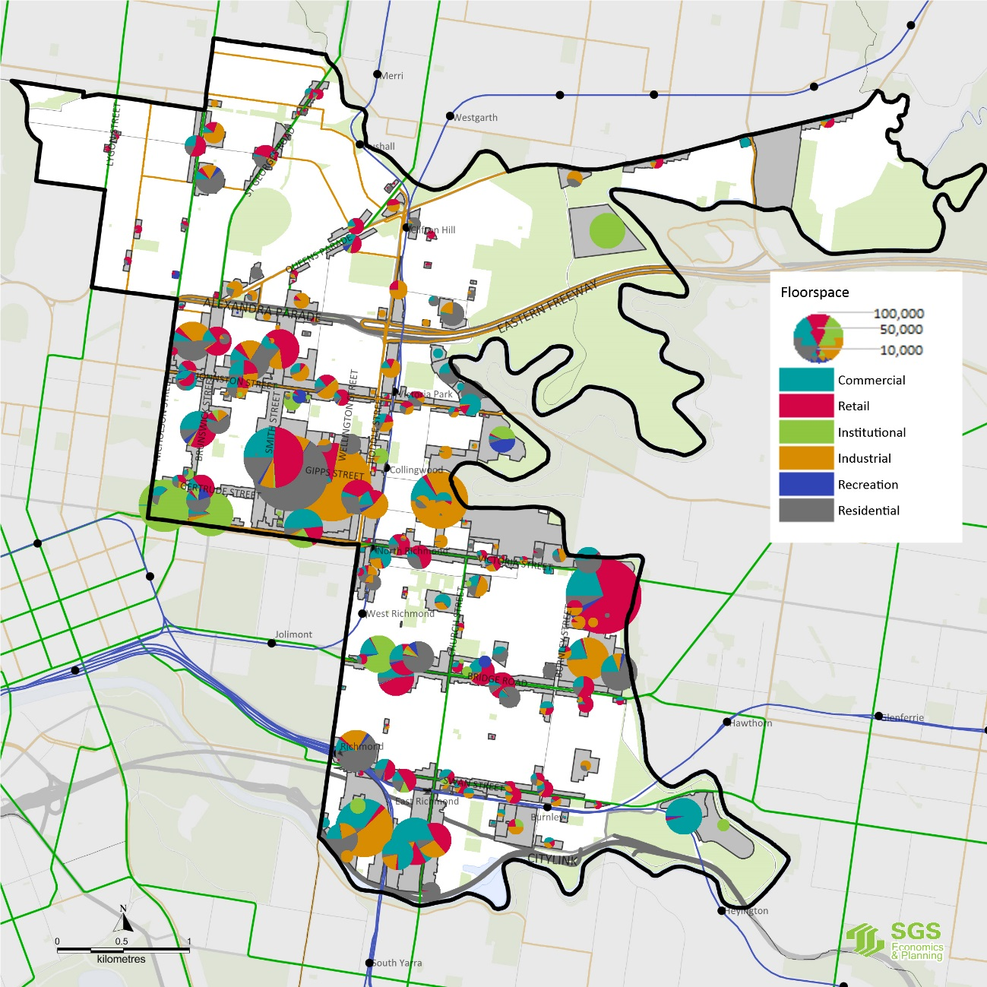
Source: SGS, 2015.

Appendix C: existing zoning

Figure 46. Carlton North, Fitzroy North and Clifton Hill zoning
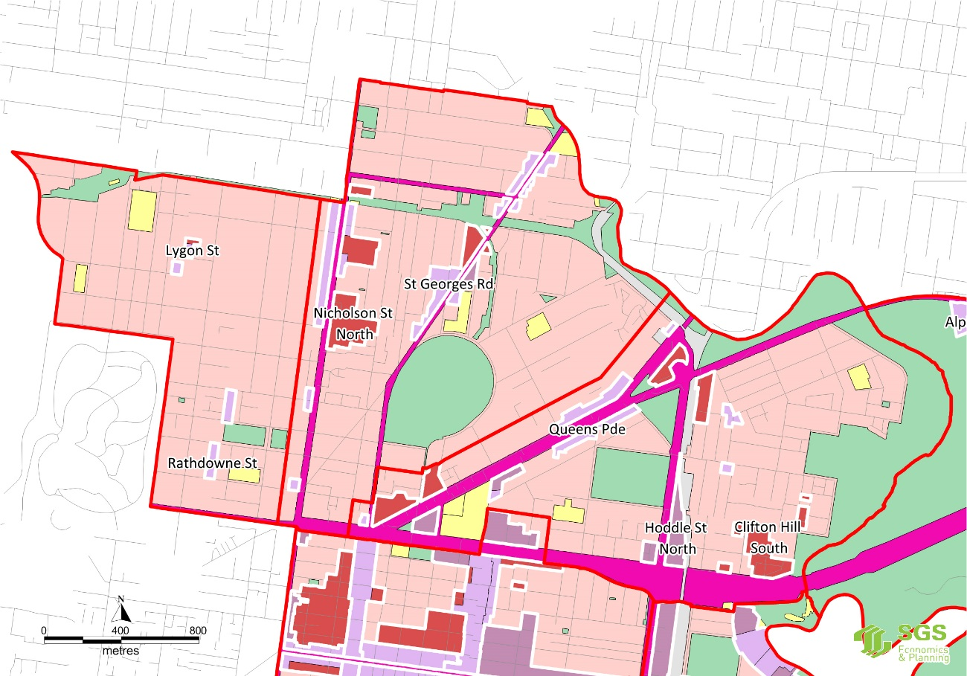
Figure 47. Fairfield-Alphington ZONES
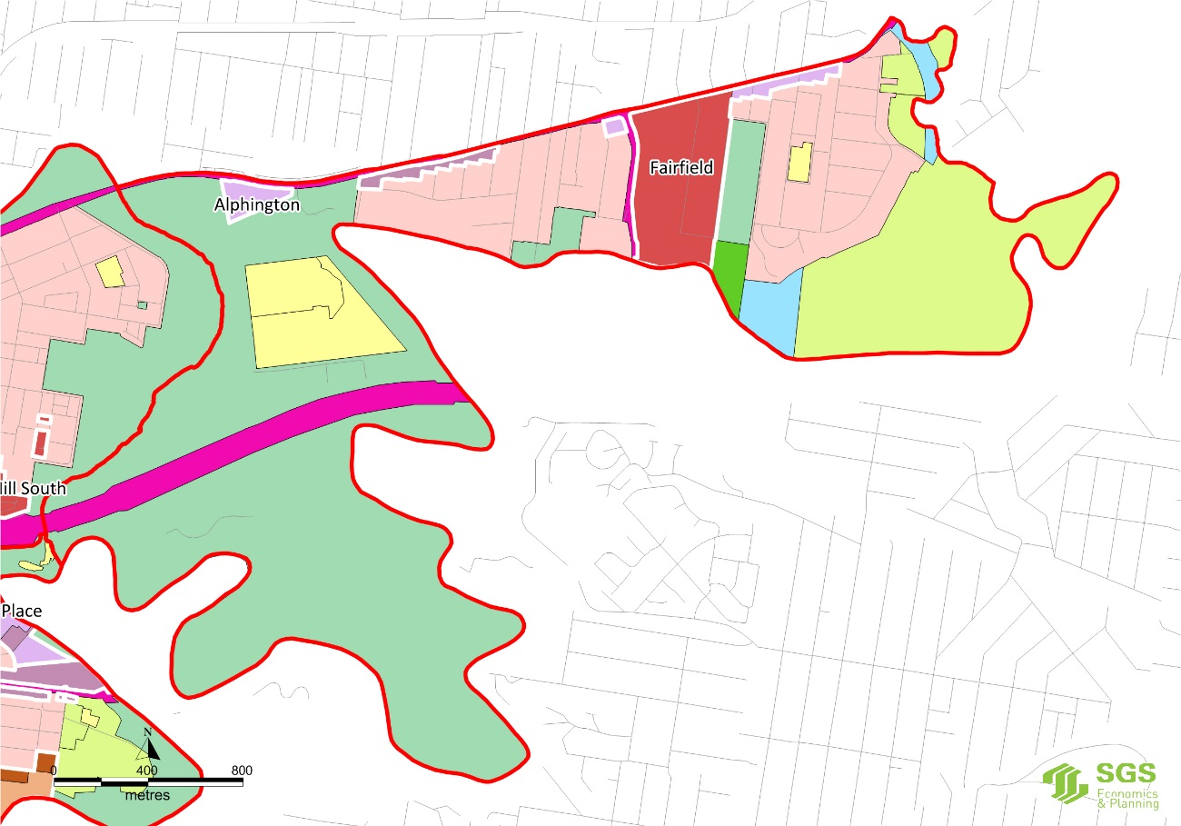

Figure 48. Fitzroy, Collingwood and Abbotsford ZONES
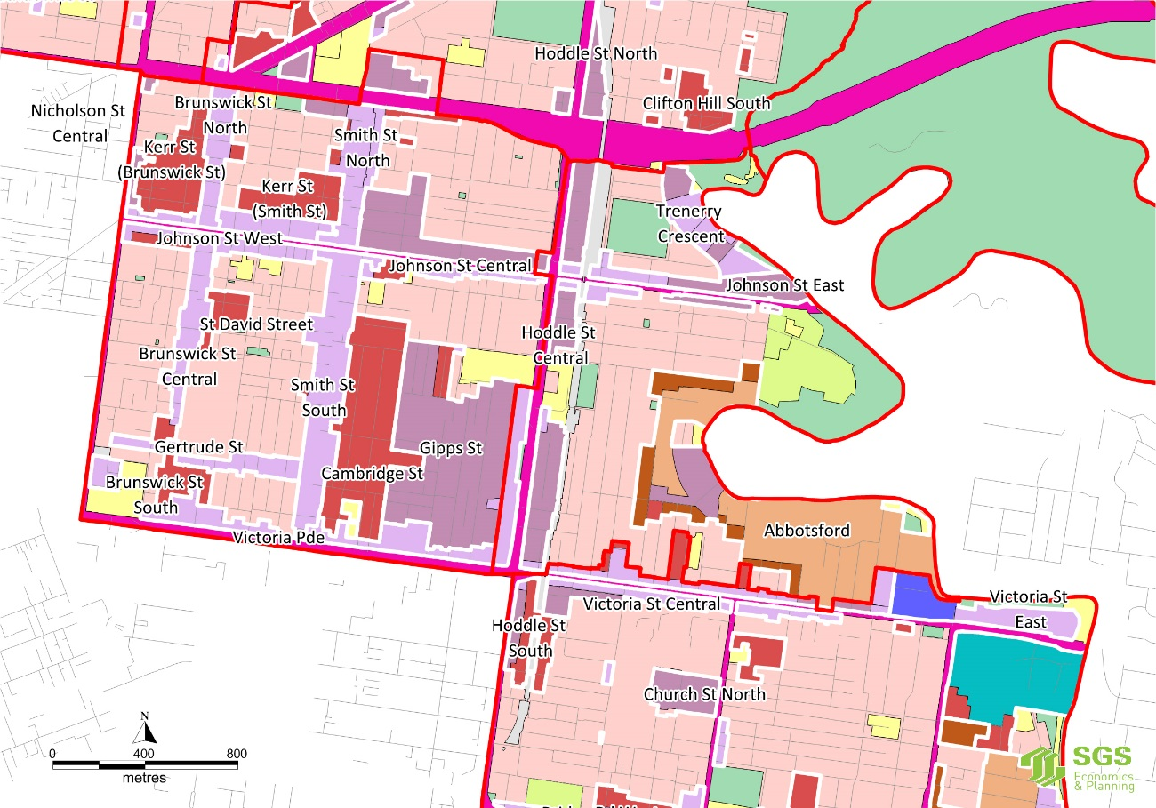

Figure 49. Richmond and Burnley-Cremorne ZONES
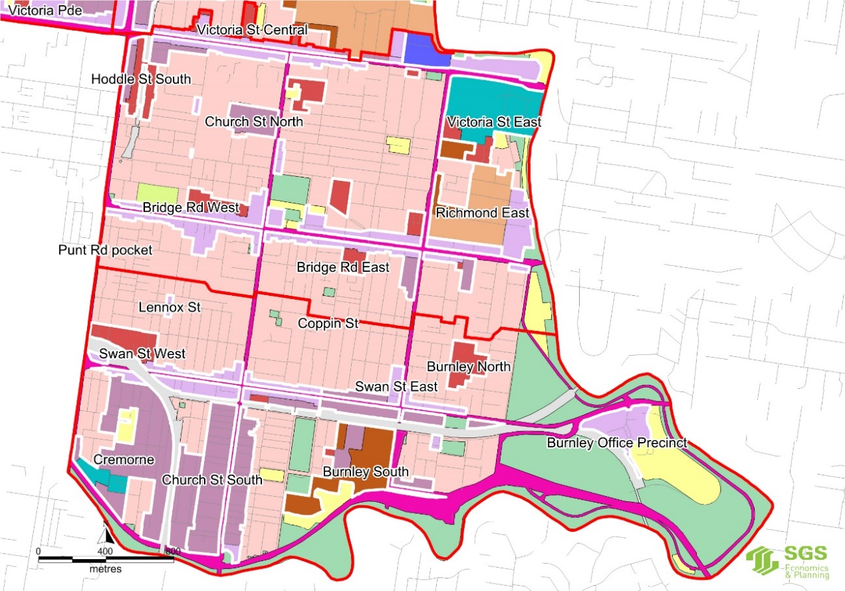



Contact us
CANBERRA
Level 6, 39 London Circuit
Canberra ACT 2601
+61 2 6263 5940
sgsact@sgsep.com.au
HOBART
PO Box 123
Franklin TAS 7113
+61 421 372 940
sgstas@sgsep.com.au
MELBOURNE
Level 14, 222 Exhibition Street
Melbourne VIC 3000
+61 3 8616 0331
sgsvic@sgsep.com.au
SYDNEY
209/50 Holt Street
Surry Hills NSW 2010
+61 2 8307 0121
sgsnsw@sgsep.com.au



SGS Economics and Planning, based on ABS data.
SGS Economics and Planning (2015) Spatial Economic and Employment Strategy - Issues and Opportunities Paper
An arts and entertainment venue from the 1970s until the late 1990s.
City of Yarra (2013) Economic Development Strategy 2015-2020.
Ibid. Analysis based on the methodology set out in SGS (2013) Valuing Australia's Creative Industries Study.
Alphington Paper Mill Development Plan, 2016, page 34.
SGS Economics and Planning estimates based on ABS data.
Is has been assumed that job to floor area ratios will decline between 2016 and 2031 by a factor of 20% (see Table 4 for individual assumptions by floor space type for each period).
Sourced from ABR data. Whilst all funds, trusts and other non-business entities have been removed, it is still possible registered businesses are dormant, or generating very limited (or no) turn over.
The categories of activity centres described by Melbourne 2030 were replaced in Plan Melbourne with a ‘flatter’ hierarchy described as Metropolitan Activity Centres, Activity Centres and Neighbourhood Centres. Yarra contains no designated Metropolitan Activity Centres.
Existing floorspace is based on analysis of the Council Rates, Council Retail Centre Audit and Expanded Urban Development Program Data. Additional spot checks and refinements have also been completed at a precinct level.
See Appendix C for a more information on this capacity analysis.
Planisphere (2014) Yarra Mixed Use Zone Review
Victoria in the Future, 2015.
Ibid.
VicRoads (2016) Traffic Volume Data for Victoria.

